BROOKSIDE PRIMARY SCHOOL
Rostherne Avenue, Great Sutton, Cheshire, CH66 2EE
0151 558 1123 www.brookside.cheshire.sch.uk Headteacher – Mr D Orme BA (Hons) NPQH Deputy Head – Ms J Smith B Ed (Hons) NPQSL
“Happy and Successful in Everything we Do!”

17 April 2023
Dear Parents

Today is the first day of the Summer Term and we are very excited about our plans for learning and enrichment during the coming few months. All our classes now embark on new areas of learning which I hope our pupils will find engaging and enjoyable. You can see on the back of this letter your child’s curriculum focus in class this half-term. For your information, we also put this half-termly overview on the ‘Classrooms’ page of our school website. As usual, you can refer back to previous topics and revisit prior learning to keep it in the children’s long-term memory. This is what we do at school too, in our timetabled revision sessions. It would be great if you could look at this at home and talk to your children about what they have learnt throughout the year so far. Your child’s class teacher will be pleased to discuss their learning with you whenever you wish.

Miss Loney, our Subject Leader for PE, has arranged for children from Y2 to Y6 to learn cricket with a qualified coach each Wednesday at school. We are looking forward to broadening our PE provision in this way to introduce our pupils to one of our most beloved national games. This may entail some changes to your child’s PE day. Y5 and Y6 will now have PE on Tuesday and Wednesday. Y3 and Y4 will have PE on Wednesday and Thursday. Other classes’ PE will remain on the same day. Children should come dressed in their PE kits on their PE day as usual.

Looking ahead to next month, please be aware of two extremely important weeks coming up. The week commencing Monday 8th May will be SATs week for our Y6s (excluding the Monday itself which is the Coronation Bank Holiday). They have worked so hard, not just in Y6, but throughout their time in Key Stage 2 and we know that each and every child will do their best, which is all we can ask them to do. The following week, w/c 15 May, it will be the turn of Y2 to do their SATs assessments and again they have all worked tremendously hard for this. Needless to say, the children’s full attendance on those dates will be really important. The Y1 phonics screening tests are not until w/c 12 June.

I wish all our pupils the very best of luck as they start a new term at school.

Yours sincerely,

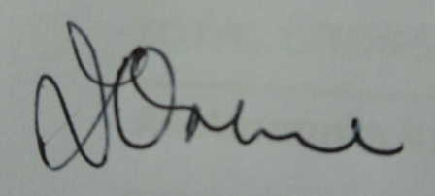

Mr D Orme
Headteacher

