**BROOKSIDE ATTENDANCE NEWSLETTER** **October 2024**

   **Welcome back!**

**We would like to take this opportunity to say a HUGE thank you to all of our Parents and Carers who have been able to adjust to our new school start time – quarter to 9! We appreciate this may have taken some getting used to, particularly for those with more than one child. Getting up and ready in the mornings can be a challenge! We have been so impressed with your huge efforts. What a great start to the new school year. Please keep it up!**

**May we remind you that if your child is not well enough to attend school, you must inform us as early as possible, on the first day of absence and each absent day after that. This can be done by calling 0151 558 1123 and leaving a voicemail by pressing option 3. Alternatively you can submit a message using ‘Absence reporting’ on our school website. Your voicemails and messages will be picked up by our Pastoral Manager Mrs Austin. Please provide as much detail as possible regarding your child’s illness and please give an honest reason.**



**Leave of Absence**

**Please do not book holidays during term time. Any term time requests will only be authorised when we consider the period of absence to be for an Exceptional Circumstance. Exceptional circumstances are one off events which are unavoidable. An ‘Application for a pupil to be absent from school’ must be completed in advance and handed into the main office. This can be found on our school website and at the main office. If the period of absence is not authorised, it is likely a Fixed Penalty Notice will be issued.**

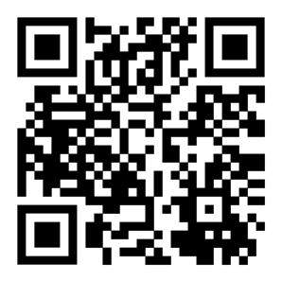

**Our Brookside Attendance and Punctuality Policy has been updated.**

**We advise all parents to take some time to read it.**

**Please use this QR code to access it:**

**If you have any queries or would like to discuss your child’s attendance, please do not hesitate to contact the school Attendance Lead Mrs Austin** 