**Autumn 2022**

We hope you have had a lovely summer break with your families and friends and are as excited as we are to start the new academic year. This term is going to be full of fun and exciting learning opportunities.

**MATHEMATICS**

During the half term, we will be recapping learning from previous years and developing our understanding of place value, and addition and subtraction.

Children will also be given the opportunity to use previously taught mathematical skills across the curriculum, particularly in Topic and Science.

This half term, children will be able to explore **Platonic Solids** linked to our work on Ancient Greece.

**Multiplication Tables**

This half term, we will be focussing on x6 multiplication and division facts.

**Please continue to practise ALL your multiplication and division facts EVERY day,**

**Children in Year 4 will sit a National Test in Summer 2023.**

**LITERACY**

In English this half

term, we will be using

**Gorilla** by Anthony

Browne to inspire our learning. We have lots of exciting writing opportunities. Children will be able to practise skills taught in Year 3 as well as being introduced to expanded noun phrases and fronted adverbials.

**Writing across the Curriculum**

Children will have the opportunity to write in a variety of different genres across the curriculum.

**Reading**

Each week, children will participate in a Guided Reading session with the class teacher and/or teaching assistant. This text will then be available for your child to share at home with an activity to complete.

All children are encouraged to read a book of their choice.

**EVERY** child will be expected to read **EVERY** school night for at least 10 minutes.

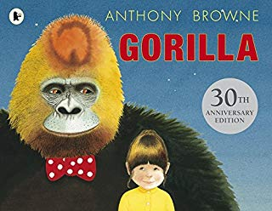

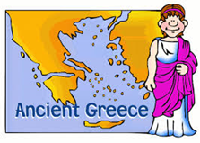

**COMPUTING**

* Children will use different technologies to produce a document about a specific topic related to the Ancient Greeks.
* The children will an edited range of text, images and evidenced tools fitting of the

purpose and audience.

KS2: 4, 6, 7

**SCIENCE**

Our Science topic this term is STATES OF MATTER. Children will be

‘working scientifically’ to exploring the differences between solids,

liquids and gases, classifying objects and identifying their properties.

They will explore in-depth how water changes state, exploring melting,

freezing, condensing as well as a particular focus on evaporation.

Finally, they will learn about the stages of the water cycle.

PHYSICAL EDUCATION

Year 4 will have PE on a

**TUESDAY** and **THURSDAY** afternoon.

Children are to come into school wearing the correct school PE kit – black shorts/joggers, white t-shirt and black trainers. As lessons will be mainly outside, please also provide with your children with a sweatshirt/tracksuit.

SWIMMING

Children in Year 4 will also participate in a course of Swimming lessons at the Ellesmere Port Sport Village every **WEDNESDAY.** Children need to bring a towel, swimming kit and £2 towards the cost of the transport.

RELIGIOUS EDUCATION

This half term, we will be

exploring JUDAISM.

How do Jews demonstrate their faith through their communities?





WATER BOTTLES

Please ensure that

your child comes into

school every day with a

water bottle.

Children will be given the opportunity to refill their bottle throughout the course of the day.

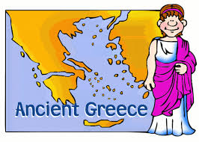

If you have any queries or issues that you will like to discuss, please contact me via email: [c.kendal@brookside.cheshire.sch.uk](mailto:c.kendal@brookside.cheshire.sch.uk) and I’ll get back to you as soon as possible.

**Year 4 Team – Mrs Kendal, Mrs Christian and Mrs Lester**

This half term, our Topic focus will be

Ancient Greece. Where possible, we

will be linking our learning across

the Curriculum to Ancient Greece.

See additional attached sheet for

more information.

Activities within all of the Curriculum areas may change depending on class achievement and interest, although all National Curriculum Objectives will remain the same to ensure coverage by the end of Key Stage 2.

**ART**

Children will research the different shapes and styles of Grecian Pots. The children will learn coil and pinch pot techniques before designing and making their own pot – with Greek style illustrations.

KS2: 1, 2

**Ancient Greece**

**Year 4 2022-2023**

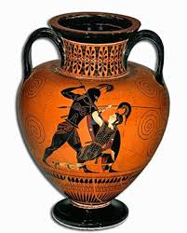

**MUSIC**

Using the story of the Trojan Horse as a stimulus, children will listen to different song styles (pop, R&B (minor and melancholic), folk, tap, soul and swing) whilst developing their knowledge and skills around dynamics, pitch, tone, rhythm, tempo and timbre. KS2: 1, 3, 4, 5, 6

KS2: 1, 2, 3

**GEOGRAPHY**

Children will locate Greece on a map before describing some of the physical features of Greece.

KS2: 1, 4, 5a, 6

**HISTORY**

Over the course of the half term, children will:

* Find out who the Ancient Greeks were and locate their civilisation on a timeline
* Explore and discuss the main types of government in Ancient Greece – monarchy, oligarchy and democracy
* Compare and contrast two city states – Athens and Sparta
* Use a combination of sources to learn about daily life in Ancient Greece
* Research Gods, Goddesses and religious beliefs in Ancient Greece
* Explore how modern life has been influenced by Ancient Greece.

KS2: 8

**COMPUTING**

Children will use different

technologies to produce a

simple document about a

specific topic related to the Ancient Greeks.

The children will an edit a range of texts and images (including an edited image of themselves) to produce a document their document. KS2: 4, 6, 7

