BROOKSIDE PRIMARY SCHOOL
Rostherne Avenue, Great Sutton, Cheshire, CH66 2EE
0151 558 1123 www.brookside.cheshire.sch.uk Headteacher – Mr D Orme BA (Hons) NPQH Deputy Head – Ms J Smith B Ed (Hons) NPQSL
“Happy and Successful in Everything we Do!”

Coronation Letter
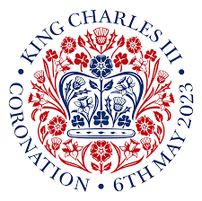
Dear Parents
An event not seen for seventy years is about to take place in our country as a new King is crowned! As you know, Monday 8 May will be a Bank Holiday to help celebrate this national moment.
At school we have been very pleased to be awarded a grant of £250 which we will use to create a Coronation Garden. Our children will be able to plant seeds which will grow into delicious food for us to enjoy and plants for us to look at to make our garden beautiful.
On Friday 5th May, our cook will be preparing a splendid Coronation Picnic for our children to enjoy outside (British weather permitting!). There is a slip on the back of this letter to complete if they wish to join in. The children will also be decorating bunting and pictures in school. There will even be a chance to win free tickets to Chester Zoo.
To help make the day even more special, on Friday 5th the children can come to school dressed in a royal outfit, as a little prince, princess, king or queen!
We are looking forward to this event and hope you are too!

Yours sincerely,

Mr D Orme
Headteacher

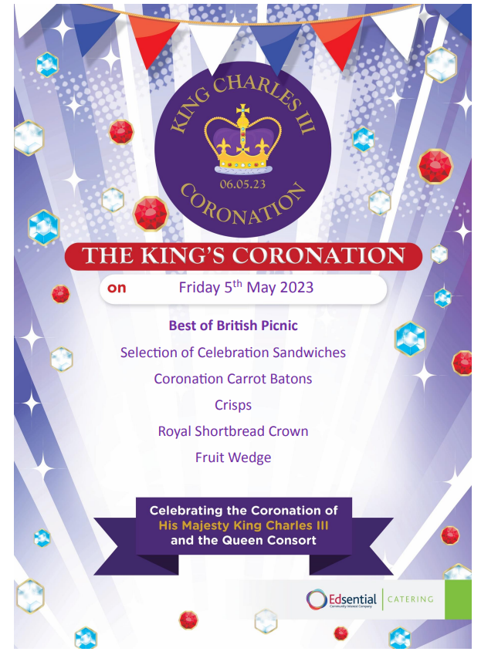

Coronation Picnic – Friday 5th May 2023
Child’s Name_________________________________
Class______________________________________
Please complete and return this slip by 28 April if your child wishes to order a school picnic lunch.
Please enclose £2.45 or pay by ParentPay (unless you are entitled to free school meals).
Signed_____________________

