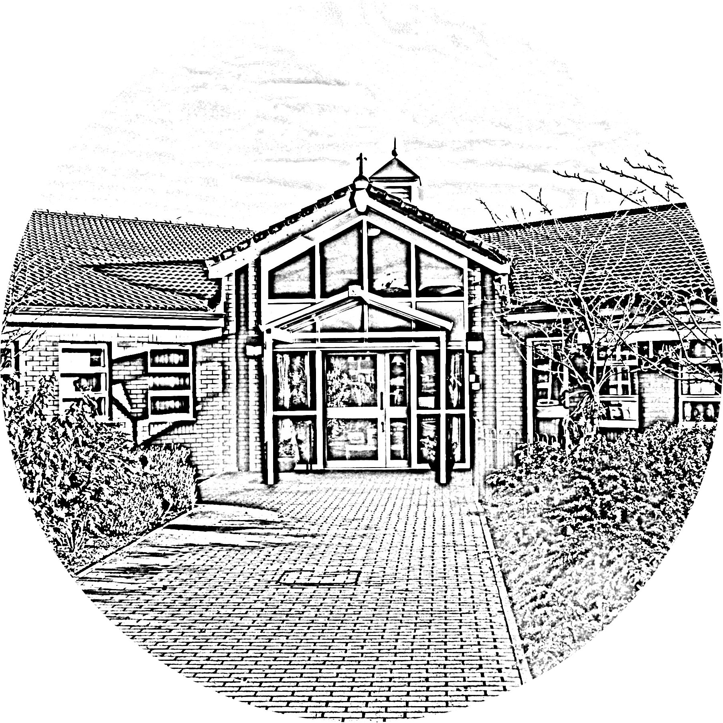

BROOKSIDE PRIMARY SCHOOL
Rostherne Avenue, Great Sutton, Cheshire, CH66 2EE
0151 558 1123 www.brookside.cheshire.sch.uk
Headteacher – Mr D Orme BA (Hons) NPQH Deputy Head – Ms J Smith B Ed (Hons) NPQSL
“Happy and Successful in Everything we Do!”

Dear Parent/Carer

Your child has expressed an interest in Dance Club. This club will run for 6 weeks and is due to commence Friday 12th January.

This is an early morning club and will begin at 8:20am in the school hall.

Each session will cost £2, £12 in total and must be paid in full in order to guarantee a place.

If you would like your child to attend please sign and return the slip below to Miss Loney. Places will be offered on a first come first served basis, there are 15 places available.

Miss Loney
………………………………………………………………………………………………………………..

Dance club
This club will run for 6 weeks.

KS1 AND KS2 Friday (8:20am- 9am) School Hall

I give permission for my child …………………………………………….. class ............ to take part in morning Dance Club

Signed.................................................................

Emergency contact detail:

Name ______________________

Mobile _____________________

