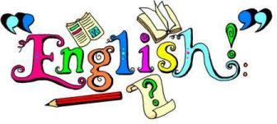
Family
‘Reading and writing is taught so differently from when I went to school!’

Sounds familiar?
Would you like to find out how you can support your children’s learning, brush up on your own English skills and work towards an adult Functional Skills English qualification?
If your answer to these questions is ‘yes’, then this free, fun and friendly Family English course could be for you!
Taking place online, every Friday morning, from 7th January – 1st April 2022, 9:30am - 11:30am
To book a place on this course, please email
emma.cawley@cheshirewestandchester.gov.uk by Wednesday 15th December. The course will run on Microsoft Teams and once you have signed up, your tutor will be in touch to discuss details.
Please note:
So that we can offer this course free of charge, you will be required to complete some paperwork. You will also need access to a pen and some paper during each session. You will need to use a device that has a working video camera, which must be turned on for the entirety of the course.

