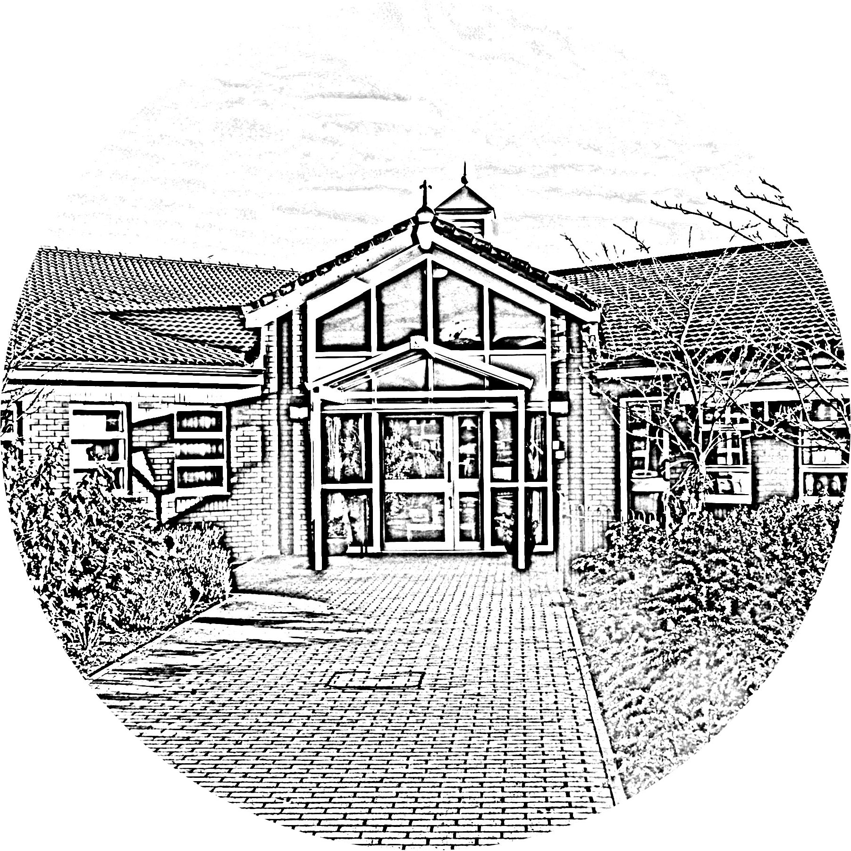

BROOKSIDE PRIMARY SCHOOL
Rostherne Avenue, Great Sutton, Cheshire, CH66 2EE
0151 558 1123 www.brookside.cheshire.sch.uk
Headteacher – Mr D Orme BA (Hons) NPQH Deputy Head – Ms J Smith B Ed (Hons) NPQSL
“Happy and Successful in Everything we Do!”

Dear Parent/Carer

Your child has expressed an interest in ‘Fit fusion’ Club. This club will run for 6 weeks and is due to commence Thursday 11th January.

If you would like your child to attend please sign and return the slip below to Miss Loney. Places will be offered on a first come first served basis.

Your child will need to bring their sports kit (PE trousers or shorts, t-shirt, trainers) and a drink.
*The club may sometimes take place outside on the school field so your child may need to bring warmer clothes each week depending on the weather.

Miss Loney
………………………………………………………………………………………………………………..

Fit Fusion club
This club will run for 6 weeks.

KS2 Thursday (3pm-4pm) School Hall

I give permission for my child …………………………………………….. class ............ to take part in Fit Fusion Club

Signed.................................................................

Emergency contact detail:

Name ______________________

Mobile _____________________

(Year 6 only) - My child may walk home by themselves: yes no

