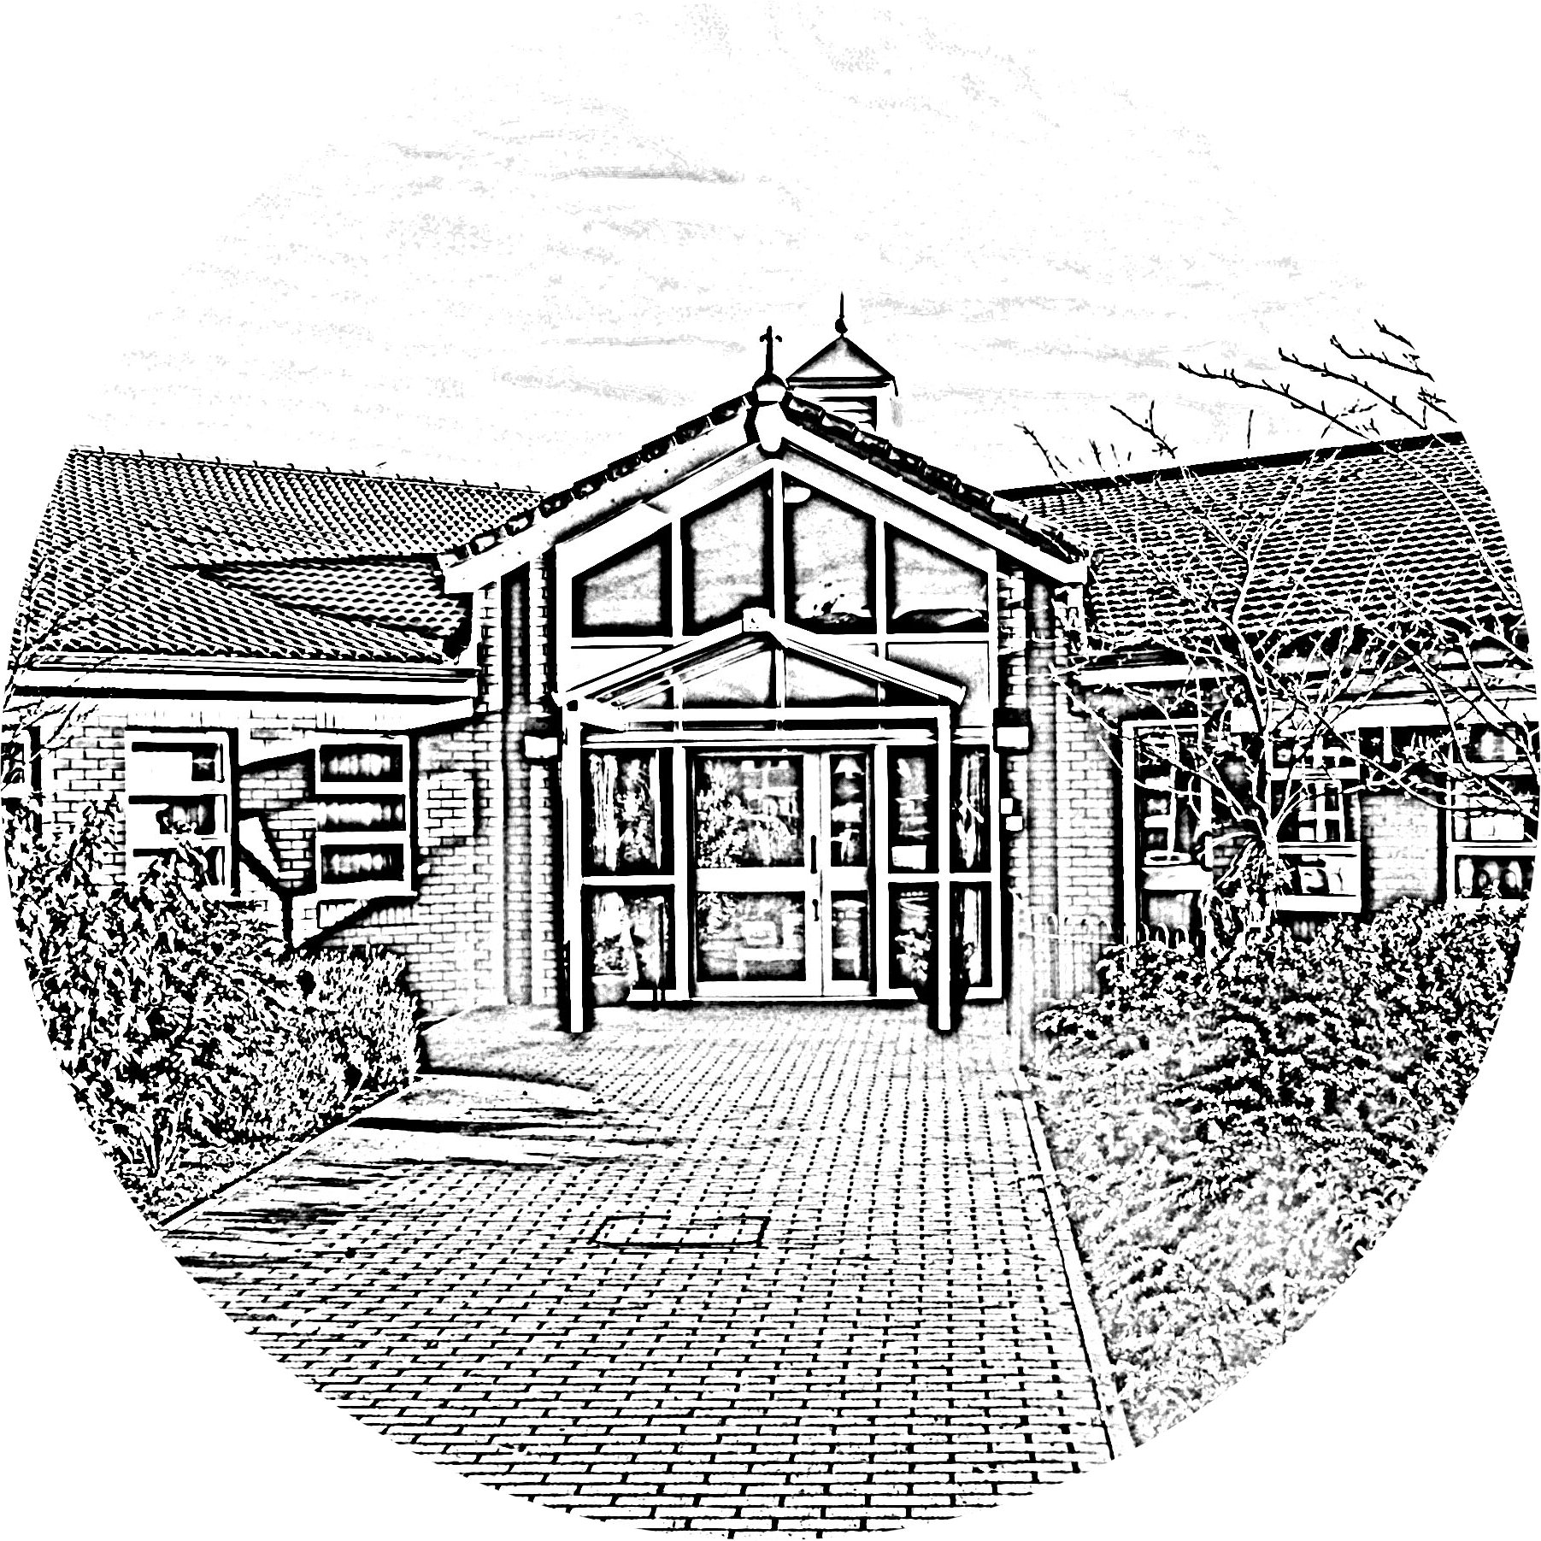

BROOKSIDE PRIMARY SCHOOL
Rostherne Avenue, Great Sutton, Cheshire, CH66 2EE
0151 558 1123 www.brookside.cheshire.sch.uk Headteacher – Mr D Orme BA (Hons) NPQH Deputy Head – Ms J Smith B Ed (Hons) NPQSL
“Happy and Successful in Everything we Do!”

Dear Parents/Carers,

Guided Reading: Home Reading Books

In order to promote reading, children will now be bringing home books to read that match those being taught in their weekly Guided Reading and Comprehension sessions.

Please note that whilst your child is studying this book throughout the week in class, only one copy of the book will be sent home which they will re-read nightly at home. This book will not be changed until the following week.

It is imperative therefore that this book is kept securely, as any lost or defaced books will incur a charge of £5 per book as they are very expensive to buy.

In addition to this, there will still be daily opportunities for your child to choose home reader books that interest them and to develop a love of reading with you at home.

If you have any questions about the new home reader books, please do not hesitate to contact your child’s class teacher.

Yours faithfully,

Mrs S Lomas
Literacy Subject Lead.

****************************************************************

Name of Child: .................................................................................................................

Please sign below to acknowledge receipt of this letter and to accept liability for any lost or defaced books.

Signed: .................................................................................................................
Date: .................................................................................................................

