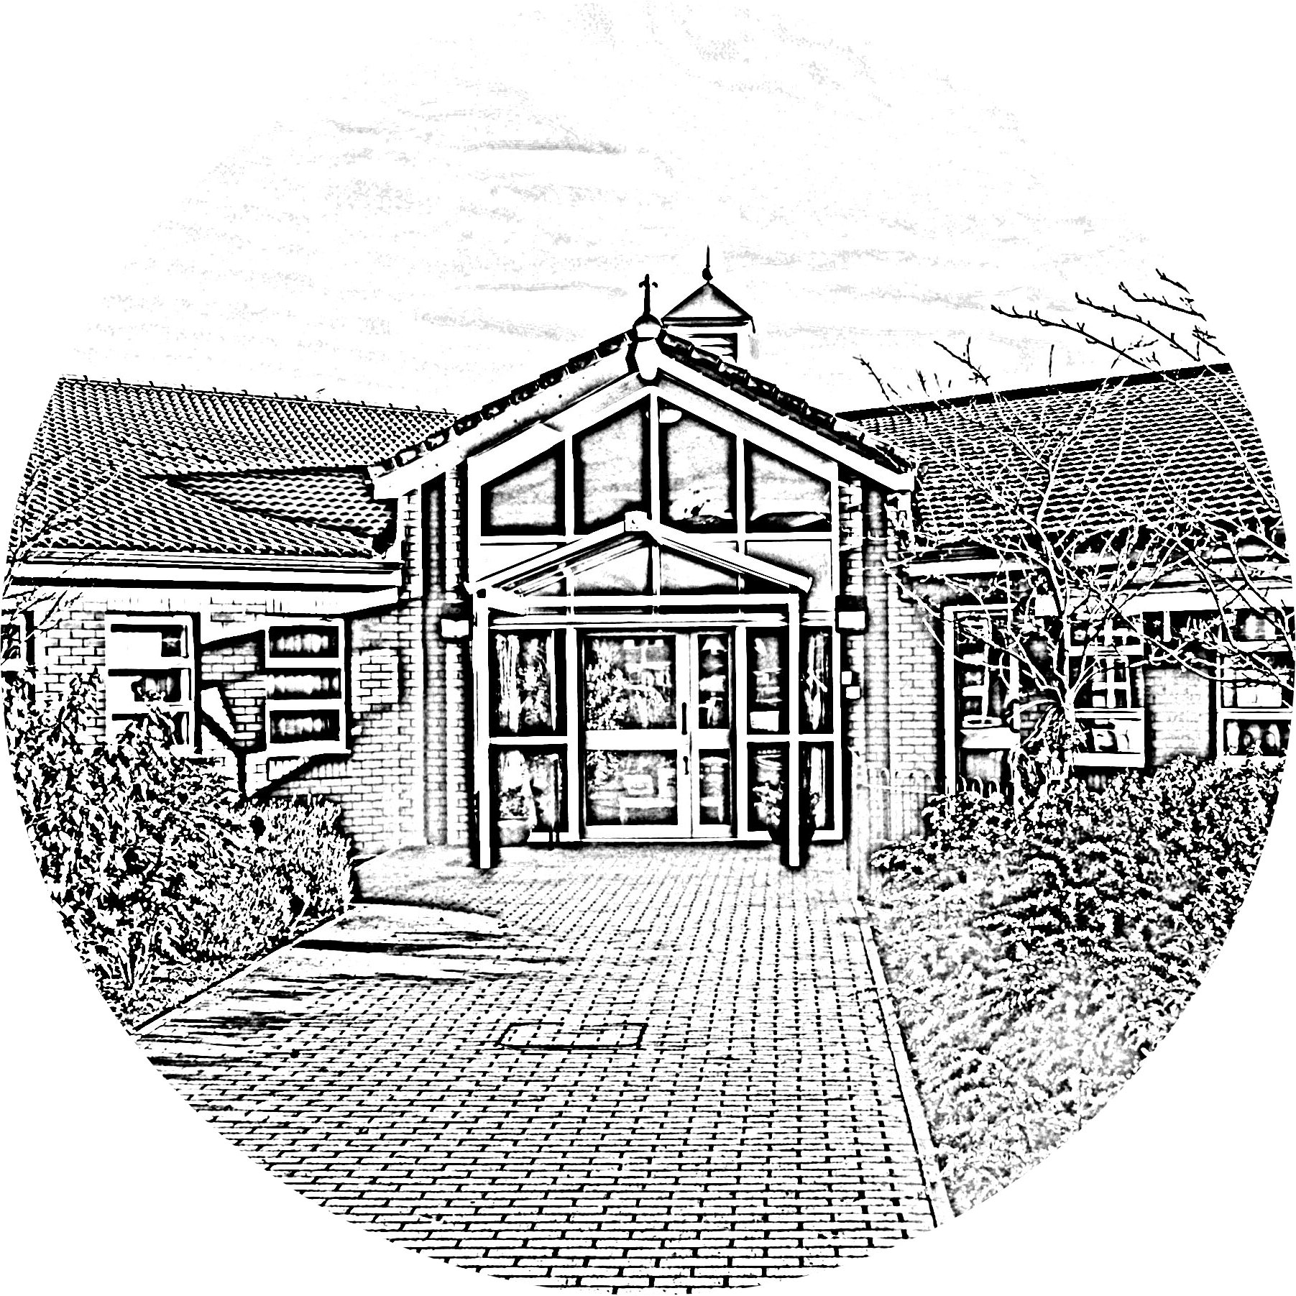

**Brookside Primary School**

Live Online Class Assembly

Dear Parents

From Monday 1 February, we will be starting a **twice-weekly live Zoom Class Assembly** on **Mondays** and **Fridays** (except Nursery which will be Thursday). Daily lessons will continue to go on the school website as usual as this is going very well.

The Class Assembly will give teachers the chance to see and talk with the children and sort any problems with their remote learning tasks etc. In addition, teachers may use the time to read a story or do other useful, appropriate activities and have a good catch-up. The children would have the chance to refocus on school, reconnect with their teachers and peers, and hopefully find motivation, especially those who are struggling in the lockdown, so supporting their mental wellbeing.

**Please read carefully the expected protocols which we have posted on Facebook and put on our school website.**

Some parents have mentioned to teachers that children in their household do not always have access to a device each. We are therefore timetabling the Class Assembly to avoid clashes between children in different classes (see below).

Class Assemblies will be led by the class teacher, with a TA in attendance. As Headteacher, I will join different classes on a regular basis.

Teachers will be putting their class Zoom links up on the school Facebook page on the day of the assembly (and/or before) so that you can automatically join in just by following the link. Please try to join the meeting about 5 minutes before it starts so that the children are present for the beginning, but don’t worry if you’re a bit late. Make sure your child’s name is clear when you accept the invitation.

|  |  |
| --- | --- |
| Class | Assembly Time |
| Nursery | 10am |
| Reception | 10:30am |
| Year 1 | 11am |
| Year 2 | 11:30am |
| Year 3 | 1pm |
| Year 4 | 1:30pm |
| Year 5 | 2pm |
| Year 6 | 2:30pm |

Many thanks,

Mr M Rodgers Headteacher