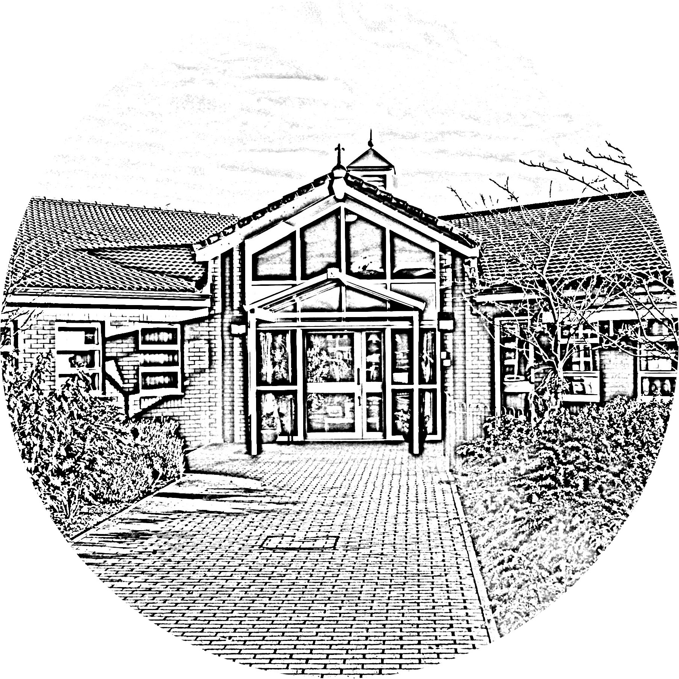

**Brookside Primary School**

**Acceptable Use Protocol for live sessions during the Coronavirus pandemic**

**Teachers**

1. Teachers will host live regular class assemblies using Zoom to enhance the learning experience for the students.

2. Discuss roles, responsibilities and expectations with learners at the outset of all sessions.

3. Another member of staff (ideally a TA) should be present in the live session to monitor any comments.

4. Teachers will use the audio and video function of Zoom.

5. Teachers will be dressed appropriately and remain professional throughout the live session.

6. Teachers will not have direct communication with students through Zoom outside the hours of 9.00am to 3.00pm. Feedback on submitted work can be an exception to this.

7. Teachers must prevent a one-to-one situation between children by ending the meeting for all participants.

8. No live sessions will be conducted on a one-to-one basis without prior arrangement and approval by SLT, e.g. 1:1 sessions between a child and SENCo.

9. Teachers must notify the school’s senior management team, learners and parents/carers of any scheduled lessons/sessions, cancelled lessons/sessions or changes in arrangements.

10. Ensure that they keep themselves up-to-date with all relevant policies and procedures, including online safety, safeguarding and data protection policies.

11. If any safeguarding concerns arise, please inform the safeguarding team immediately.

**Students**

1. Students will not communicate on Zoom with teachers outside the hours of 9am to 3.00pm.

2. Students must be dressed appropriately for the duration of the live session but they do not have to use the video feature.

3. Students must remain on mute until invited to speak.

4. Students are expected to behave in the same manner as they would do in the classroom. Any disruptive/inappropriate behaviour can result in a removal from the live session and accounts may be temporarily suspended.

5. Students should be ready and waiting at the starting time of the lesson to receive the call via Zoom.

6. Students are prohibited from recording or capturing / screen grabbing content from the video call.

7. Students must remain in a public part of their house and parents should be made aware that the children are commencing an online session.

8. Students should be respectful of others: as in the class, we expect our students to be courteous, polite and respectful to the teacher and to their other students.

**Parents/Carers**

1. Parents/carers should ensure children are fully prepared for their live session by: plugging in the device, assembling necessary equipment (this may include headphones, the home learning workbook and a pencil) and logging in for the children.

2. Students should work in a peaceful / quiet space but must remain in a public part of the house -broadcasting from the bedroom is a little intimate for a class setting. Devices must not be taken into the bathroom: just as with regular school, students should go to the bathroom before the session.

3. Parents/carers should ensure their child is appropriately dressed for sessions.

4. Expectations for how your child should conduct themselves during a live class assembly should be set: face the screen; mute yourself when you're not speaking; raise a hand to contribute; unmute yourself when ready to talk.

5. Parents/carers should ensure that their child behaves appropriately in the same way as if they were in school. Any student behaving inappropriately, may have their school account temporarily suspended.

6. Parents/carers must ensure other family members are out of camera shot.

7. Sessions will be pitched appropriately for children to access independently. Therefore, no live sessions will require any contributions / support from parents/carers.

8. If a parent needs to speak to a teacher, they should do so through the ordinary channels, by calling the school office and arranging an appointment or by emailing the teacher direct.