BROOKSIDE PRIMARY SCHOOL
Rostherne Avenue, Great Sutton, Cheshire, CH66 2EE
0151 558 1123 www.brookside.cheshire.sch.uk Headteacher – Mr D Orme BA (Hons) NPQH Deputy Head – Ms J Smith B Ed (Hons) NPQSL
“Happy and Successful in Everything we Do!”

Monday 8 January 2024
Ms Kendal
Dear Y4 Parents

I just wanted to update you on the current situation. As you know, Ms Kendal has been unwell and not in school for some time having been signed off sick from work. I am sorry for the disruption this may have caused to you or the children and my priority has been to minimize this as much as possible for our pupils and to try to provide consistency.

I am very grateful to Mr Lowry who stood in before Christmas and did an excellent job. My thanks too to our fantastic teaching assistants, Mrs Parkinson and Miss Russell for their ongoing commitment to the children and their education. Mr Lowry was booked elsewhere for the start of this term so we acquired the services of another brilliant teacher, Mr Hale. He will now be covering until Ms Kendal returns, hopefully within the next few weeks.

Mr Hale is being supported by myself and subject leaders to ensure that our planned curriculum (a copy of which you received last week) is delivered to a high standard. Homework will continue to be provided.

I am delighted with how well our Y4 children have behaved in class and carried on learning with the interest and hard work which I have become accustomed to seeing from them.

Ms Kendal will organise a Parents’ Evening in due course on her return to school to update you on your child’s progress in Y4.

Yours sincerely,

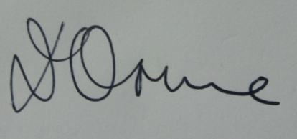
Mr D Orme
Headteacher

