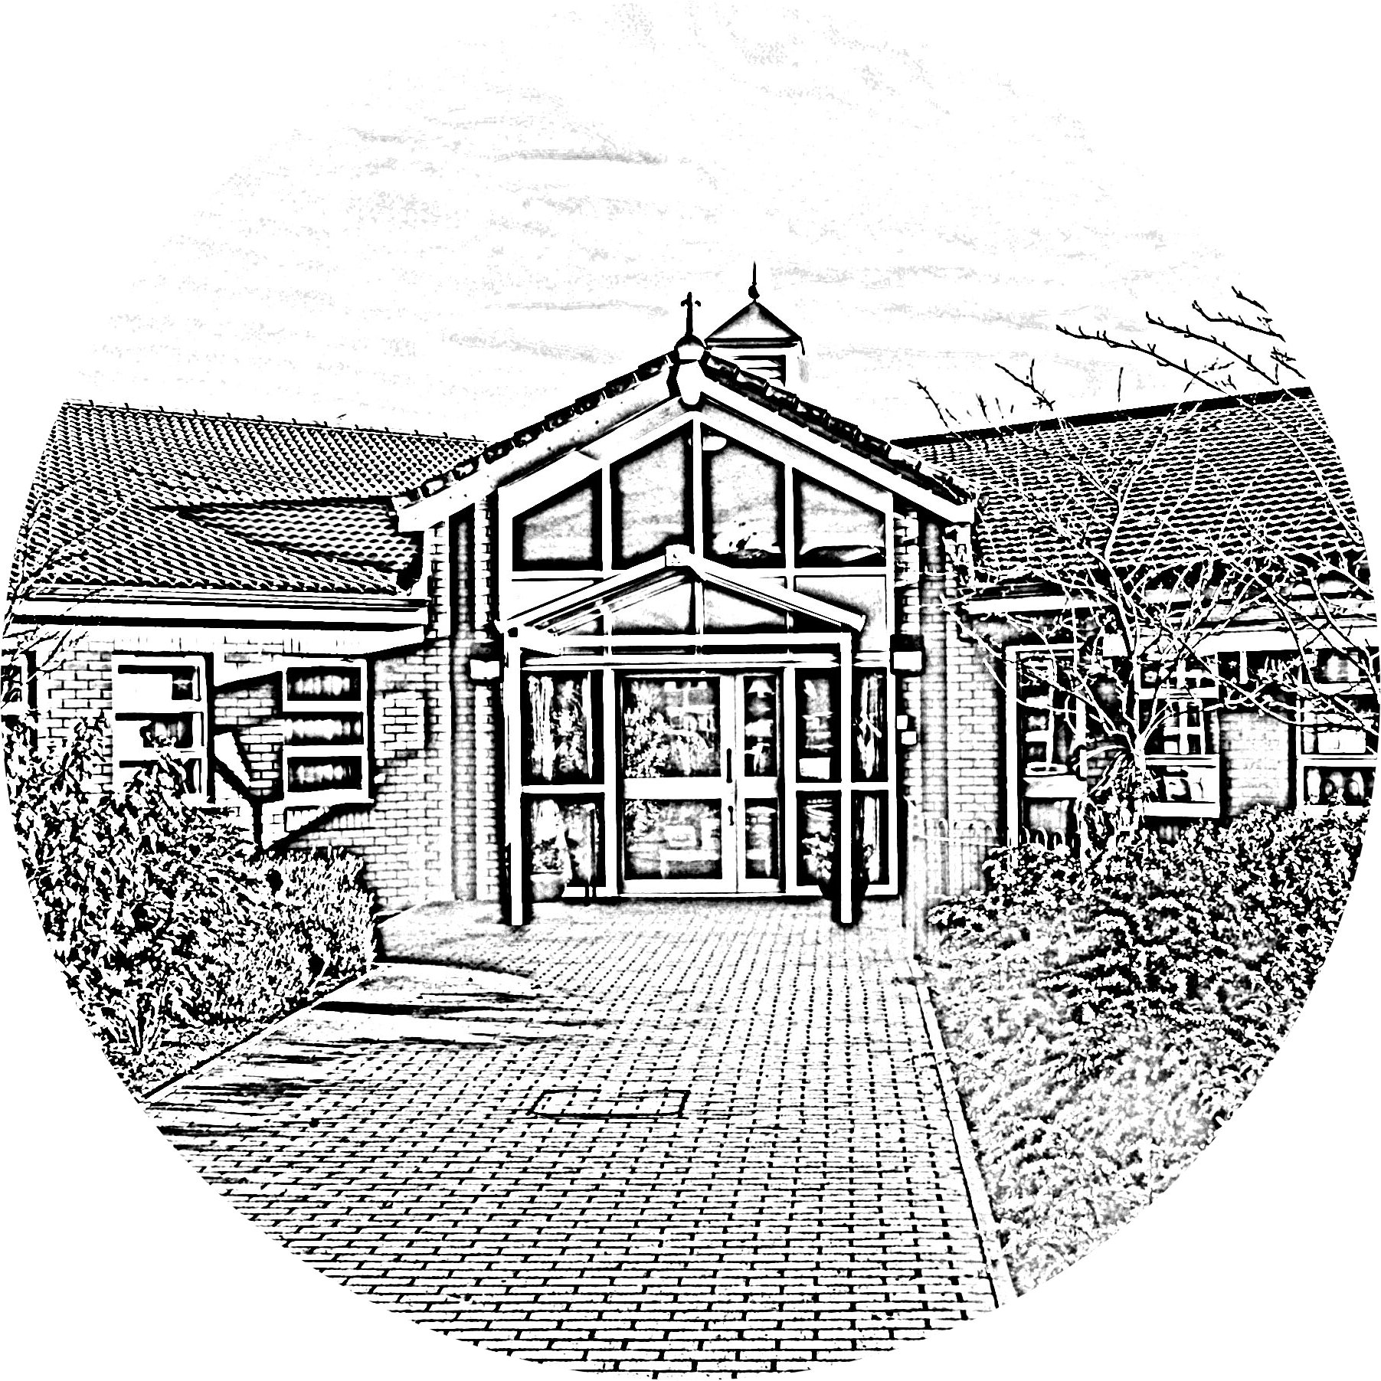

**BROOKSIDE PRIMARY SCHOOL**

Rostherne Avenue, Great Sutton, Cheshire, CH66 2EE

0151 558 1123 www.brookside.cheshire.sch.uk

Headteacher – Mr D Orme BA (Hons) NPQH Deputy Head – Ms J Smith B Ed (Hons) NPQSL

*“Happy and Successful in Everything we Do!”*

Dear Parent/Carer

Your child has expressed an interest in **Multi Skills Club**. This club will run for 6 weeks and is due to commence Tuesday 17th September. It will cost £1 per session - **£6 in total**. Once you return your child’s slip to the school office our Admin team will add this club to your ‘Parent Pay’ so you can complete your payment online and secure your child’s place. Places will be offered on a first come first served basis.

Your child will need to bring their sports kit (PE trousers or shorts, t-shirt, trainers) and a drink.

*The club will take place outside on the school field so your child may need to bring warmer clothes each week depending on the weather.

Miss Loney

………………………………………………………………………………………………………………..

**Mutli-Skills club**

This club will run for 6 weeks.

YEAR 1, 2 AND 3 Tuesday (3:15pm-4pm) School Field

I give permission for my child …………………………………………….. class ............ to take part in Multi skills Club

Signed.................................................................

**Emergency contact detail:**

Name ______________________

Mobile _____________________

(Year 6 only) - My child may walk home by themselves: yes no

Year 6 only) - My child may walk home by themselves: yes no