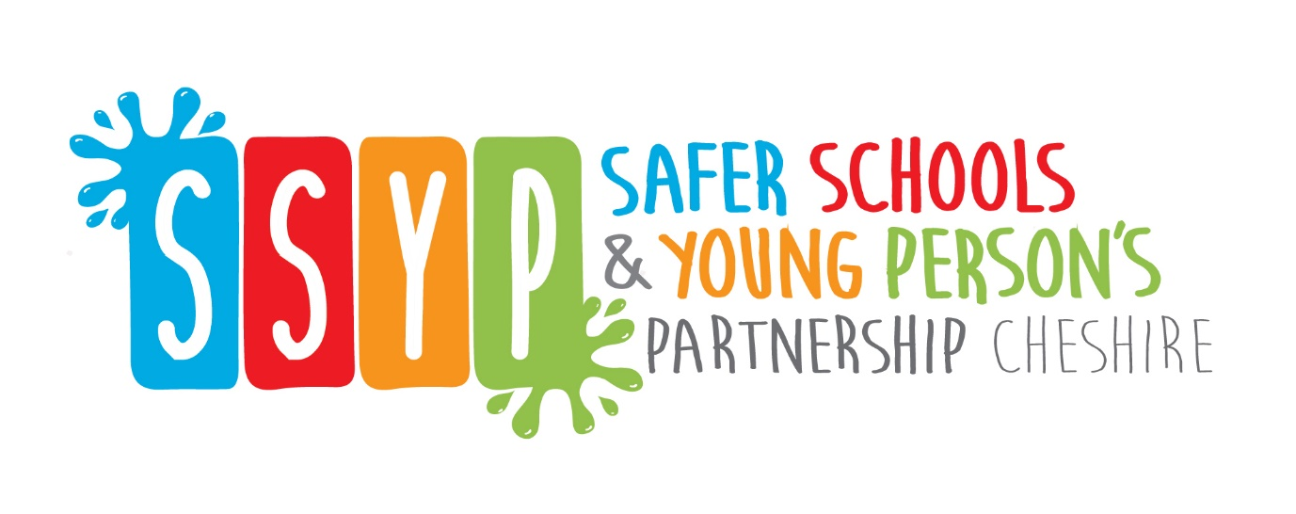
SSYP Newsletter – Edition 1
Welcome All,
I hope you are all keeping well. Due to recent events, the Safer Schools and Young People Partnership have put together a newsletter containing some information about online safety for you to send out to parents/carers. This is the first of many which we will send during lockdown to help support the local community during this stressful time, we will look to send one every week covering different helpful topics.
We will be covering internet safety in this first newsletter. Whilst our young people are at home during lockdown, while the schools are closed, it is very important that we, as adults know how to safeguard them while they are using any online platform. Below we have some links to some informative websites so that you feel confident safeguarding them whilst they are home in your care and online.
Some of this information is already available on social media but we hope that you find it helpful, we have included information from our own sources here at Cheshire Police as well as Parent Info, CEOP, Think You Know. Please feel free to signpost this to your community/families/partners.
Think you know is the education programme from NCA-CEOP, a UK organisation that protects children both online and offline. On their website you can explore one of the six “Thinkuknow” websites for advice about staying safe when you are on a phone, tablet or computer, use this link to access the site.
https://www.thinkuknow.co.uk/
Use this link to go direct to the parents/carers part of the website
https://www.thinkuknow.co.uk/parents/

Another useful site is the NSPCC – The NSPCC have launched a new campaign, Listen To Your Selfie, which aims to teach young people about online sexual abuse and what constitutes a healthy relationship. The campaign, which has been funded by BBC Children in Need, features two films where selfies come to life and question a situation – The Game focuses on a same-sex online grooming scenario, and The Party highlights peer-to-peer sexual pressure and grooming. ‘Listen To Your Selfie’ is aimed at helping young people recognise signs they are being manipulated, controlled or exploited so they feel empowered to make their own decisions or choices. We hope that by putting this in the spotlight we can help young people to feel able to speak up if they feel worried or scared about a situation or relationship.

NSPCC

Whilst children are at home, they are still communicating with their friends they may still be communicating on social media and gaming sites. You can find tools about online bullying here. www.anti-bullyingalliance.org.uk/tools-information/all-about-bullying/online-bullying

And finally if your young person or you want any advice about anything, or just to talk, Childline online platform has a variety of help and guidance. Access the site below.
https://www.childline.org.uk/info-advice/
For hints and tips please follow our social media accounts below. You can contact us online or via our website
https://www.cheshire.police.uk/

***Want to stay in touch please follow our Safe Schools and Young person FaceBook and Twitter account ***

Follow @cheshirepolice on Twitter | Like Cheshire Police on Facebook Follow @CheshireSSYP on Twitter

Kind Regards PC Sarah Bailiff
Youth Engagement Officers, Safer Schools Partnership,

