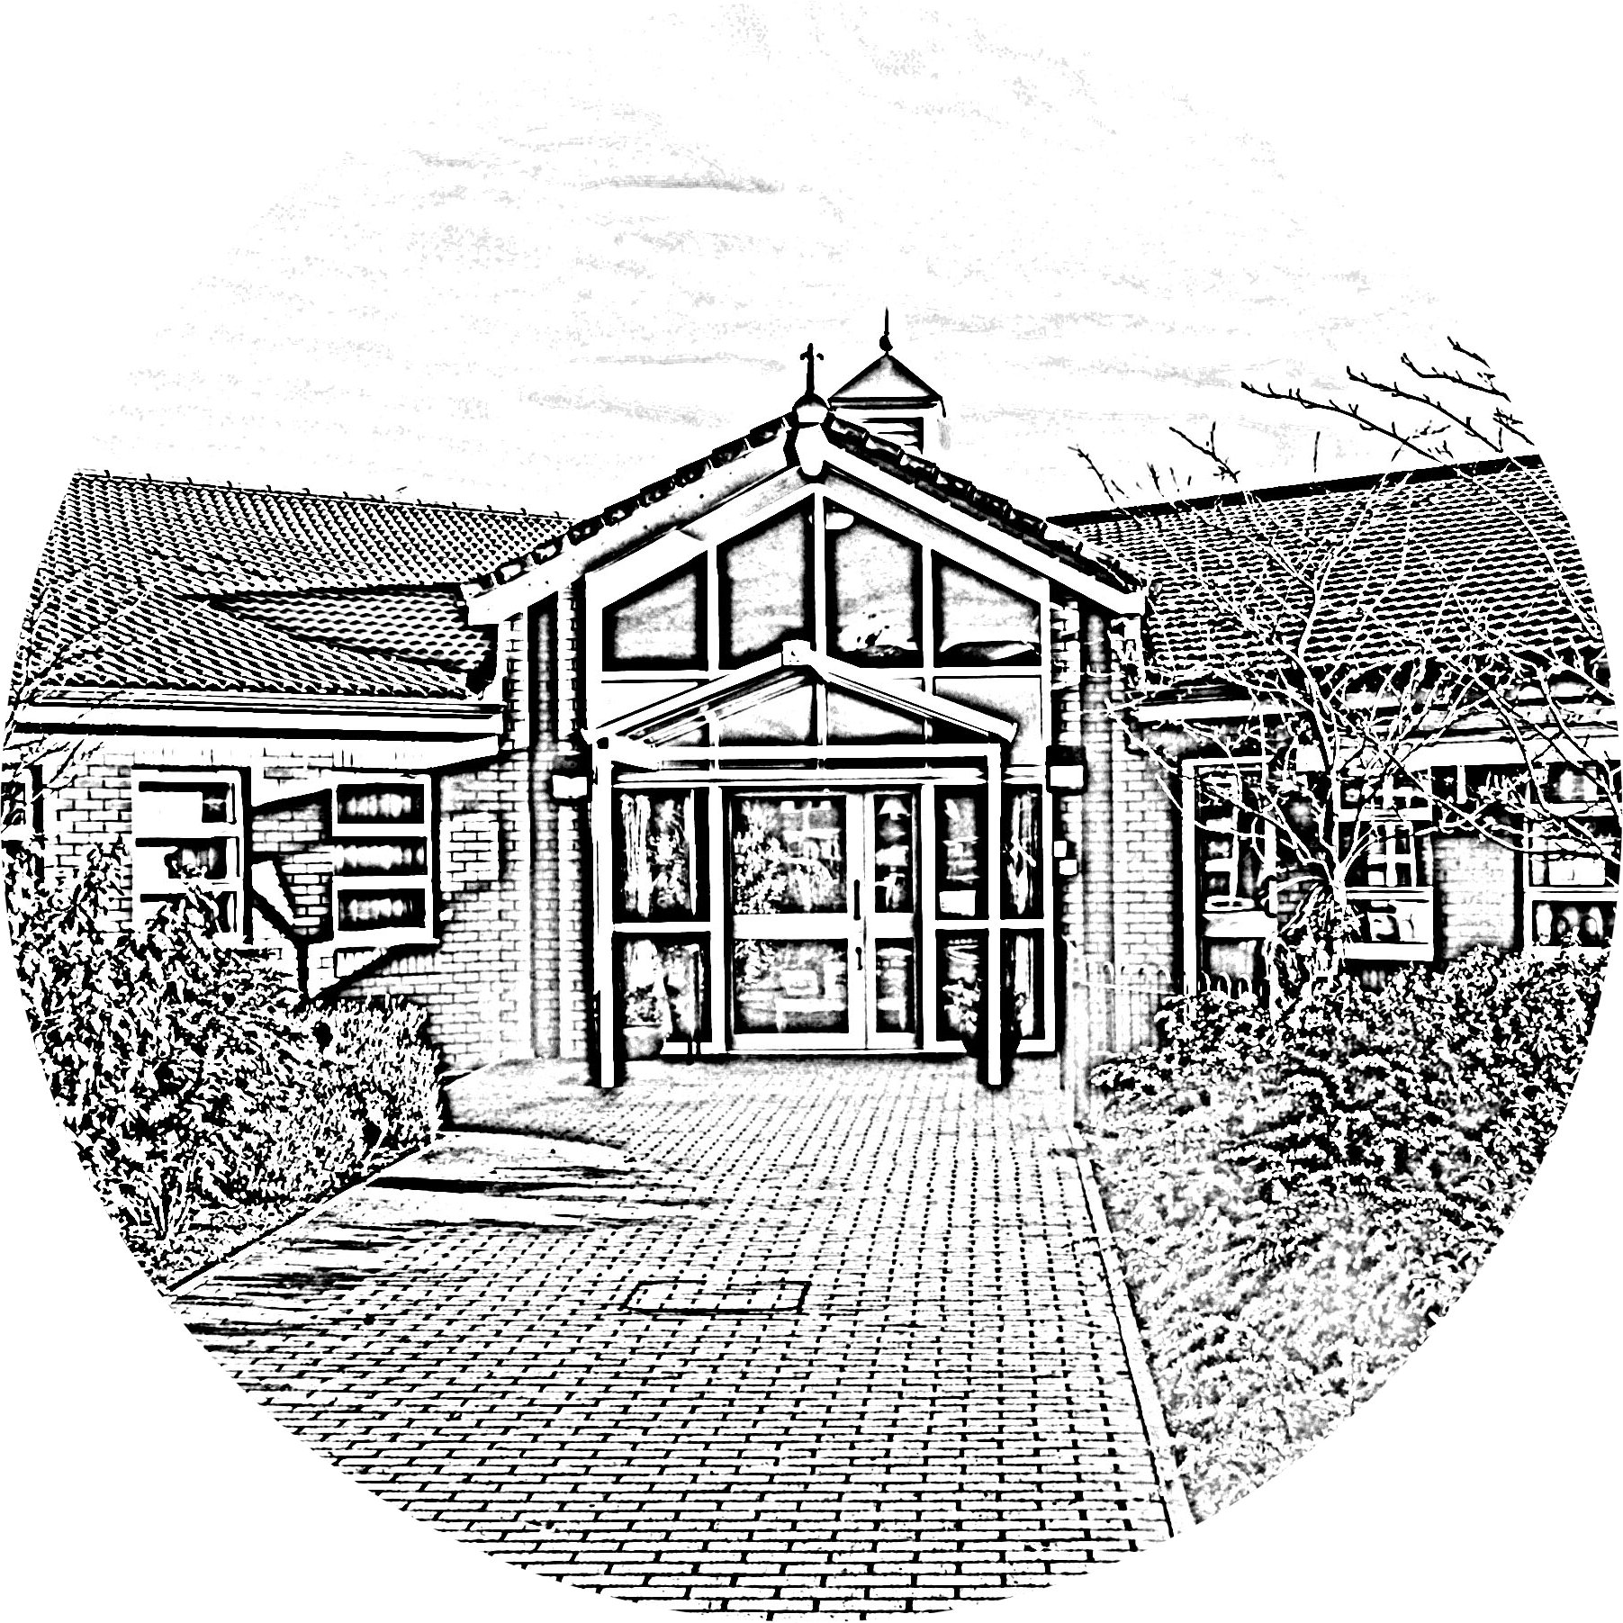
Brookside Primary School
School Subject Access Request Form

Please complete this form if you want us to supply you with a copy of any personal data we hold about you or your child. You are currently entitled to receive this information under the General Data Protection Regulation (GDPR).
We will endeavour to respond promptly and in within one month of the latest of the following:
- our receipt of your request; or
- our receipt of any further information we may ask you to provide to enable us to comply with your request.

Please Note: The information you supply in this form will only be used for the purposes of identifying the personal data you are requesting and responding to your request. You are not obliged to complete this form to make a request, but doing so will make it easier for us to process your request quickly.
- Details of the person requesting the information:
Full Name:
Address:
Telephone:
Email Address:

2. Are you the subject of the information you are requesting?
Please tick the appropriate box and read the instructions which follow it.
 | YES | I am the data subject
 | NO | I am acting on behalf of the data subject in a parental capacity
 | NO | I am acting on behalf of the data subject and have enclosed written authority and proof of the data subject’s identity and my own identity (see below).

3. Proof of Identity
To ensure we are releasing data to the right person we require you to provide us with proof of your identity and of your address. Please supply us with a photocopy or scanned image (do not send the originals) of one of each of the following:
1. Proof of Identity Passport, photo driving licence, national identity card, birth certificate.
2. Proof of Address Utility bill, bank statement, credit card statement (no more than 3 months old); current driving licence; current TV licence; local authority tax bill, HMRC tax document (no more than 1 year old).
Where requesting details of information held about a pupil, we need to confirm your right to this information. In order to do this we need a copy of the child’s birth certificate or other official documentation confirming your parental/guardianship rights.
Where requesting information on behalf of another individual, we need a copy of the written authority of the individual involved confirming both their and your identity and clearly stating you are acting on their behalf and with their full knowledge.
If we are not satisfied you are who you claim to be, we reserve the right to refuse to grant your request.
Note: Where requests are made in person and we can identify an individual due to a current or prior relationship with the school, for example if you are a parent known to us, we may wave the right of identification at our discretion.

4. Details of the Data Subject (if different to 1. above)
Full Name:
Address:

5. What information are you seeking?
Please describe the information you are seeking. Please provide any relevant details you think will help us to identify the information you require.
5. Information about the collection and processing of data
If you want information about any of the following, please tick the boxes:
Why we are processing your personal data
To whom your personal data are disclosed
The source of your personal data

6: Disclosure of CCTV images
If the information you seek is in the form of video images captured by our CCTV security cameras, would you be satisfied with viewing these images at our premises?

[ ] YES [ ] NO

7. Declaration
Please note that any attempt to mislead may result in prosecution.

I confirm that I have read and understood the terms of this subject access form and certify that the information given in this application to Brookside Primary School is true. I understand that it is necessary for Brookside Primary School to confirm my/the data subject’s identity and it may be necessary to obtain more detailed information in order to locate the correct personal data.

I further understand that, in line with the School’s Subject Access Request Policy, if I am requesting information in relation to my child the school reserves the right to request the consent of my child in relation to the releasing of information. If consent is not forthcoming, the school are unable to comply with my request.

Signed: ............................................................................................................................ Date: ..............................

Documents which must accompany this application:
- Evidence of your identity (see section 2)
- Evidence of the data subject’s identity (if different from above)
- Authorisation from the data subject to act on their behalf (if applicable)

Please return the completed form to: Ms Caroline Kendal – School Data Protection Guardian
Brookside Primary School, Rostherne Avenue, Great Sutton, Cheshire. CH66 2EE
Email: c.kendal@brookside.cheshire.sch.uk 0151 338 2052

Additional Rights: If after you have received the information you have requested you believe that:
- the information is inaccurate or out of date; or
- we should no longer be holding that information; or
- we are using your information for a purpose of which you were unaware;
- we may have passed inaccurate information about you to someone else;

then you should notify our Data Protection Officer at once.

