BROOKSIDE PRIMARY SCHOOL
Rostherne Avenue, Great Sutton, Cheshire, CH66 2EE
0151 558 1123 www.brookside.cheshire.sch.uk Headteacher – Mr D Orme BA (Hons) NPQH Deputy Head – Ms J Smith B Ed (Hons) NPQSL
“Happy and Successful in Everything we Do!”
3 March 2023
Dear Parents

Parents’ Evening

Communication and feedback – both ways – is absolutely fundamental to providing and sustaining a high quality education. At Brookside, we hold two parents’ evenings each year: one in the Autumn Term and one in the Spring Term. During the Summer Term, class teachers write detailed end-of-year school reports. Of course, you are always very welcome to come and chat with our teachers or myself at any time about your child’s progress and wellbeing.

We will be holding Parents’ Evening in a couple of weeks (w/c 20th March). You will have the option of coming in personally, meeting your child’s class teacher and looking at their school work, or having a phone call conversation instead with the teacher. Whichever way, please engage with us in the interests of the children.

Please complete, sign and return the slip below.

Yours sincerely,

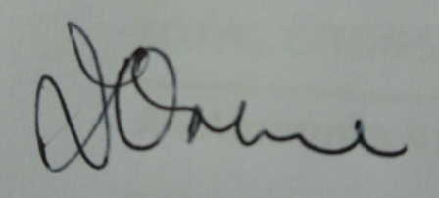

Mr D Orme
Headteacher

Parents’ Evening – Child’s name:_________________________________ Class: __________

Depending on class: Tick one: Tues 21st Mar ____ Wed 22nd Mar ____ Thurs 23rd Mar ____

Tick one: 3 – 3:30 ___ 3:30 – 4 ___ 4 – 4:30 ___ 4:30 – 5 ___ 5 – 5:30 ___

Tick one: visit in person ____ phone call & number _________________________

Signed (parent/guardian): ____________________________________________

