BROOKSIDE PRIMARY SCHOOL
Rostherne Avenue, Great Sutton, Cheshire, CH66 2EE
0151 558 1123 www.brookside.cheshire.sch.uk Headteacher – Mr D Orme BA (Hons) NPQH Deputy Head – Ms J Smith B Ed (Hons) NPQSL
“Happy and Successful in Everything we Do!”

20 January 2023
Dear Parents

STRIKE ACTION
You may be aware from media coverage that the teaching union, the NEU, have declared strike action, which will take place on 1 & 28 February and 15 & 16 March in our area.
The strike is happening because of a national dispute between the unions and the government, principally over teachers’ pay, and not because of any issues at our school.
I’m getting in touch to give you as much notice as possible that learning may be disrupted on these dates. We’re considering several options, including partial opening, moving some lessons online and closing the school.
We recommend that you start to make alternative childcare arrangements for these dates.
I’m sorry about the potential disruption to you and to your child’s education. I understand that this situation may be frustrating, and ask that all members of our school community continue to treat each other with respect. Brookside Primary School remains committed to providing a safe and secure environment for our pupils and delivering high-quality teaching.
We are working closely with our staff who are members of the NEU union to keep up to date with the situation, and I will inform you of the final arrangements as soon as possible.
Yours sincerely,

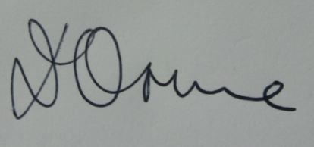
Mr D Orme
Headteacher

