BROOKSIDE PRIMARY SCHOOL
Rostherne Avenue, Great Sutton, Cheshire, CH66 2EE
0151 558 1123 www.brookside.cheshire.sch.uk Headteacher – Mr D Orme BA (Hons) NPQH Deputy Head – Ms J Smith B Ed (Hons) NPQSL
“Happy and Successful in Everything we Do!”

27 January 2023
Dear Parents

STRIKE ACTION
A week ago, I wrote to you about the strike action planned by members of the teaching union, the NEU, which has declared strike action on 1 & 28 February and 15 & 16 March in our area. The strike is happening because of a national dispute between the unions and the government, principally over teachers’ pay, and not because of any issues at our school.
I wanted to give you as much notice as possible that schooling may be disrupted on these dates and I recommended that you start to make alternative childcare arrangements for those dates.
I can now inform you of a partial closure at Brookside. We will be closing two classes on Wednesday 1 February: Reception Class and Year 3. We are asking you not to send your child into school on those dates if they are in either of those two classes.
Any free school meal children from Y3 and any children from Reception whose parent/s are in receipt of benefits and have registered for free school meals will still be entitled to a lunch on this date. You can order this by calling the school office no later than 4pm on Monday 30th January. You will be able to collect your packed lunch from the school office on the morning of Wednesday 1 February.
Other teachers who are members of the NEU are entitled to strike and may choose to strike on subsequent strike days and I will inform you of any future strike action nearer the time.
Please see our school website class pages for online learning opportunities to make use of if you choose to.
I’m sorry about the disruption to you and to your child’s education. I understand that this situation may be frustrating, and ask again that all members of our school community continue to treat each other with respect.
Yours sincerely,

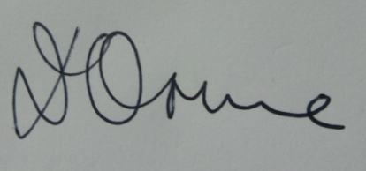
Mr D Orme
Headteacher

