BROOKSIDE PRIMARY SCHOOL
Rostherne Avenue, Great Sutton, Cheshire, CH66 2EE
0151 558 1123 www.brookside.cheshire.sch.uk Headteacher – Mr D Orme BA (Hons) NPQH Deputy Head – Ms J Smith B Ed (Hons) NPQSL
“Happy and Successful in Everything we Do!”

26 April 2023
Dear Parents

STRIKE ACTION
As you will be aware from the news, members of the teaching union, the NEU, have declared strike action on 27 April and 2 May. The strike is happening because of a continuing national dispute between the unions and the government, principally over teachers’ pay, and not because of any issues at our school.
I can now inform you of a partial closure at Brookside.
ALL classes will be open as normal tomorrow (Thursday 27 April).
THREE classes will be closed on Tuesday 2 May:
- Nursery
- Reception
- Year 2
We are therefore asking you not to send your child into school on 2 May if they are in those classes and for you to make alternative childcare arrangements for that date.
Any free school meal children from Nursery, Reception and Y2 whose parent/s are in receipt of benefits and have registered for free school meals will still be entitled to a lunch on 2 May. You can order this by calling the school office no later than 12pm this Friday - 28 April. You will be able to collect your packed lunch from the school office on the morning of Tuesday 2 May.
Please see our school website class pages for a selection of possible online learning opportunities.
I’m very sorry about the disruption to you and to your child’s education. I understand that this situation may be frustrating, and as last time I ask again that all members of our school community continue to treat each other with respect.
Yours sincerely,

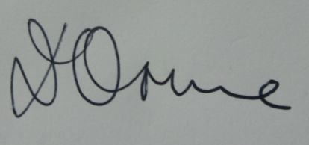
Mr D Orme
Headteacher

