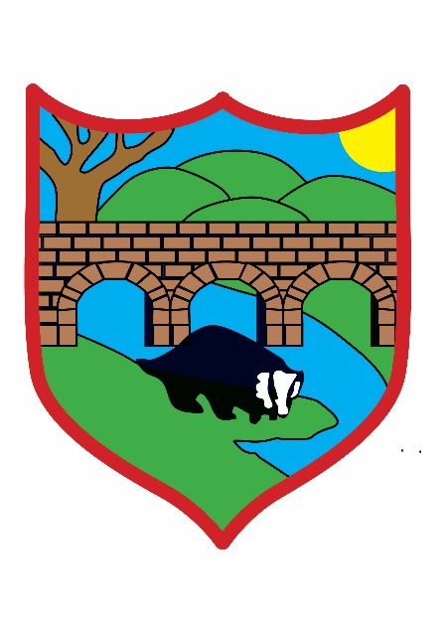
Broughton Primary School
Class Dojo Policy use in school and for Remote Learning
2026-2027

Headteacher: Mrs Anna Bewsher
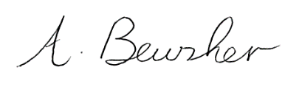
Chair of Governors: Gilda Wells
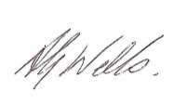
Date of next review: September 2027
It is the responsibility of all members of staff who use Class Dojo to ensure it is used according to this policy. Monitoring of the policy will be conducted by Senior Leaders who may ask to view the Class Dojo page to ensure the policy is being adhered to.
The information and protocols in this policy are designed to assist pupils, parents and teachers in the use of Class Dojo as a communication tool at Broughton Primary School. This policy states appropriate and acceptable use.
What is Class Dojo?
Class Dojo is an online platform that is designed to communicate securely between school and home. It is used widely across both primary and secondary schools in the UK successfully.
Class Dojo has four main elements:
 | Use when school is open: | Use during any form of home learning/out of term time:
Dojo points | Staff will be using this to record team points earned by each child. This is shared with pupils and parents continuously. | Staff will be using this to record team points earned by each child (team points can be earned through home learning tasks). This is shared with pupils and parents continuously.
Class Story | Teachers will use this element to share relevant whole class messages each week including class news, celebrations, updates and reminders. | Teachers will use this element to share general class news, celebrations, updates and reminders relating to the class. It may include information about home learning tasks being set but Tapestry/SEESAW will be used to upload the actual tasks.
Student Story | This is an optional element which children can choose to access to share their work with their class peers. | This is an optional element which children can choose to access to share their work with their class peers.
Messaging | This element will be used to communicate privately between teachers and pupils. | This element will be used to communicate between teachers and pupils. Silent hours will be set by class teachers during school holidays and outside of usual working hours.

The Class Dojo app or website offers a social media-style interface which manages the flow of frequent information from school to home. It can be accessed through a smartphone or tablet app or through a desktop browser. Teachers at Broughton Primary School will be accessing Class Dojo through school iPad or laptops. It is secure and personal to our school and provides information in an easy to use format similar to Facebook.

Class Dojo is compliant with the GDPR. Parents give permission for the school to process their child's data on the system when they complete the data processing consent form.

Our Class Dojo account is only available to parents and pupils registered at Broughton Primary School. Parents are reminded that they should not take images from Class Dojo and post them elsewhere online. Breaching this requirement will lead to account suspension.

At the start of the academic year, parents of children in Nursery - Year 6 will be sent a passcode which connects them to their child's account.

Why we are using Class Dojo at Broughton Primary School:
- It is easy to use with a child-friendly interface
- It can be used to track and share team points with parents and carers
- Teachers can share work with pupils
- Pupils can share their learning with their teacher
- It can be used to upload photos and write comments
- It celebrates the children’s learning individually and this can be extended to sharing learning with the whole class
- It is an effective home school communication tool which can be used to support home learning
- Posts can be translated into 35 languages

How Class Dojo will be used at Broughton Primary School:
Teachers in Year 1 to Year 6 will use Class Dojo to communicate the following with parents and carers:
- Team points earned by their child in school
- Wow moments / information about work their child is proud of
- Relevant whole-class/individual reminders and updates about the week(s) ahead in school
- Information about home learning

Use of Class Dojo during when the school is closed linked to home learning:
Information about any learning expected to be completed at home may be shared via Class Dojo.
- Teachers may share resources and links for home learning on the Class Story
- Pupils will be able to share their completed work with their teacher, if they wish to, on the Student Story

Roles and responsibilities
Teacher’s Roles
- To follow all safeguarding polices and staff code of conduct
- To award team points to children in their class as per guidance
- To share relevant updates and reminders with children and parents
- To share information about home learning tasks during periods of lockdown
- Display images in line with parental consent
- To use Class Dojo in a positive manner to celebrate learning
- Post images of learning in the classroom, school trips, residential visits, to share with parents
- Be aware of online safety in regard to images of pupils
Parent’s Roles
- To follow all safeguarding polices and parent code of conduct
- To use images and team points to discuss with pupils about their learning
- Provide positive feedback for their child by commenting on, or liking, their work
- Parents and carers are not permitted to share images shared on Class Dojo via any form of social media
- To use the whole school communication system; telephone, email to inform the school of important information about pupils
- Children and families must not make negative or derogatory comments about other children or families
- No inappropriate language must be used by any member of the community

What Class Dojo must not be used for:
- Replacement of absence messages: an email or telephone call to the main school office is required prior to the school day starting.
- A replacement for parent-teacher meeting
- Complaints; these must be communicated with school in the usual way
- Private messages will usually only be replied to during the hours of 8-5.30pm and during term-time, unless it is an emergency.

Residential Trips:
Teachers may use the Class Story feature whilst children are on residential trips to share information with all parents.
Teachers will not usually respond to individual parent messages or send individual parent messages whilst on residential trips. If parents have any questions whilst children are on residential trips these should be directed via the school office via a phone call.

Parents and Carers are expected to follow the usual Code for Conduct when communicating with school. Pupils will be expected to use appropriate language and behaviours when using Class Dojo. If there is inappropriate or misuse of the Class Dojo, the headteacher will be informed and the school has the right to terminate use of Class Dojo with individuals or the whole school community.

Class Dojo points are used in the same way as Team Points and teachers will award team points for the following areas:
- Showing Values
- Behaviour for Learning
- Keeping Ourselves Safe
- Teamwork
- Completing reading/homework at home
- Teachers are only expected to look at Class Dojo during the school hours between 8am and 5.30pm. Quiet hours will be set for the rest of the day.
- Please note that some staff members work part-time hours and so may not reply to private messages until they return to work.
- Class Dojo should not be used to send urgent/emergency messages to and from school. These must be sent via the school office email in the usual way.
- Teachers will not engage in any conversations about personal matters via the class/student pages. If parents or carers wish to speak to their child’s class teacher about personal matters, this must be done via the private messaging service.
- School will require consent to share photos on the Class Story page. If parents or carers do not give permission, teachers will not share child’s images on the class page. Teachers may still upload photos to a child’s individual story/private messages which their parents will be able to see and comment on.
- During term-time, we will operate on a 48-hour response turn around as we do per emails. Teachers may not be able to check Class Dojo whilst they are teaching in school. Please be patient and understand that teachers are working hard with your children in school, as well as monitoring Class Dojo.
- Any abusive, inappropriate or intolerant behaviour on Class Dojo will be reported and the login will be terminated.
Acceptable use specifically relating to periods of school closure:
- Class Dojo will be used as the tool for sharing information about home learning during periods of school closure.
- Tasks may be set via uploaded documents, and may be accompanied by a short teacher video if necessary
- Children may take a photo of their work and upload it to their portfolio for their teacher to view should they wish to.
- The teacher will acknowledge it by ‘liking’ it and may add an additional comment on some pieces of work.
- Parents and carers may use the messaging tool on Class Dojo to ask questions about the home learning set or seek clarification. Parents and carers must remember that teachers will be responsible for the needs of all pupils in their class and must not mis/overuse this tool.

Please read in conjunction with the following polices:
• Behaviour Policy
• E Safety Policy
• Safeguarding Policy

