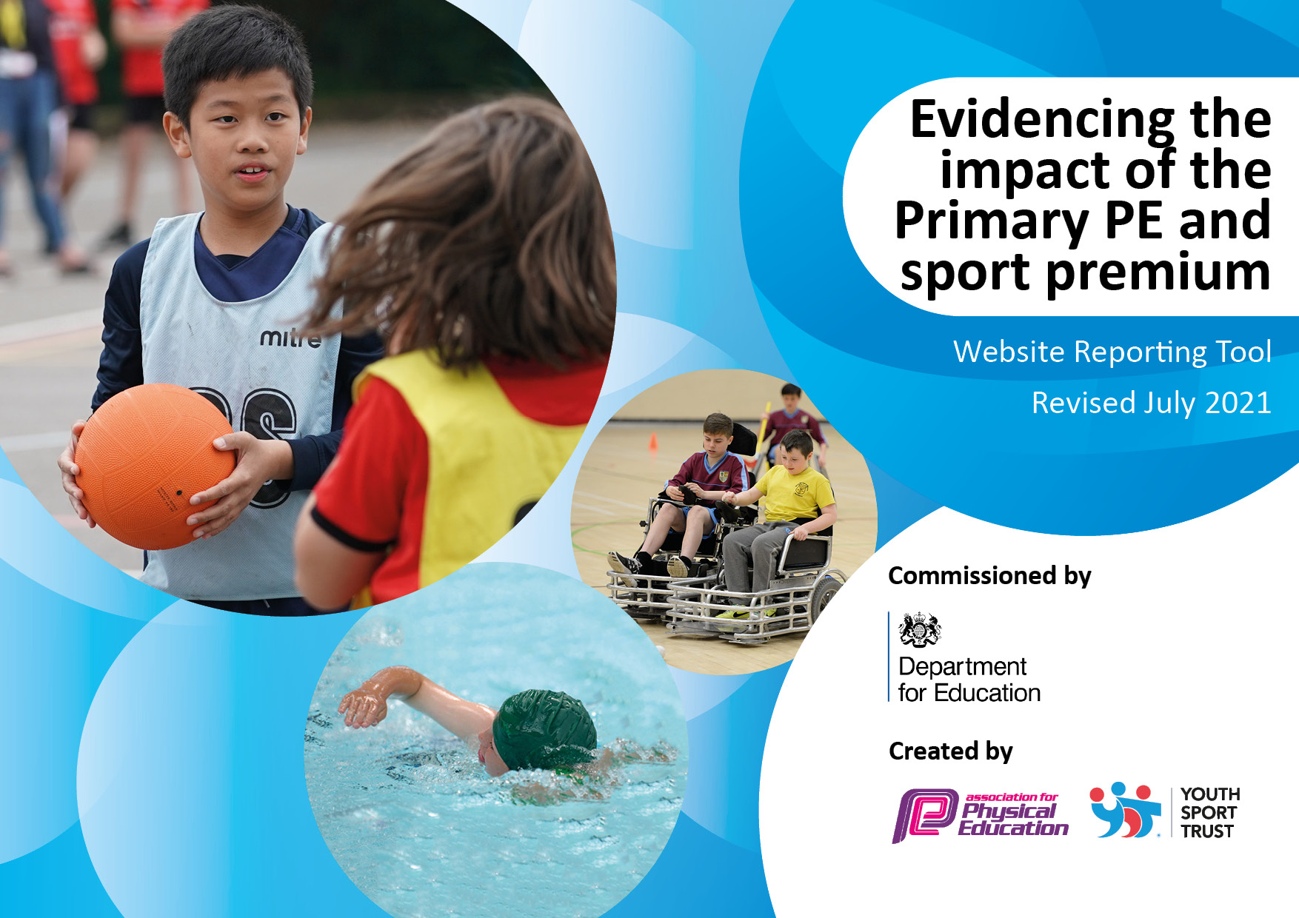
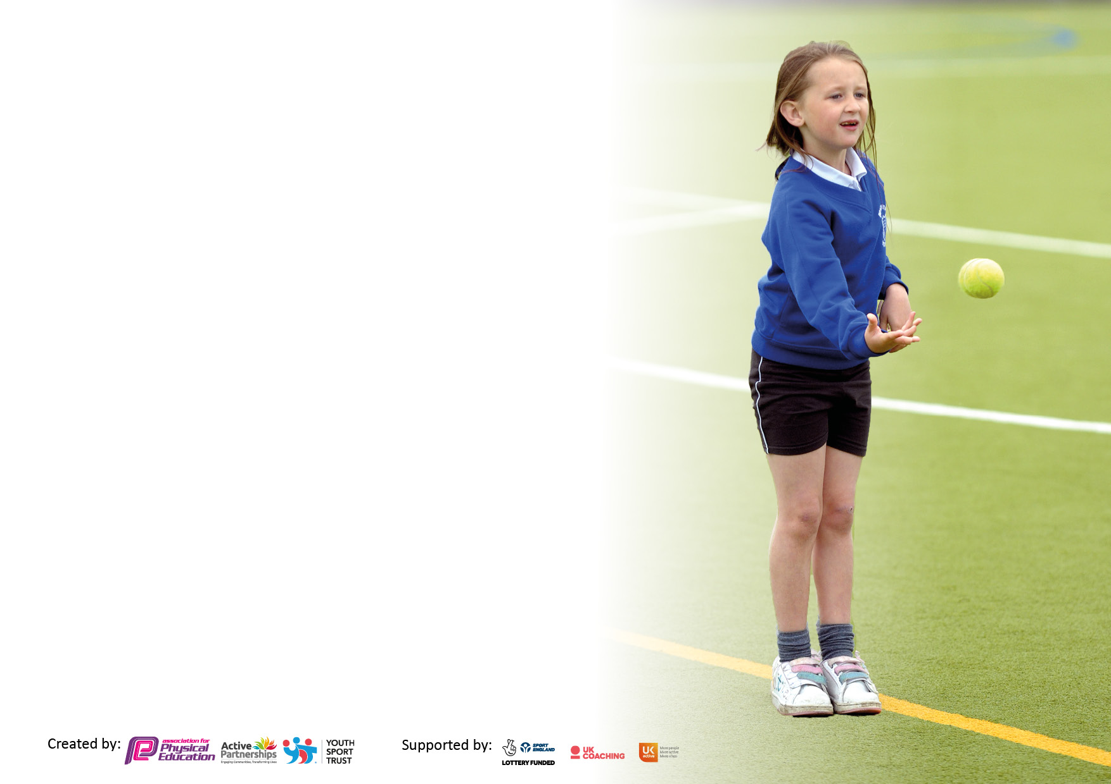

It is important that your grant is used effectively and based on school need. The Education Inspection Framework makes clear there will be a focus on ‘whether leaders and those responsible for governors all understand their respective roles and perform these in a way that enhances the effectiveness of the school’.

Under the Quality of Education Ofsted inspectors consider:
Intent - Curriculum design, coverage and appropriateness
Implementation - Curriculum delivery, Teaching (pedagogy) and Assessment
Impact - Attainment and progress

To assist schools with common transferable language this template has been developed to utilise the same three headings which should make your plans easily transferable between working documents.

Schools must use the funding to make additional and sustainable improvements to the quality of Physical Education, School Sport and Physical Activity (PESSPA) they offer. This means that you should use the Primary PE and sport premium to:

- Develop or add to the PESSPA activities that your school already offer
- Build capacity and capability within the school to ensure that improvements made now will benefit pupils joining the school in future years
- The Primary PE and sport premium should not be used to fund capital spend projects; the school’s budget should fund these.

Pleasevisitgov.ukfortherevisedDfEguidanceincludingthe5keyindicatorsacrosswhichschoolsshoulddemonstrate animprovement.Thisdocumentwillhelpyoutoreviewyourprovisionandtoreportyourspend.DfEencouragesschools to use this template as an effective way of meeting the reporting requirements of the Primary PE and sport premium.

We recommend you start by reflecting on the impact of current provision and reviewing the previous spend.

Schools are required to publish details of how they spend this funding, including any under-spend from 2019/2020, as well as on the impact it has on pupils’ PE and sport participation and attainment. All funding must be spent by 31st July 2022.

We recommend regularly updating the table and publishing it on your website throughout the year. This evidences your ongoing self-evaluation of how you are using the funding to secure maximum, sustainable impact. Final copy must be posted on your website by the end of the academic year and no later than the 31st July 2021. To see an example of how to complete the table please click HERE.

Details with regard to funding
Please complete the table below.

Total amount allocated for 2022/23 | £17,200
Total amount of funding for 2022/23. To be spent and reported on by 31st July 2023. | £17,200
Swimming Data
Please report on your Swimming Data below.

Meeting national curriculum requirements for swimming and water safety.

N.B. Complete this section to your best ability. For example you might have practised safe self-rescue techniques on dry land which you can then transfer to the pool when school swimming restarts.
Due to exceptional circumstances priority should be given to ensuring that pupils can perform safe self rescue even if they do not fully meet the first two requirements of the NC programme of study
What percentage of your current Year 6 cohort swim competently, confidently and proficiently over a distance of at least 25 metres?  N.B. Even though your pupils may swim in another year please report on their attainment on leaving primary school at the end of the summer term 2020.  Please see note above | 79%%
What percentage of your current Year 6 cohort use a range of strokes effectively [for example, front crawl, backstroke and breaststroke]?  Please see note above | 79%
What percentage of your current Year 6 cohort perform safe self-rescue in different water-based situations? | 79%
Schools can choose to use the Primary PE and sport premium to provide additional provision for swimming but this must be for activity over and above the national curriculum requirements. Have you used it in this way? | Yes/No

Action Plan and Budget Tracking
Capture your intended annual spend against the 5 key indicators. Clarify the success criteria and evidence of impact that you intend to measure to evaluate for pupils today and for the future.

Academic Year: 2022/2023 | Total fund allocated: | Date Updated:13/7/2023
Key indicator 1: The engagement of all pupils in regular physical activity – Chief Medical Officers guidelines recommend that primary school pupils undertake at least 30 minutes of physical activity a day in school |  |  |  | Percentage of total allocation:
 |  |  |  | 40%
Intent | Implementation |  | Impact
Your school focus should be clear what you want the pupils to know and be able to do and about  what they need to learn and to  consolidate through practice: | Make sure your actions to achieve are linked to your intentions: | Funding allocated: | Evidence of impact: what do pupils now know and what can they now do? What has changed?: | Sustainability and suggested next steps:
To provide at least 30 mins of physical activity per day, for all children, at lunch time.  Increase personal fitness for all children across the school- addressing lack of PE lessons during restrictions. | Playtime organiser employed to co-ordinate and track involvement for all children on a daily basis.  Continue annual training of Sports Leaders who can then promote and undertake daily lunch time clubs to ensure engagement.  Purchase playground equipment to engage as many children as possible at break/lunch times.  A focus on fundamental skills for KS1, personal fitness lessons planned for autumn half term for KS2. | £4,900  £1900 | Children are engaged in activity and all children are active for at least 30 active minutes.  Range of activities for children to engage in which are accessible at all times.  Increased personal fitness and skill for all children. Children enjoy keeping active and have a range of activities they can do. | Playground leaders trained to continue leading activities for the next year.  Continue in 2022/2023 to start the year improving personal fitness for KS2 and working on fundamental skills for KS1 using the planning from this year.
Key indicator 2: The profile of PESSPA being raised across the school as a tool for whole school improvement |  |  |  | Percentage of total allocation:
 |  |  |  | 20%
Intent | Implementation |  | Impact
Your school focus should be clear what you want the pupils to know and be able to do and about  what they need to learn and to  consolidate through practice: | Make sure your actions to achieve are linked to your intentions: | Funding allocated: | Evidence of impact: what do pupils now know and what can they now do? What has changed?: | Sustainability and suggested next steps:
Develop knowledge and interest of PESSPA for all staff.  Sports leaders to engage children in activity on a daily basis.  Use IPEP and coaches effectively throughout the year to deliver high quality PE sessions on a weekly basis.  New resources | PESSPA mentioned in regular staff meetings to put Physical Education at the heart of school life. Sharing ideas on how to do this- what works well etc.  Children are aware of the importance of PESSPA and keeping active for all children.  Curriculum maps in line with competition and coaching calendar. Staff to receive regular CPD through observation of coaches. PE sessions timetabled each half term.  New resources to up skill PE lessons. | £0  £550  £350  £2,000 | Information shared with staff regularly. Increased number of staff members interested in PESSPA.  Sports leaders delivering sessions to the rest of the school on a daily basis- where needed.  IPEP plans downloaded and used by staff. Coaching sessions planned effectively for the year. | Keep staff interest in PESSPA, start to encourage more active lessons, next year at least 1 active Maths or English session per week.  Year 5 children to observe leaders, to be trained next year.  Plans used and taught from, PE teaching staff able to utilise plans to the best of their ability and adapt lesson to suit the class.

Key indicator 3: Increased confidence, knowledge and skills of all staff in teaching PE and sport |  |  |  | Percentage of total allocation:
 |  |  |  | 5%
Intent | Implementation |  | Impact
Your school focus should be clear | Make sure your actions to | Funding | Evidence of impact: what do | Sustainability and suggested
what you want the pupils to know | achieve are linked to your | allocated: | pupils now know and what | next steps:
and be able to do and about | intentions: |  | can they now do? What has
what they need to learn and to |  |  | changed?:
consolidate through practice:
Ensure all staff are adequately trained, have updated CPD and have resources to ensure they have the knowledge and skills to teach PE and Sport. | CPD opportunities for staff were possible- observation of coaches, team teach lessons. More confident PE teachers sharing good practise and showing how to utilise plans.  Continue the use of IPEP program as a whole school tool for lesson planning and whole school PE assessment. | £400 | High quality PE lessons are taught on a weekly basis.  Increased confidence in a number of staff members on how to deliver an effective PE lesson. | Confident and knowledgeable staff members to give CPD and continue doing team teach to increase confidence for all staff members.
Key indicator 4: Broader experience of a range of sports and activities offered to all pupils |  |  |  | Percentage of total allocation:
 |  |  |  | 35%
Intent | Implementation |  | Impact
Your school focus should be clear | Make sure your actions to | Funding | Evidence of impact: what do | Sustainability and suggested
what you want the pupils to know | achieve are linked to your | allocated: | pupils now know and what | next steps:
and be able to do and about | intentions: |  | can they now do? What has
what they need to learn and to |  |  | changed?:
consolidate through practice:
Additional achievements:  Wheelchair Basketball  OAA  Forest School Provision  Outdoor walking experience in the local area.  Phunky Foods  Yoga  Carlisle United coaching and festivals  U Dance | Wheelchair Basketball sessions for all children in school.  OAA – den building activities. New resources for children to experience den building in the school grounds.  Reception and Year 1 children have a Forest School session each week led by Forest School Expert.  All children in KS1 and KS2 will take part in a small fell walk.  Initiative to support staff CPD develop child/parent awareness of healthy foods/eating.  Children to take part in yoga activities to increase range and also help with mental-health well-being.  Gives the children opportunity to attend festivals for both boys and girls at a professional stadium  All year 3/4 children. | £500  £350  £4,000  £400  £50  £500  £500  £130 | All children have received a wide range of different activities during the school year. Opportunities that they can either continue with outside of school and one-off experiences. | New resources allow for activities to continue next year.  Future funding- look into water-based activities in the local are e/g/ canoeing.  Continue to look for opportunities for new sports.

Key indicator 5: Increased participation in competitive sport |  |  |  | Percentage of total allocation:
 |  |  |  | %
Intent | Implementation |  | Impact
Your school focus should be clear | Make sure your actions to | Funding | Evidence of impact: what do | Sustainability and suggested
what you want the pupils to know | achieve are linked to your | allocated: | pupils now know and what | next steps:
and be able to do and about | intentions: |  | can they now do? What has
what they need to learn and to |  |  | changed?:
consolidate through practice:
Introduction of more formal intra-school tournaments, taking place outside PE lessons.  Increased participation in consortium competition calendar for as many children as possible.  Participation in competition farther afield.  Increased participation in SEND competitions.  New kits to wear during competitions. | Intra-school competitions for all engagement of all pupils in KS2. Link competitions to the consortium competition.  Purchasing of new equipment.  Monitor the children attending events and make sure all children have equal opportunity to do so. Take the opportunity when it arises, to enter more than one team to events.  Look for different competition outside the consortium to increase participation and opportunity for children.  Enter into any SEND competitions that are available.  Purchase a school kit that all children in KS2 can wear. Old kit will be used for KS1. Short sleeve kit so can be used in the Summer Term. | £300  £750  £250  £200  £250 | All children in KS2 have experienced participation in competitive sport this school year.  All children in years 2/3/4/5/6 have taken part in competitive sport. | Continue to build on intra-competition calendar. Start competition for KS1- working on fundamental skills.  Continue to look for opportunities outside the consortium.  Continue to develop enjoyment in competitive sport.

Signed off by
Head Teacher: | - Bewsher
Date: | 21.7.2023
Subject Leader: | E. Barcock
Date: | 21.7.2023
Governor:
Date:

