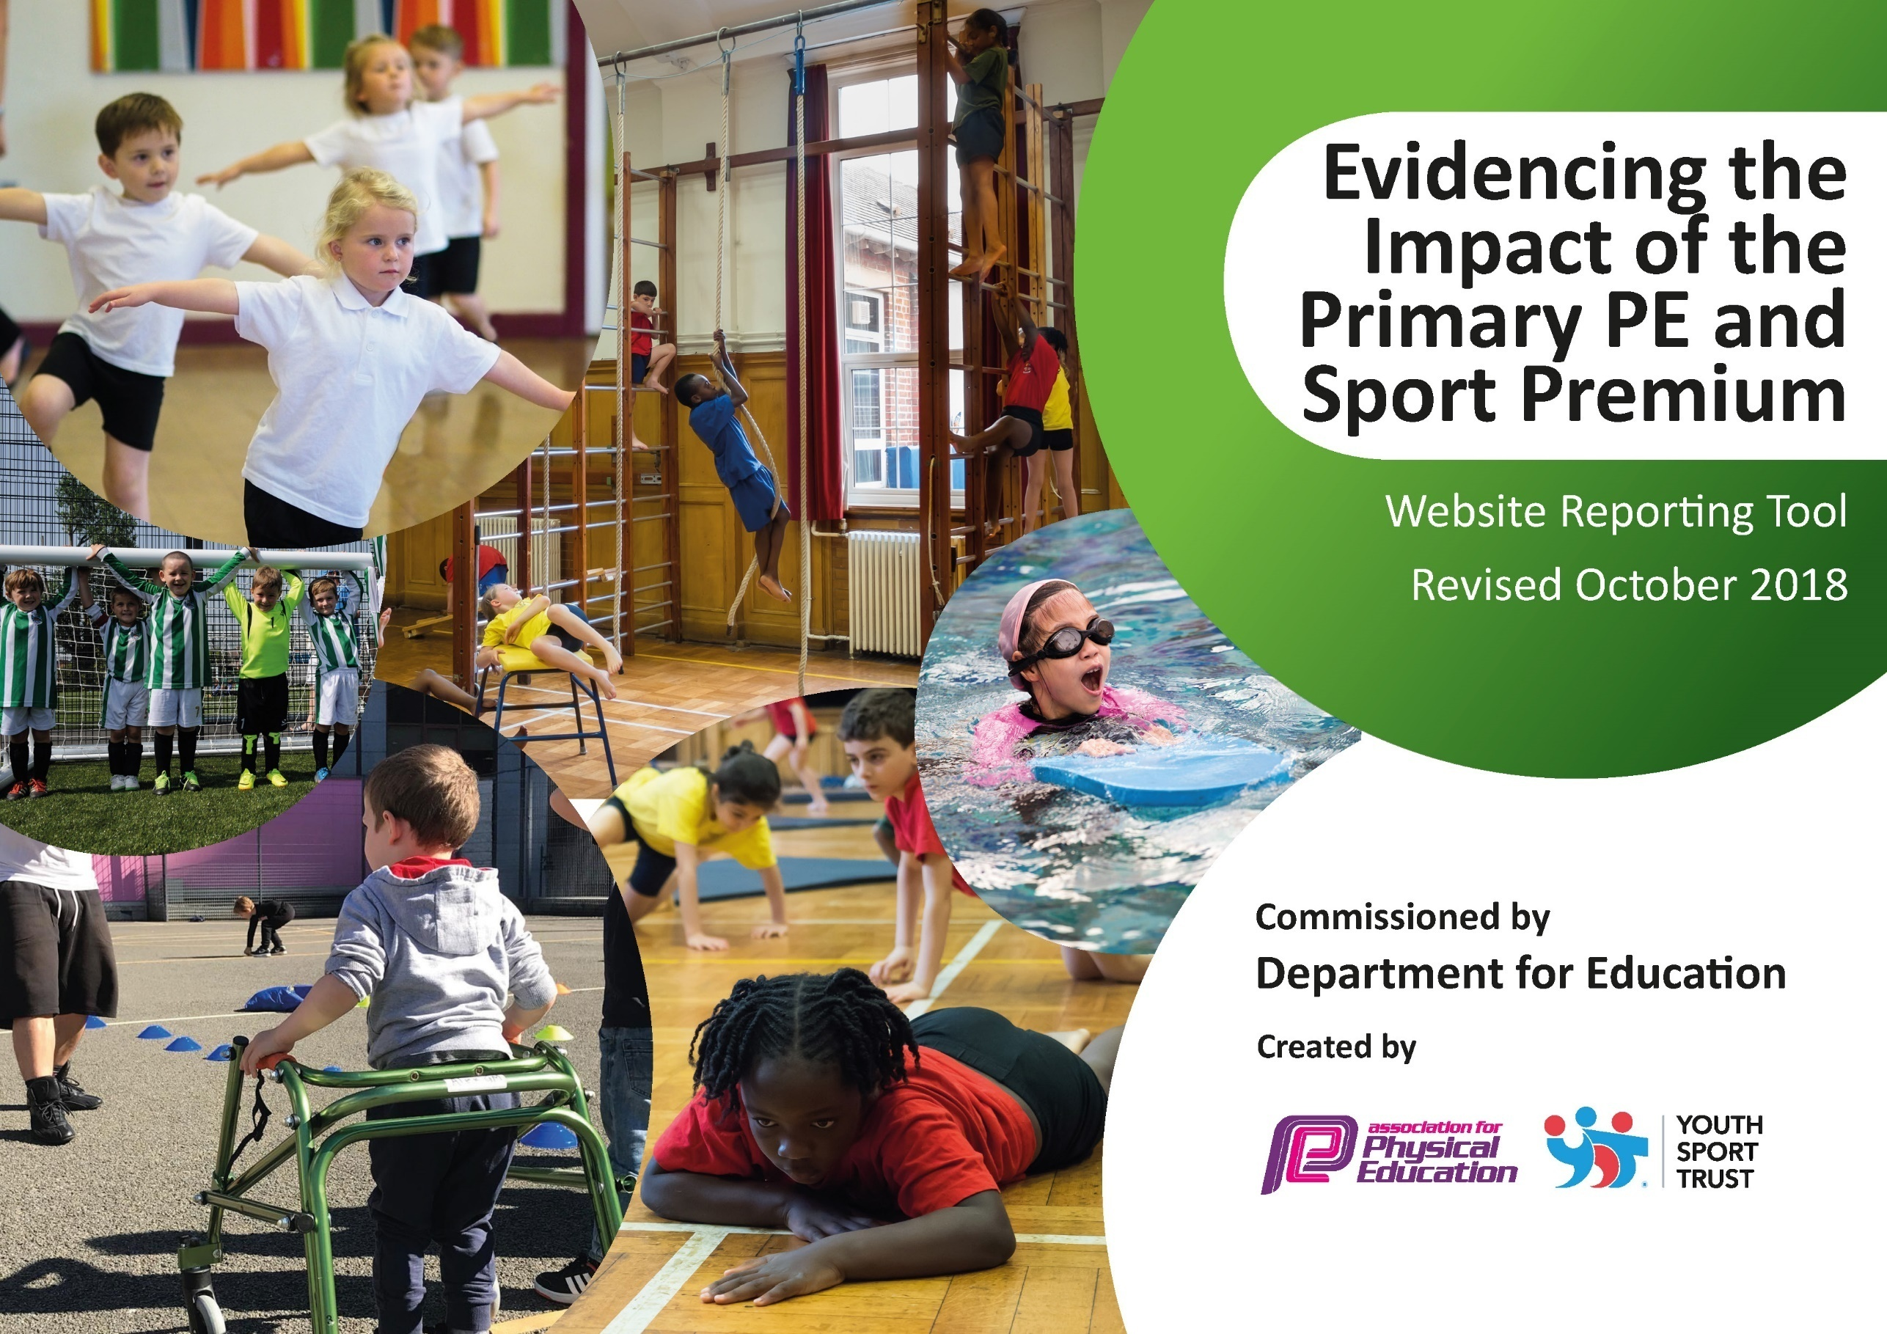
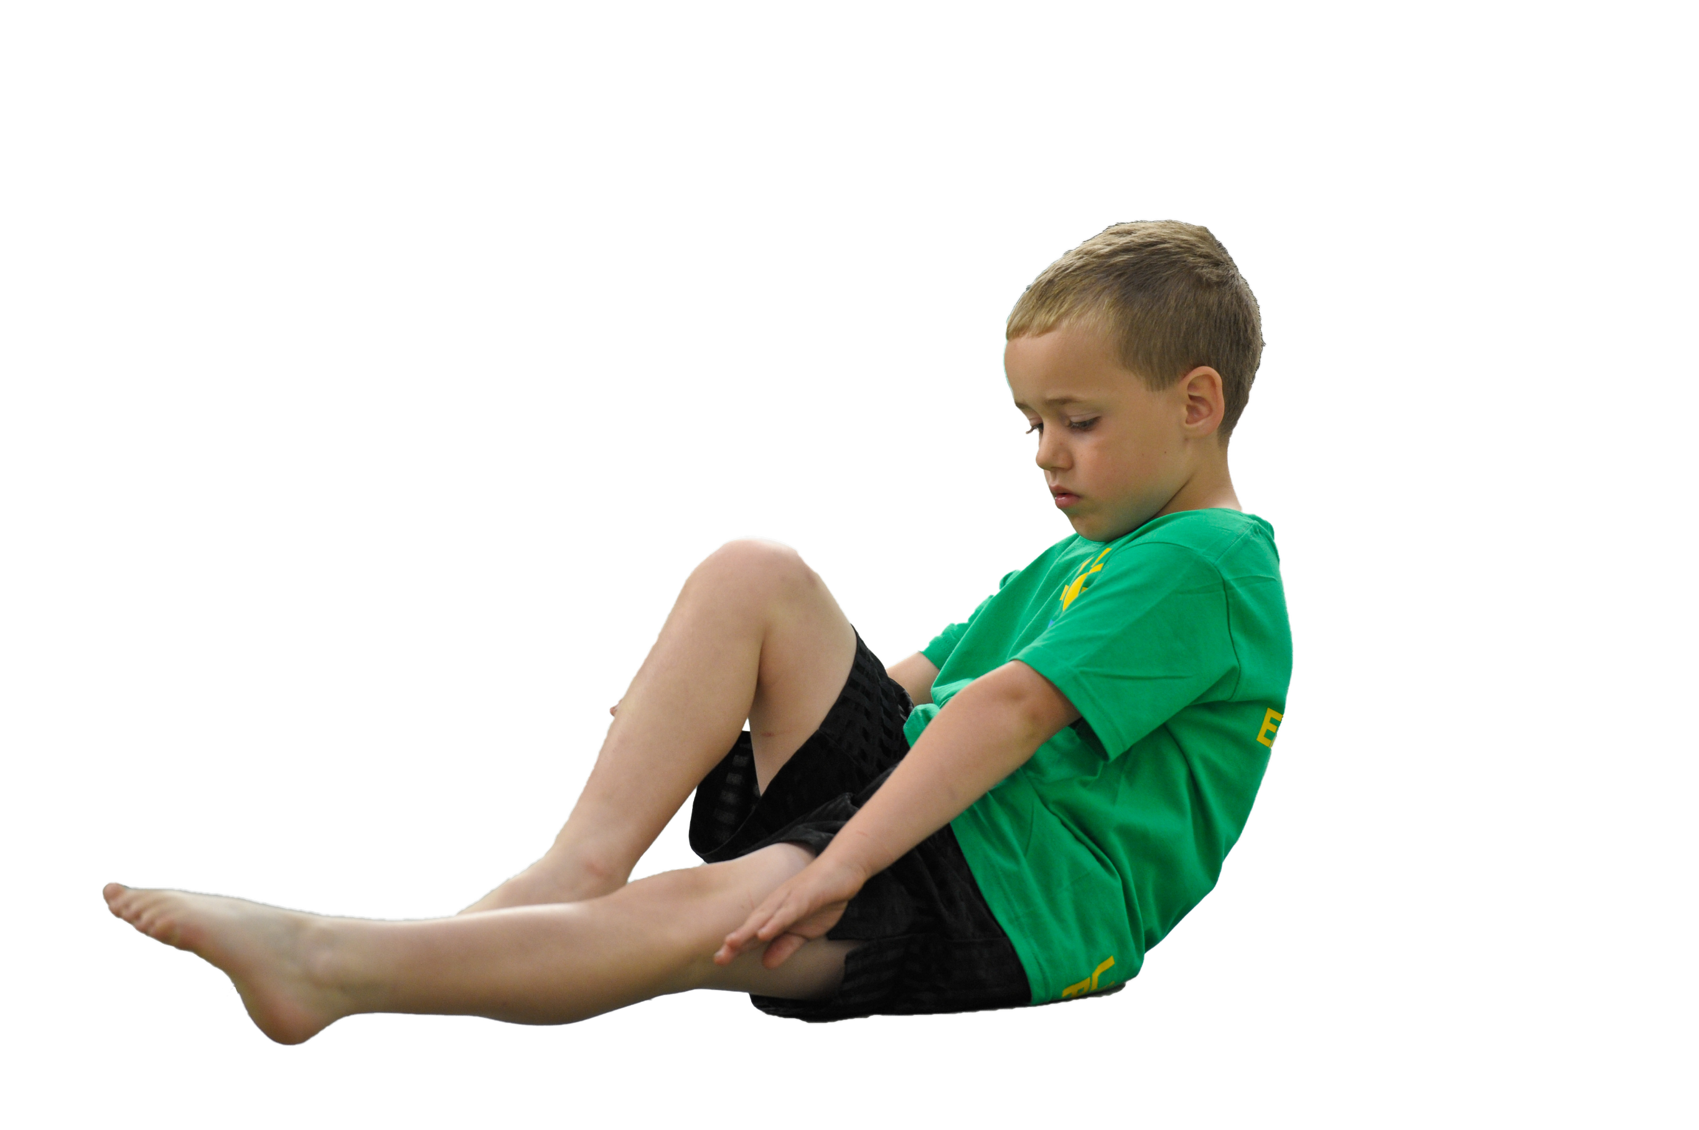
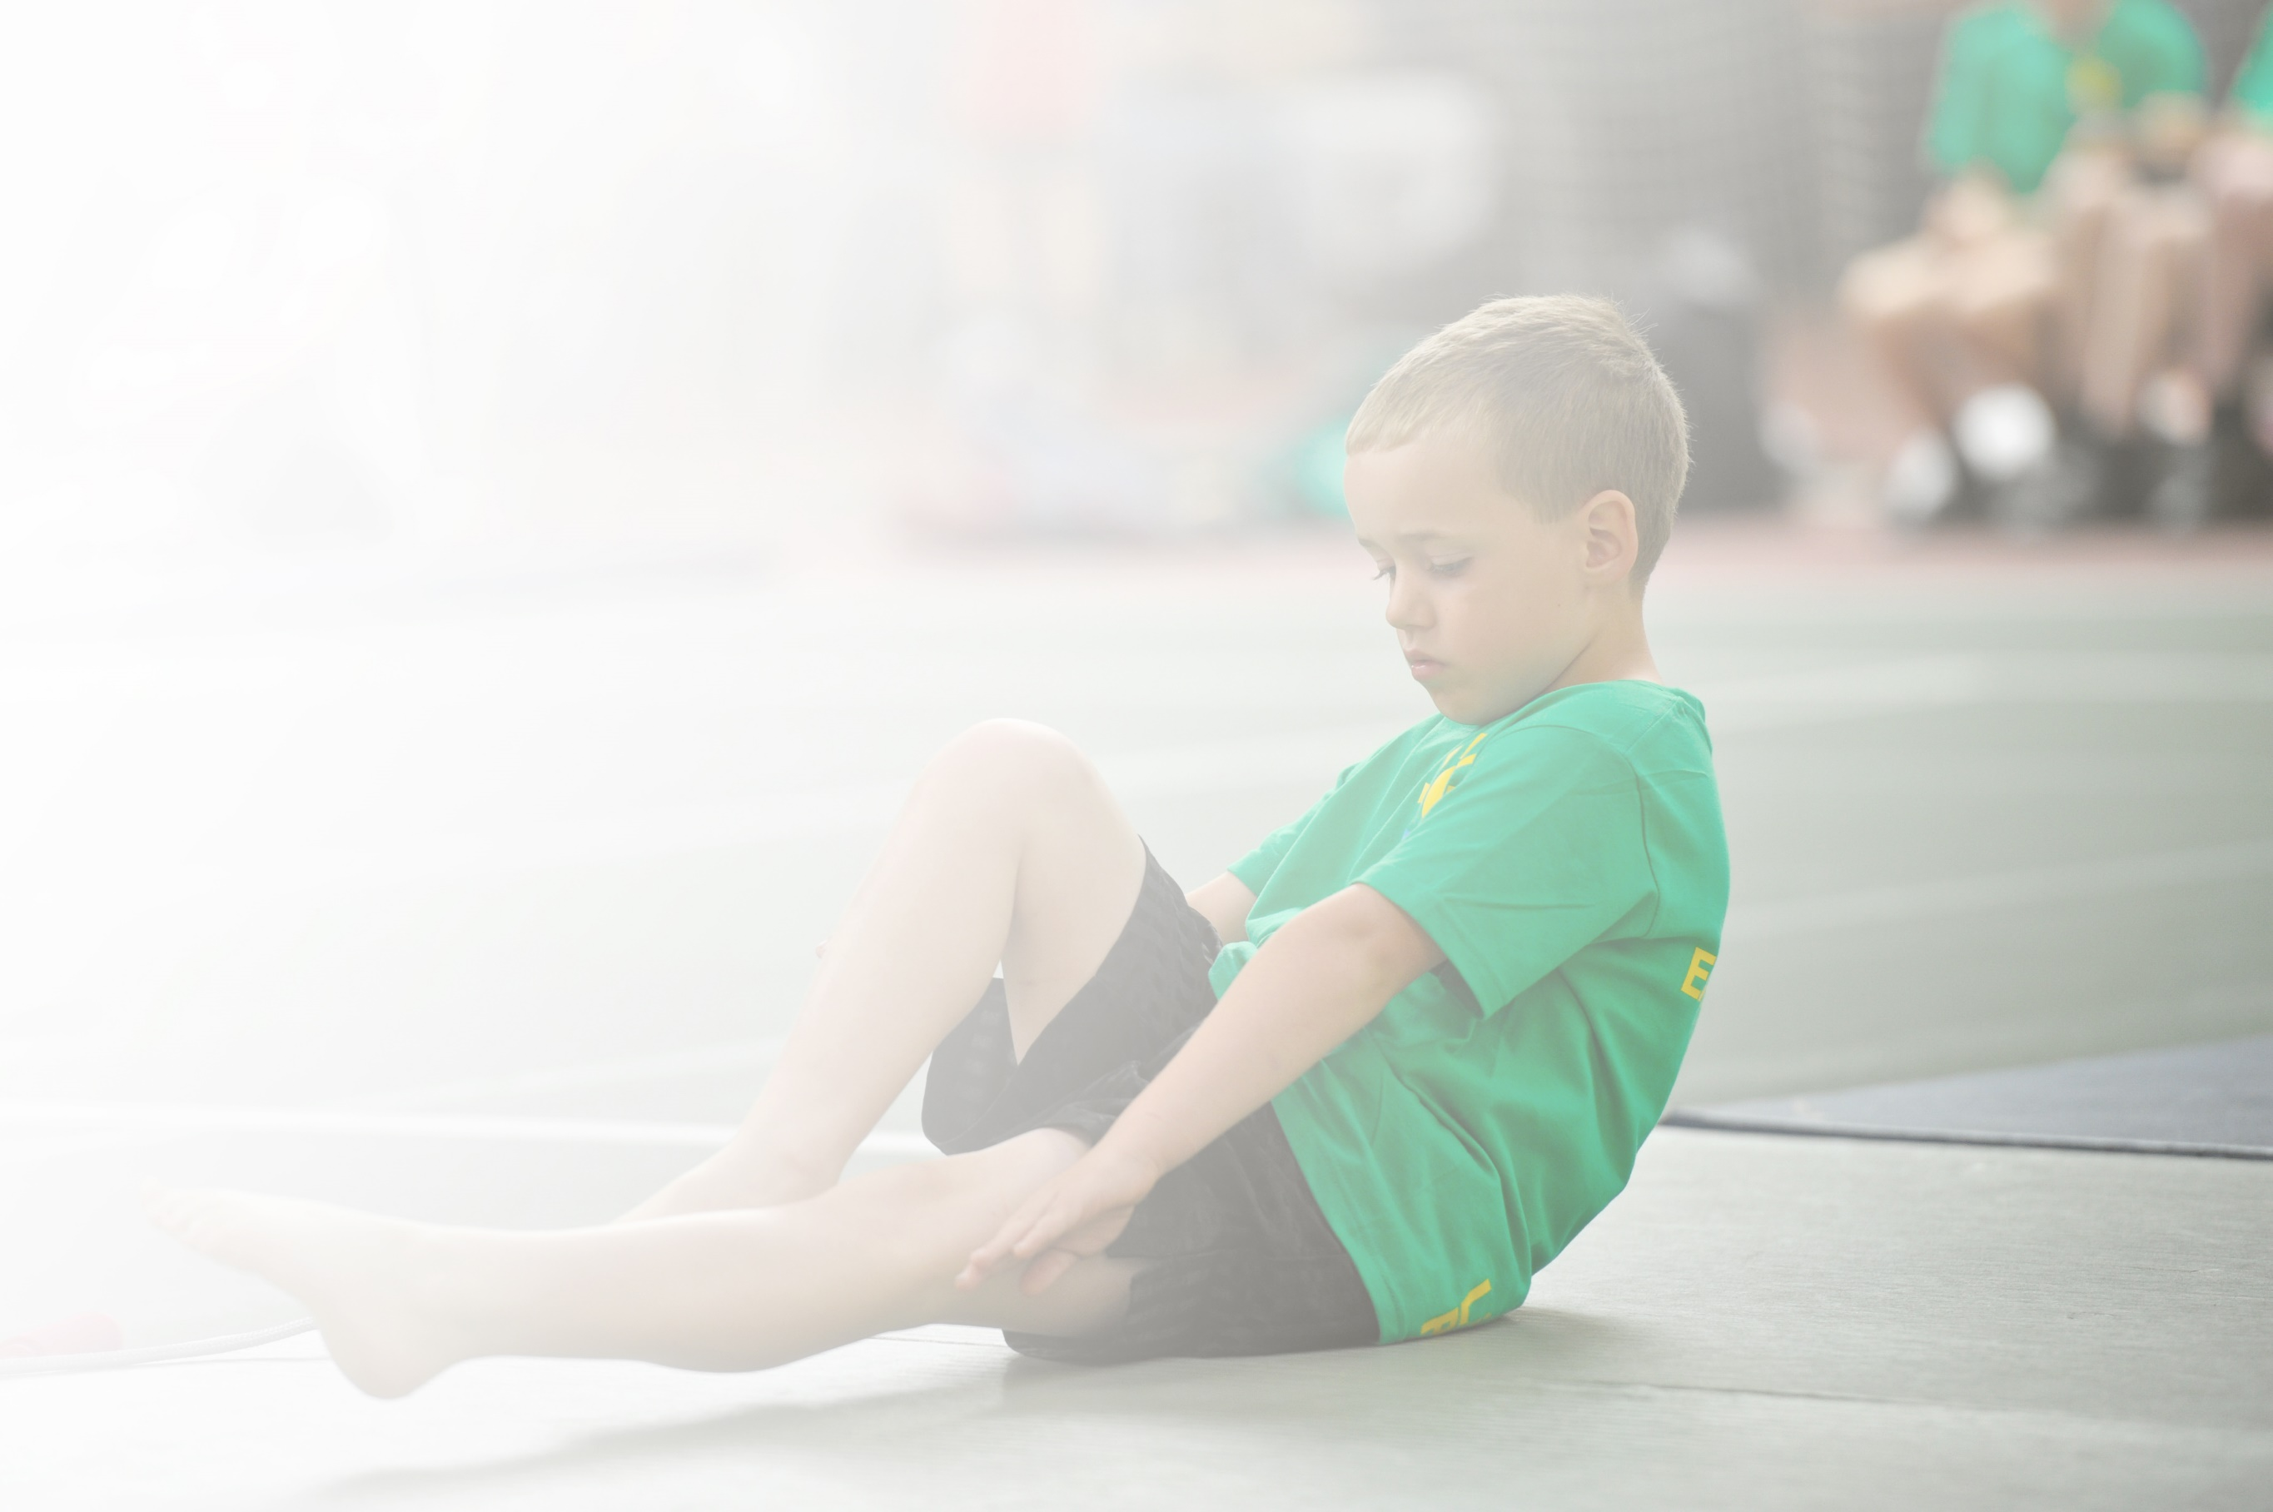
Schools must use the funding to make additional and sustainable improvements to the quality of Physical Education, Sport and Physical Activity (PESPA) they offer. This means that you should use the Primary PE and Sport Premium to:

- Develop or add to the PESPA activities that your school alreadyoffer
- Buildcapacityandcapabilitywithintheschooltoensurethatimprovementsmadenowwillbenefitpupilsjoiningthe school in futureyears

Please visit gov.ukfor the revised DfE guidance including the 5 key indicators across which schools should demonstrate an improvement. This document will help you to review your provision and to report
your spend. DfE encourages schools to use this template as an effective way of meeting the reporting requirements of the Primary PE and Sport Premium.

We recommend you start by reflecting on the impact of current provision and reviewing the previous
spend.UndertheOfstedSchoolsInspectionFramework,inspectorswillassesshoweffectivelyleadersusethe PrimaryPEandSportPremiumandmeasureitsimpactonoutcomesforpupils,andhoweffectivelygovernorshold them to account forthis.

Schools are required to publish detailsof how they spend this funding as well as on the impact it has on pupils’ PE and sport participation and attainment by the end of the summer term or by 31 July 2019 at the
latest.
We recommend regularly updatingthe table and publishing it
on your website throughout the year, as evidence of your
ongoing review into how you are using the money to
secure maximum, sustainable impact. To see an
example of how to complete the table please
click HERE.

Support for review and reflection - considering the 5 key indicators from DfE, what development needs are a priority for your setting and your students now and why? Use the space below to reflect on previous spend, identify current need and priorities for the future.

Key achievements to date: | Areas for further improvement and baseline evidence of need:
- Gold Sports Mark Award  - Increased particpation in intra-school competitions  - Good achievement rate in competions  - Healthy living week introduced  - Nurture groups in place  - A broader range of activities introduced than those traditionally offered in school  - All children receive 30 mins exercise daily | - Consolidate standardised delivery of PE and assessment across the whole school  - Ensure all staff have the knowledge and skill base to deliver high quality PE lessons  - Ensure all children are involved in competitive sport at least once throughout the year  - Develop groups to enhance emotional well-being in school  - Continue educating children on the impact of staying healthy and what that entails.  - To continue to provide 30 mins exercise daily for all pupils

Meeting national curriculum requirements for swimming and water safety | Please complete all of the below:
What percentage of your current Year 6 cohort swim competently, confidently and proficiently over a distance of at least 25 metres?  N.B. Even though your children may swim in another year please report on their attainment on leaving  primary school. | 89%
What percentage of your current Year 6 cohort use a range of strokes effectively [for example, front crawl, backstroke and breaststroke]? | 89%
What percentage of your current Year 6 cohort perform safe self-rescue in different water-based situations? | 89%
Schools can choose to use the Primary PE and Sport Premium to provide additional provision for swimming but this must be for activity over and above the national curriculum requirements. Have you used it in this way? | No

Action Plan and Budget Tracking
Capture your intended annual spend against the 5 key indicators. Clarify the success criteria and evidence of impact that you intend to measure to evaluate for students today and for the future.

Academic Year: 2019/20 | Total fund allocated: £17040 | Date Updated: September 2019
Key indicator 1: The engagement of all pupils in regular physical activity – Chief Medical Officer guidelines recommend that primary school children undertake at least 30 minutes of physical activity a day in school |  |  |  | Percentage of total allocation:
 |  |  |  | %
School focus with clarity on intended impact on pupils: | Actions to achieve: | Funding allocated: | Evidence and impact: | Sustainability and suggested next steps:
To continue to provide opportunities for 30 minutes of activity a day at lunchtimes. | Playtime organiser employed to co-ordinate and track involvement for all children on a daily basis.  Continue annual training of Sports Leaders who can then promote and undertake daily lunch time clubs. | £4650  £150 | Increased personal fitness.  Improved attitudes towards physical activity.  Increased engagement of all pupils in regular physical activity.  Improved attitudes towards the afternoon curriculum as a result of more focused lunchtime activities.  Increased mental well-being. | Current funding allowed a new member of staff to receive CPD to continue playtime organiser duties in the following year with no further CPD.  Current funding still allows for play leaders to be trained, but current leaders can train younger members in subsequent years when funding is no longer available.
Key indicator 2: The profile of PESSPA being raised across the school as a tool for whole school improvement |  |  |  | Percentage of total allocation:
 |  |  |  | %
School focus with clarity on intended impact on pupils: | Actions to achieve: | Funding allocated: | Evidence and impact: | Sustainability and suggested next steps:
The school will continue to focus on embedding whole school standardisation of high quality PE lessons with an emphasis on sports participation and inter school competition.  Consolidate using the assessment tool for PE. | Develop use of IPEP program as a whole school tool for lesson planning and whole school PE assessment. | £600 | Consistent high quality PE lessons delivered throughout the school.  Increased staff confidence in delivering PE lessons.  Good progression of skills taught throughout the school.  Increased participation from pupils during PE lessons.  Consistent approach to assessment throughout school. | Increased staff skill base to plan and deliver high quality PE lessons.  Increased staff knowledge about skills progression throughout the school.  Increase knowledge of assessment.  Current funding allows use of IPEP to continue next year.

Key indicator 3: Increased confidence, knowledge and skills of all staff in teaching PE and sport |  |  |  | Percentage of total allocation:
 |  |  |  | %
School focus with clarity on intended  impact on pupils: | Actions to achieve: | Funding  allocated: | Evidence and impact: | Sustainability and suggested  next steps:
Ensure all staff are adequately trained, have updated CPD and have resources to ensure they have the knowledge and skills to teach PE and Sport. | CPD opportunities for teaching staff in targeted areas to improve existing knowledge and skill base e.g. refresher course in gymnastics.  Develop use of IPEP program as a whole school tool for lesson planning and whole school PE assessment. | £500  As above. | Gymnastics course attended by 4 members of staff resulted in increase in confidence to plan and deliver gymnastics lessons in school.  As above | CPD allowed for increased knowledge in lesson planning and delivering.  As above.
Key indicator 4: Broader experience of a range of sports and activities offered to all pupils |  |  |  | Percentage of total allocation:
 |  |  |  | %
School focus with clarity on intended  impact on pupils: | Actions to achieve: | Funding  allocated: | Evidence and impact: | Sustainability and suggested  next steps:
To extend opportunities further than those traditionally offered in school.  We hope to make a lasting positive impact through exposing children to new experiences and opportunities that they would not ordinarily participate in. | Forest School  Running club  Gifted and Talented Program  Specialist in school Sports Coaches | £5000  £500  £500  £3000 | Increased awareness of the outdoors resulting in improved health, emotional and physical well-being.  A broader experience of a range of sports and activities for pupils.  Increased fitness .  Gifted and Talented Program did not take place due to restrictions.  Weekly CPD for staff.  Specialist skills taught to pupils. | Children familiar with the roles and responsibilities in the Forest to allow smaller sessions to take place.  New Forest School leader in place to continue sessions.  The continuation of sports funding 2020-2021 will allow FS leader two afternoons in the forest to focus on specific year groups and have different year groups for ‘one-off’ sessions throughout the year.  Current funding allows specialist Sports Coaches to continue in 2019-2020  Increased confidence, knowledge and skills of all staff in teaching PE and sport through observation of lessons.
Key indicator 5: Increased participation in competitive sport |  |  |  | Percentage of total allocation:
 |  |  |  | %
School focus with clarity on intended  impact on pupils: | Actions to achieve: | Funding  allocated: | Evidence and impact: | Sustainability and suggested  next steps:
To increase the amount and range of competitions the school attends | Cockermouth Sports Consortium  Wright Sports Services Cockermouth Competitions | £1450  £800 | Pupils develop positive attitudes to sport & sportsmanship.  Opportunities to network with other pupils from other schools.  Provide opportunities to evaluate and recognise success.  Increased participation in competitive sport. | Co-ordinator to continue participation in competitions.  Continue consortium PE cluster meetings to ensure competition calendar is continued in subsequent years.

