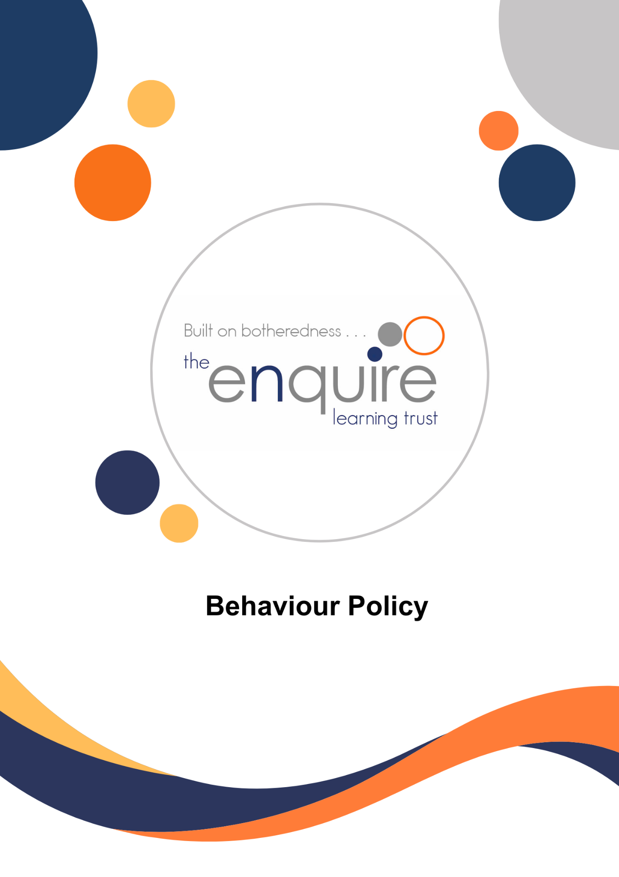

Contents

Section | Title | Page
1 | Policy overview | 4
2 | Aim | 5
3 | Objectives | 5
4 | The classroom environment | 5
5 | The role of the Teacher | 6
6 | The role of the Principal | 6
7 | The role of Parents and Carers | 7
8 | Positive discipline | 7
9 | Support pupils | 8
10 | Curricular links with behaviour management | 8
11 | Bullying and racism | 8
12 | Child on child sexual harmful behaviour | 9
13 | Monitoring behaviour | 9
14 | Use of reasonable force | 10
15 | Prohibited items on the school site | 10
16 | Expected behaviour / code of conduct | 11
17 | Exclusion and suspension | 12
18 | Guidance and legislation | 12
19 | Appendix 1 – Confiscation advice | 13

Version History

Approved by: | Trustees
Last reviewed: | July 2026
Next review due by: | July 2027

Date | Author | Version | Comment
April 2020 | JH
October 2022 | RC |  | Review and update with DFE charges
September 2023 | RC / JH |  | Reviewed –  Added guidance (from DfE) re searches of pupils (if applicable) – see page 10
September 2024 | RC / JH |  | Reviewed – no changes
May 2025 | RCo |  | Review – Updated link to KCSIE 2025
July 2026 | RCo |  | Review – Updated link to KCSIE 2026

1. Policy Overview
Within our academies, high standards of behaviour are expected from all pupils. A positive working environment is essential for positive relationships and members of staff should lead by example.
This policy applies to pupil behaviour whether the pupil is on the Academy site, outside of the Academy site or outside of the school day. The Academy will take appropriate action where a pupil’s behaviour falls below the expected standards.
Policies and practice promote an environment conducive to learning and ensuring high achievement for all young people, irrespective of their differing needs. Children are asked to:
- Arrive in the Academy and at lessons punctually and be prepared to learn.
- Bring appropriate equipment such as: PE kit and reading books and any other necessary equipment
- Wear the Academy uniform correctly.
- All pupils are expected to be polite, courteous and respectful to everyone on the Academy site and to comply with reasonable requests or instructions made by staff on the first time of asking.
- All pupils complete any task reasonably assigned to them in connection with their education.
- Children are expected to have regard for their own safety and that of others.
This policy is to be read in conjunction with the following guidance:
- Behaviour in schools guidance (publishing.service.gov.uk)
- Searching, Screening and Confiscation (publishing.service.gov.uk)
- Suspension and Permanent Exclusion from maintained schools, academies and pupil referral units in England, including pupil movement (publishing.service.gov.uk)
- DfE advice template (publishing.service.gov.uk)
- technical-guidance-schools-england.docx
- Keeping children safe in education 2026 (comes into force from 1 September 2026)

Links with other policies:
- Safeguarding and Child Protection Policy
- Anti bullying policy
- SEN Policy
- Positive Handling Policy
- Exclusion Policy

2. Aim
We aim to offer a happy, well-organised, positive and stimulating environment where children will work purposefully, where effective learning can take place and where children demonstrate good social and learning behaviours.
This behaviour policy is therefore intended to support all members of our school community in living and working together in a mutually beneficial way. It aims to promote an environment in which everyone feels happy, safe and secure.

We aim for the children to develop the following:
- Respect for oneself, others and property.
- Positive self-esteem.
- Co-operation and collaboration.
- Care for others.
- Self-discipline.
- Self-motivation and resilience.
- Independence.
3. Objectives
- To ensure a common policy concerning behaviour that will generate positive consistent approaches amongst staff.
- To examine and reaffirm the importance of PSHE/citizenship and other areas of the curriculum as a vehicle for positive behaviour.
- To ensure regular and consistent use of the expectations throughout each Academy.
- To develop strategies to support pupils showing challenging behaviour.
- To challenge and address any form of bullying (including cyberbullying, prejudiced-based and discriminatory bullying). (Please see our Anti-Bullying Policy for further details of our approach.)
- To work in partnership with parents to inform and offer support with regard to any individual behaviour difficulties.
4. The Classroom Environment
Disruptive behaviour affects both the teacher and other children. As recognised in the Special Educational Needs and Disability Code of Practice (January 2015), poor behaviour may be a result of unmet needs and the class teacher will, with support from other staff in the Academy, implement strategies to provide the necessary support to the pupil. Reasonable adjustments will also be made to support pupils with SEND.
Adjustments to behavioural expectations may be made for any pupil, who needs additional support with their behaviour choices. These may be temporary or permanent depending on the individual circumstances of the pupil. Where possible, these adjustments are made proactively and by design to ensure all pupils can meet behavioural expectations. For example, a pupil new to the school may need time to settle into new routines and expectations, or a pupil who is experiencing a bereavement etc.
Low-level disruptive behaviour can be influenced positively by effective classroom management techniques.
Positive Influences
- Structured and well-prepared activities taking place in a friendly atmosphere and pitched at an appropriate level.
- Courteous and respectful interactions with pupils making use of pleasant humour.
- Clear messages of enjoyment about being with the group.
- Creating space and “play” opportunities for individual children where appropriate.
- Giving children opportunities to explore feelings, make choices, clarify values and work collaboratively.
- Considering furniture layout, groupings, pace of lessons and challenging tasks.
- Avoiding stereotyping, especially stereotyping children as troublemakers.
- Being aware of home circumstances and values.
Negative Influences
- Loud use of public reprimands and threats.
- Constant use of criticism and sarcasm.
- Aggressive reaction to minor incidents which increases the likelihood of major confrontation.
- Being unjust or inconsistent.
5. The Role of the Class Teacher
The class teachers have high expectations of our children with regard to behaviour, and they strive to ensure that all children achieve to the best of their ability.
The class teacher treats each child fairly and enforces the classroom code consistently. The teachers treat all children in their classes with respect and understanding.
It is the responsibility of class teachers to ensure that the school rules are enforced in their classes, and that their classes behave in a responsible manner during lesson time.
Where external support agencies are involved in meeting the needs of a particular child, the class teacher liaises and works co-operatively with those agencies, as necessary, to support and guide the progress of the child. The class teacher may, for example, in consultation with the Special Educational Needs Co-ordinator (SENCO) discuss the needs of a child with their Social Worker.
6. The Role of the Principal
It is the responsibility of the Principal, under the School Standards and Framework Act 1998, to implement the school behaviour policy consistently and to report to the Academy Improvement Committee, when requested, on the effectiveness of the policy. It is also the responsibility of the Principal to ensure the health, safety and welfare of all children in the school.
The Principal supports staff by implementing the policy, by setting the standards of behaviour, and by supporting staff in their implementation of the policy.
The Principal has the responsibility for giving suspensions to individual children for serious acts of misbehaviour. For repeated or very serious acts of anti-social behaviour, the Principal may permanently exclude a child.

7. The Role of Parents and Carers
We collaborate actively with parents and carers, so that children receive consistent messages about how to behave both at home and at school.
We try to build a supportive dialogue between home and school, and we inform parents and carers immediately if we have concerns about their child's welfare or behaviour.

If we have to use reasonable sanctions to address any behaviour concerns with a child, we expect parents and carers to support these actions. If parents and carers have any concerns about the way that their child has been treated, they should initially contact the class teacher. If their concerns remain, they should contact the Principal to discuss the issues involved. If parents or carers wish to complain further about actions taken by us, the Enquire Learning Trust’s Complaints Policy is available on our website.
8. Positive Discipline
Each Academy has developed a Code of Conduct that should be clearly understood by all and adhered to in the interests of everyone. These key rules will be prominently displayed around the Academy and regularly referred to by staff and children.
System of affirmation/strategies for praise and reward
Any praise given to pupils should be genuine, personal and specific.
Children behave positively if they think they are worthwhile people. Affirming a person increases or restores her/his sense of self-esteem. It is particularly necessary with children whose own self-image is low. Affirming a child will sometimes avoid problematic situations.
Good behaviour is praised and rewarded by staff to give recognition to the efforts being made by pupils to behave appropriately. This will also have the effect of communicating staff expectations to pupils who are not behaving in an acceptable manner.

At Buckingham Primary Academy a positive reward system is used including the use of
class dojos for positive behaviour and following the four school rules:

To be respectful,
To be responsible,
To be kind,
To be safe.

The school rules are reinforced throughout the school day. There is a consistent and positive
approach to language used by all staff at Buckingham Primary Academy which has a
restorative approach of the three Rs, Regulate, Relate and Repair this includes language
stems and following each instruction or request to a pupil with ‘thank you’ and avoiding using ‘please’ at the start of a request or instruction. Staff model positive language and behaviour. (See table below)

All staff at Buckingham Primary Academy have high expectations and boundaries, which
refine and restrict the amount of stress to allow children to be resilient, challenged and be safe.

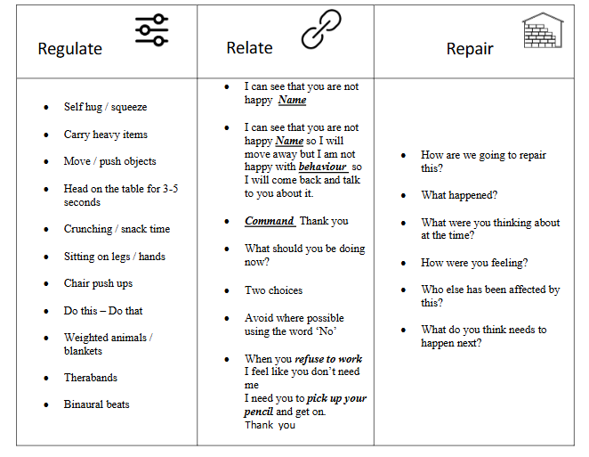

(Describe academy system here)
Assertiveness/Warnings/Consequences
Faced with inappropriate behaviour it is tempting for any teacher to threaten punishment. However, punishments and rewards keep children dependent upon external motivators. The development of self-awareness and self-discipline is sacrificed for the sake of immediate compliance.

Behaviours have consequences. However, negative consequences imposed too quickly take away the need for the pupil to face the issues, make choices and take responsibility. At Buckingham Primary Academy our approach using 3 Rs - integrates core principles of
neuro development and traumatology to inform work with children, families and the
communities which they live. This approach is a preventative approach.

9. Support Pupils
A behaviour modification programme for individuals may be applied if appropriate.
The class teacher and child will identify targets. If there are a number of incidents of negative behaviour, outside agencies may be consulted.
It is important to consider a differentiated approach to learning if a child is displaying challenging behaviour. It is also important to try and establish the reasons why the child is displaying challenging behaviour and provide the appropriate support to mitigate the behaviours; this may include focussed interventions in-school and/or liaison with a range of external professionals/agencies to access additional support.
Differentiation should be an inherent part of planning for individual needs.
At Buckingham Primary Academy in addition to FTT we also include: use of personalised behaviour charts, visual timetables to reinforce positive behaviour which are adapted and tailored to the specific needs of pupils, checkins, ELSA. Hull LA SEMH Collaborative referral for support is from Steps to Success, OUTREACH service through The Whitehouse, PRU.
Staff: It is important for staff to feel that they can rely on each other when dealing with challenging behaviour. Members of staff should feel that they are able to seek support and advice from colleagues, particularly SLT, before a situation becomes out of hand.

10. Curricular Links with Behaviour Management
Our Academies have a positive approach to behaviour management and as such, believe in actively developing children to be self-disciplined. In order to do this, it is essential that children are given opportunities to discuss different types of behaviour and their effect on others. A significant part of the curriculum is committed to Personal Social and Health Education (PSHE) when many of these issues can be considered. At Buckingham Primary Academy our PSHE follows Pol Ed and we incorporate support from outside agencies which incluse: PCSOs, NSPCC, HEADStart, Advotalk.
11. Bullying and Racism
Each academy has an Anti-Bullying and Anti-Racism approach and actively explores these issues within the curriculum. These subjects are discussed from the viewpoint of the bully and the victim to enable pupils to understand the feelings and emotions of others.
We need to be clear about what we mean by bullying. We define it as:
- the wilful, conscious desire to hurt or threaten someone, physically, emotionally or materially on a number of occasions; or
- when a person or a group deliberately intends to cause someone else to feel hurt, distressed, threatened or humiliated; or
- behaviour by an individual or group, usually repeated over time, that intentionally hurts another individual or group either physically or emotionally.

In accordance with the academy’s Anti-Bullying Policy, any incident of bullying occurring at the Academy will be taken seriously and followed through appropriately by staff. Parents of both the bully and the victim will be involved and kept informed as appropriate. A written record of any such incident will be made and recorded on CPOMs.
The Enquire Learning Trust sees racism as a form of bullying and does not condone it in any form.

12. Child on child Sexual harmful behaviour
Sexually harmful behaviour from young children is not always contrived or with the intent to harm others. There may be many reasons why a young person engages in sexually harmful behaviour and it may be just as distressing to the young person who instigates it as to the young person it is intended towards. Sexually harmful behaviour may include:
- Inappropriate sexual language
- Inappropriate role play
- Sexual touching
- Sexual assault/abuse
Staff are aware of the importance of:
- Making clear that sexual violence and sexual harassment is not acceptable, will never be tolerated and is not an inevitable part of growing up.
- Not tolerating or dismissing sexual violence or sexual harassment as ‘banter’, ‘part of growing up’, just having a laugh’ etc.
- Challenging behaviours (potentially criminal in nature) such as grabbing bottoms, breasts and genetalia, flicking bras and lifting up skirts. Dismissing or tolerating such behaviours risks normailising them.
- Upskirting will never be tolerated. This behaviour typically involves taking a picture under a person’s clothing without them knowing, with the intention of viewing their genitals or buttocks to obtain sexual gratification or cause the victim humiliation, distress or alarm.

13. Monitoring Behaviour
Senior leaders monitor behaviour regularly to identify any patterns in incidents. Appropriate actions are taken to ensure that these patterns are broken. CPOMs is ued to record and monitor behaviour of pupils who present with challenging or out of character behaviour. This is monitored and individual cases are discussed at Senior Leadership Team Meetings and briefings if appropriate to determine next steps to support a pupil manage their behaviour. n

14. Use of Reasonable Force
In exceptional circumstances and as a very last resort, where there is a danger of injury to a pupil or member of staff, positive handling using reasonable force may be appropriate. Positive handling methods are only used by staff with appropriate training where de-escalation techniques have failed or cannot be used.
The Academy will always communicate with parents where such techniques have been used. These incidents are recorded on CPOMs.
Please refer to the academy’s positive handling policy.

15. Prohibited Items on the School-Site

No pupil should bring any prohibited items on to the school-site. The following are prohibited items:
- knives and weapons
- alcohol
- illegal drugs
- stolen items
- cigarettes
- any article that a member of staff reasonably suspects has been, or is likely to be used:
  - to commit an offence, or
  - to cause personal injury to, or damage to property of; any person (including pupils)
- an article specified in regulations:
  - Tobacco and cigarette papers,
  - Fireworks; and
  - Pornographic images.

The Principal and staff (who are authorised by the Principal) have a statutory power to search a pupil or their possessions where they have reasonable grounds to suspect that a pupil may have a prohibited item listed above. Under common law, school staff have the power to search a pupil for any item if the pupil agrees. The member of staff will ensure the pupil understands the reason for the search and how it will be conducted so that their agreement is informed Searching, screening and confiscation (publishing.service.gov.uk).

If a pupil needs to be searched, parents/carers will be contacted and asked to come in and undertake the search with two members of staff present. If it is deemed necessary, the pupil will be kept separate from other pupils until the parents/carers can attend. The two members of staff will be the same sex as the pupil being searched. In limited circumstances, there may be an exception to whether the two members of staff are of the same sex and this is if the principal deems there is a serious risk of harm to the pupil or another, if the search is not carried out immediately, or it is not within a practical reasonable timeframe to allocate two same sex staff member’s. If the search is carried out under these circumstances the reason will be recorded alongside the record of the search on CPOMs. Two members of staff will be present during any search of a pupil.

Authorised staff will seek permission from a pupil to undertake a search of a pupil’s possessions (for example, their locker, desk, drawer, pencil case, bag, lunch box, coat, hat etc.). The members of staff will ensure that the pupil understands the reason for the search and how it will be conducted so that their agreement is informed. Parents will also be informed and consent gained. Two members of staff will conduct the search and parents/carers can attend and witness the search of the pupil’s possessions.

If a pupil refuses to give consent for their possessions to be searched, parents/carers will be contacted and asked to come in and undertake the search with two members of staff present. If it is deemed necessary, the pupil will be kept separate from other pupils until the parents/carers can attend.

Any kind of search will take place in a location away from other pupils and staff, providing the pupil with privacy. Two members of staff will always be present and consent from parents sought.

If a pupil is found to be in possession of a prohibited item, they may be permanently excluded depending on the circumstances, (e.g. threatening another pupil with a knife/weapon, sharing a vape or cigarettes with other pupils on the school-site etc.) or receive a suspension (e.g. bringing a vape into school and storing in their coat, bags etc – no other pupils are involved etc.).

Staff will liaise with both parents/carers and the appropriate professionals if a child is found to be in possession of a prohibited item – this may involve liaising with the Police and Social Care. Staff will also follow the ‘DfE Searching, Screening & Confiscation Advice for Schools, July 2022 (paragraphs 57-81, Appendix 1).

If any child is found to be suffering from the effects of alcohol or other substances, arrangements will be made for that child to be taken home and Social Care will be informed with a Multi-Agency Referral Form completed.

16. Expected behaviour/Code of Conduct
Each Academy has a clear set of behavioural standards and code of conduct for all pupils; these are clearly set out on the Academy website and are communicated to pupils and parents on a regular basis. High standards of work and behaviour are expected at all times. A positive approach to discipline is taken and pupils are encouraged to show consideration and care for people and property.
17. Exclusion and Suspension
The Enquire Learning Trust recognises that in order to ensure a positive atmosphere based on a sense of community and shared values it may, on occasions, be necessary to exclude an individual or individuals either for a fixed period, not exceeding forty five academy days in any one academic year, or, in some circumstances, permanently.

Such exclusions will only be resorted to when the academy can demonstrate with adequate evidence that all reasonable steps have been taken (including education off site) and/ or that the presence of the learner is likely to be severely detrimental to his/herself, other learners or employees. There may also be occasions when a suspension is appropriate because of unacceptable behaviour.

Good discipline in academies is essential to ensure that all pupils can benefit from the opportunities provided by education. The Trust supports its academies in using exclusion as a sanction where it is warranted. However, permanent exclusions should only be used as a last resort, in response to a serious breach, or persistent breaches, of the Academy's Behaviour Policy; and where allowing the pupil to remain in the academy would seriously harm the education or welfare of the pupil or others in the academy.

We follow the Suspension and Permanent Exclusion from maintained schools, academies and pupil referral units in England, including pupil movement, published by the DfE in September 2022 which has regard to the standard national list of reasons for exclusion. Currently, schools and local authorities must make full-time educational provision for suspended pupils from day 6 of their exclusion.

Parents and carers must ensure their child is not present in a public place during the first five days of an exclusion.

Reintegration Meeting

Principals have a duty to offer the parents or carers a reintegration interview in respect of certain time-limited suspensions.

The reintegration meeting aims to set out a strategy in which the risk of further suspension or permanent exclusion is reduced. The meeting will be a collaboration between academy staff, parents/carers and the pupil. The meeting will also be an opportunity for exploration of working with other professionals to identify any additional individual needs or multi agency approach that may be required. It will look at risk assessment and have an effective timescale for reviewing any intervention identified.

The Role of the AIC

The AIC will consider academy statistics on suspension and exclusion and professionally challenge school leaders on any suspension and exclusion in their academy during their termly meetings as a regular item on the agenda. The support for children at risk of permanent exclusion will be explored.

The principal will inform the AIC of any suspensions that are more than 5 academy days in one term. The AIC are not required to meet for suspensions of 5 days or less but parents may make a representation. The AIC do not have the power to consider to reinstate pupils with suspensions of 5 days or less.

If the suspension is between 6 and 15 days and parents request a hearing from the AIC, the AIC must meet within 50 school days of receiving the principals notice to consider reinstatement or uphold the Principal’s decision based on the evidence presented.

The principal will inform the AIC of suspensions that are more than 15 days in one term. The AIC must then meet within 15 school days to explore the suspension/s and have the power to either uphold the principal’s decision or reinstate the pupil based on the evidence presented.

The AIC must meet within 15 school days if the exclusion is permanent or if the suspension means the pupil will miss a public examination or national curriculum test. The AIC has the power to then uphold the principal’s decision or reinstate the pupil based on the evidence presented.
Any pupils that are at risk of exclusion or have been identified as requiring additional support should be referred to the Enquire Learning Trust SEMH Collaborative for support with strategies and interventions. For more information on the SEMH Collaborative please speak to your academy Principal or SENDCO.
Please refer to The Enquire Learning Trust Exclusion Policy for further information regarding the exclusion of pupils.

Guidance and legislation
Keeping children safe in education 2026 (comes into force from 1 September 2026)
Searching, screening and confiscation (publishing.service.gov.uk)
Behaviour in schools guidance (publishing.service.gov.uk)
Suspension and Permanent Exclusion from maintained schools, academies and pupil referral units in England, including pupil movement (publishing.service.gov.uk)

Appendix 1
Confiscation Advice

DfE Searching, Screening & Confiscation, Advice for Schools, July 2022 (paragraphs 57 -81):

Confiscation

Items found as a result of a search

57. An authorised staff member carrying out a search can confiscate any item that they have reasonable grounds for suspecting:
• poses a risk to staff or pupils;
• is prohibited, or identified in the school rules for which a search can be made (see paragraphs 2-3); or
• is evidence in relation to an offence.

Prohibited or illegal items

58. Controlled drugs must be delivered to the police as soon as possible unless there is a good reason not to do so. In these cases, the member of staff must safely dispose of the drugs. In determining whether there is a good reason to dispose of controlled drugs, the member of staff must have regard to the following guidance in paragraph 59 below issued by the Secretary of State.

59. The member of staff should take into account all relevant circumstances and use their professional judgement to determine whether they can safely dispose of the controlled drug. When staff are unsure as to the legal status of a substance and have reason to believe it may be a controlled drug, they should treat it as such. If the member of staff is in doubt about the safe disposal of controlled drugs, they should deliver them to the police.

60. Other substances which are not believed to be controlled should also be delivered to the police, or disposed of as above, if the member of staff believes they could be harmful.

61. Where a person conducting a search finds alcohol, tobacco, cigarette papers or fireworks, they may retain or dispose of them as they think appropriate but should not return them to the pupil.

62. If a member of staff finds a pornographic image, they may dispose of the image unless they have reasonable grounds to suspect that its possession constitutes a specified offence (i.e. it is extreme or an indecent image of a child) in which case it must be delivered to the police as soon as reasonably practicable. Members of staff should never intentionally view any indecent image of a child (also sometimes known as nude or semi-nude images). Staff must never copy, print, share, store or save such images. See paragraphs 72-79 for further advice on searching electronic devices.

63. Where a member of staff finds stolen items, these must be delivered to the police as soon as reasonably practicable. However, if there is good reason to do so, the member of staff may also return the item to the owner, or retain or dispose of it if returning them to their owner is not practicable. In determining whether there is a good reason to return the stolen item to its owner or retain or dispose of the item, the member of staff must have regard to the following guidance issued by the Secretary of State in paragraph 64 below.

64. The member of staff should take into account all relevant circumstances and use their professional judgement to determine whether they can safely dispose of the seized article. In taking into account the relevant circumstances, the member of staff should consider the following:
• the value of the item - it would not be reasonable or desirable to involve the police in dealing with low value items such as pencil cases, though school staff may judge it appropriate to contact the police if the items are valuable;
• whether the item is banned by the school;
• whether retaining or returning the item to the owner may place any person at risk of harm; and
• whether the item can be disposed of safely.

65. Any weapons or items which are evidence of a suspected offence must be passed to the police as soon as possible.

66. Items that have been (or are likely to be) used to commit an offence or to cause personal injury or damage to property should be delivered to the police as soon as reasonably practicable, returned to the owner, retained or disposed of. In deciding what to do with such an item, the member of staff must have regard to the guidance issued by the Secretary of State in paragraphs 67-68.

67. The member of staff should take into account all relevant circumstances and use their professional judgement to determine whether the item should be delivered to the police, retained, returned to the owner or disposed of. In taking into account all relevant circumstances the member of staff should consider:
• whether it is safe to dispose of the item; and
• whether and when it is safe to return the item.

68. If a member staff suspects a confiscated item has been used to commit an offence or is evidence in relation to an offence, the item should be delivered to the police.

69. Members of staff should use their judgement to decide to return, retain or dispose of any other items banned under the school rules. In deciding what to do with such an item, the member of staff must have regard to the guidance issued by the Secretary of State in paragraph 70.

70. The member of staff should take into account all relevant circumstances and use their professional judgement to determine whether they can safely dispose of the seized item. In taking into account all relevant circumstances, the member of staff should consider:
• the value of the item;
• whether it is appropriate to return the item to the pupil or parent; and
• whether the item is likely to continue to disrupt learning or the calm, safe and supportive environment of the school.

71. Members of staff should follow any additional guidance and procedures on the retention and disposal of items put in place by the school.

Electronic devices

72. Electronic devices, including mobile phones, can contain files or data which relate to an offence, or which may cause harm to another person. This includes, but is not limited to, indecent images of children, pornography, abusive messages, images or videos, or evidence relating to suspected criminal behaviour.

73. As with all prohibited items, staff should first consider the appropriate safeguarding response if they find images, data or files on an electronic device that they reasonably suspect are likely to put a person at risk.

74. Staff may examine any data or files on an electronic device they have confiscated as a result of a search, as defined in paragraph 57, if there is good reason to do so.

75. If the member of staff conducting the search suspects they may find an indecent image of a child (sometimes known as nude or semi-nude images), the member of staff should never intentionally view the image, and must never copy, print, share, store or save such images. When an incident might involve an indecent image of a child and/or video, the member of staff should confiscate the device, avoid looking at the device and refer the incident to the designated safeguarding lead (or deputy) as the most appropriate person to advise on the school’s response. Handling such reports or concerns can be especially complicated and schools should follow the principles as set out in Keeping children safe in education. The UK Council for Internet Safety also provides the following guidance to support school staff and designated safeguarding leads: Sharing nudes and semi-nudes: advice for education settings working with children and young people.

76. If a member of staff finds any image, data or file that they suspect might constitute a specified offence, then they must be delivered to the police as soon as is reasonably practicable.

77. In exceptional circumstances members of staff may dispose of the image or data if there is a good reason to do so. In determining a ‘good reason’ to examine or erase the data or files, the member of staff must have regard to the following guidance issued by the Secretary of State in paragraphs 78 and 79 below.

78. In determining whether there is a ‘good reason’ to examine the data or files, the member of staff should reasonably suspect that the data or file on the device has been, or could be used, to cause harm, undermine the safe environment of the school and disrupt teaching, or be used to commit an offence.

79. In determining whether there is a ‘good reason’ to erase any data or files from the device, the member of staff should consider whether the material found may constitute evidence relating to a suspected offence. In those instances, the data or files should not be deleted, and the device must be handed to the police as soon as it is reasonably practicable. If the data or files are not suspected to be evidence in relation to an offence, a member of staff may delete the data or files if the continued existence of the data or file is likely to continue to cause harm to any person and the pupil and/or the parent refuses to delete the data or files themselves.

Confiscation as a disciplinary penalty

80. Schools’ general power to discipline enables a member of staff to confiscate, retain or dispose of a pupil’s property as a disciplinary penalty, where reasonable to do so.

81. The law protects members of staff from liability in any proceedings brought against them for any loss of, or damage to, any item they have confiscated, provided they acted lawfully.

Legally, schools do not have to give the name of the pupil from whom drugs have been taken to the police. Schools should consider this on a case-by-case basis. Please see the DfE and ACPO drug advice for schools for more information on the relevant powers and duties in relation to powers to search for and confiscate drugs, liaison with the police and with parents.
Section 62 of the Coroners and Justice Act 2009 defines prohibited images of children. Section 63 of the Criminal Justice and Immigrations Act 2008 defines extreme pornographic images.
Section 91 of the Education and Inspections Act 2006.

