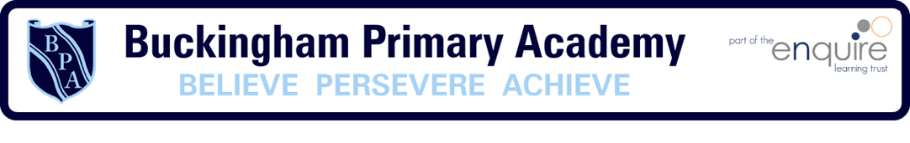
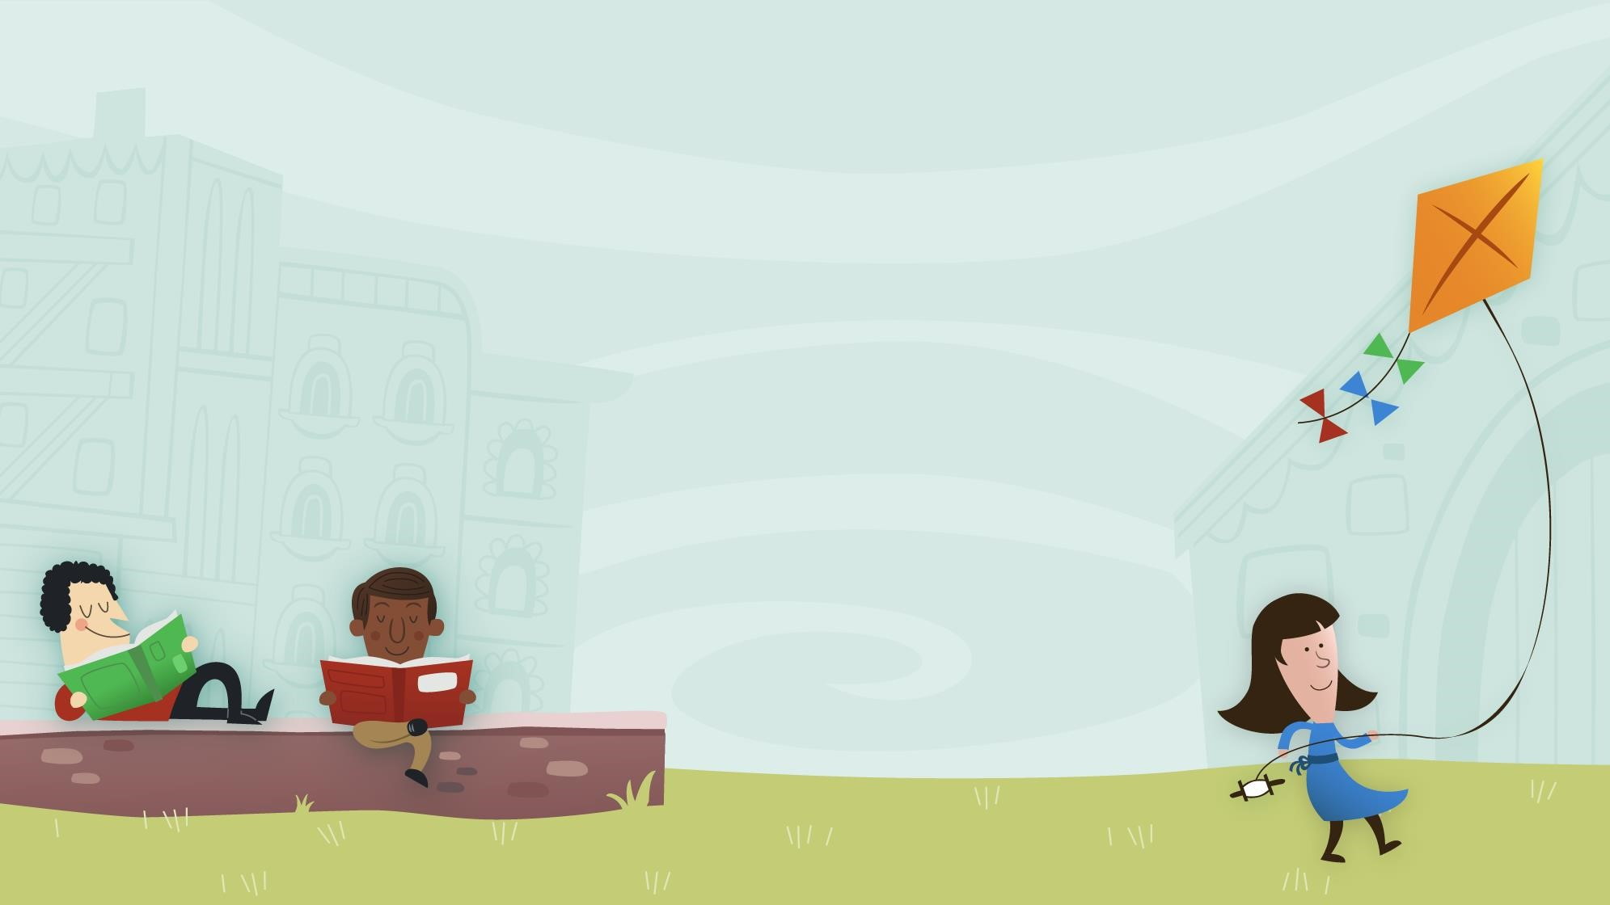

Drawing Club & Writing
in FS1 and FS2
What are we going to cover?
- Mark making & emergent writing
- Symbols
- Drawing Club
- Pencil grips
- Letter formation
- Writing in the EYFS curriculum
- Supporting your child with writing at home

What is Mark Making?
- Mark making in the Early Years is when children start to intentionally create their own lines, patterns, or shapes using their bodies or tools. It's the first step in a child's developmental journey towards writing and drawing, and is usually first seen in babies and toddlers.
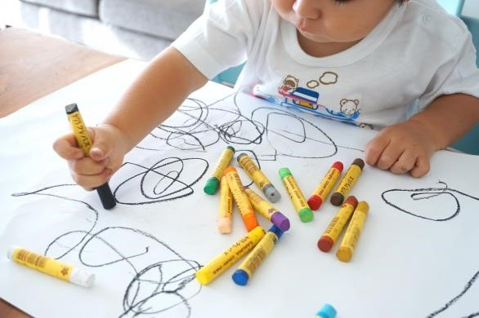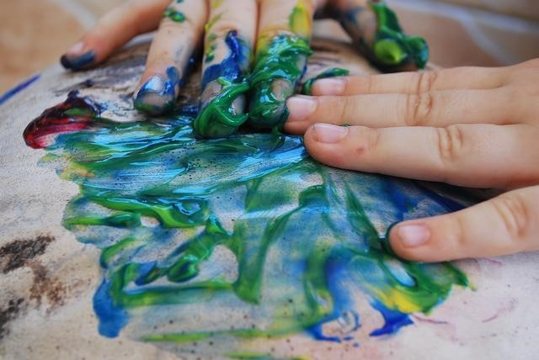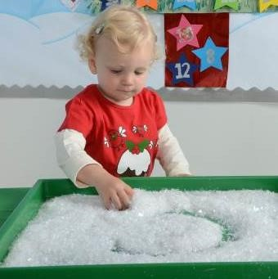

What is Emergent Writing?
- Emergent writing is young children’s first attempts at the writing process. Children as young as 2 years old begin to imitate the act of writing by creating drawings and symbolic markings that represent their thoughts and ideas.
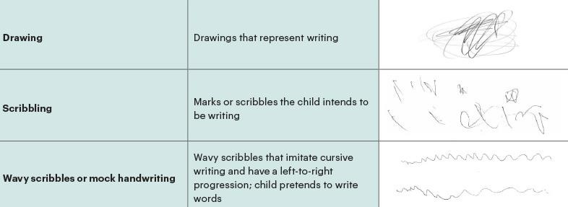

- Young children learn that writing has a purpose and that print is meaningful (i.e. it communicates ideas, stories, and facts).
- For example, young children become aware that the red street sign says Stop and the letters under the yellow arch spell McDonald’s. They recognise that certain symbols, logos and markings have specific meanings.
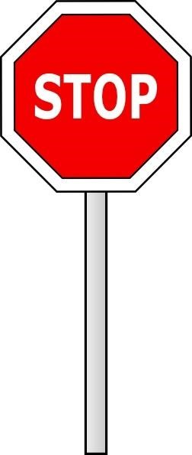

Symbols
- Symbols are all around us and are something we use as part of our everyday lives.
- Symbols communicate a message or an instruction. Do you recognise these?
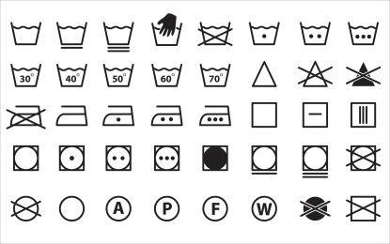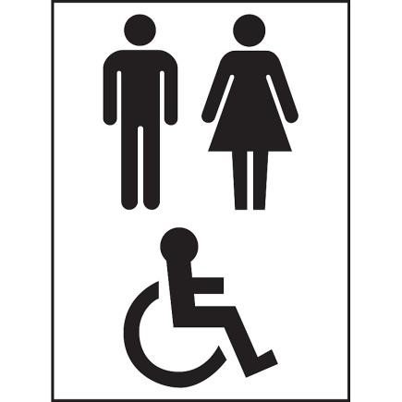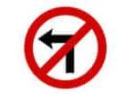
Symbols
- To children, letters are symbols, until they learn what they are, they are just a series of lines, curves and dots.
- In Reception, we introduce symbols which the children can draw/write, which can mean whatever their imaginations want them to be!
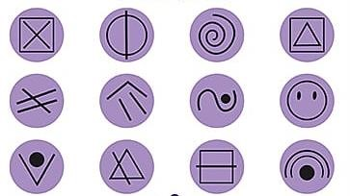
- “Young children need to feel 3 things when they write and mark make: joy, purpose and magic.” Greg Bottrill

Symbols & Messaging

- When you see a notification on your phone, it’s hard to ignore it, you want to open it and see what it says.
- This is what we want children to feel when they are mark-making. We want them to be excited about making and receiving messages.
- A simple rebrand of ‘writing’ to ‘messaging’, offers both children and adults a delight in what might otherwise be a struggle.
- When ‘messaging’ takes off, the phrase ‘reluctant writers’ goes out the window! Children want to message – they love its simplicity and its warmth.

The Message Centre
- In each of our Nursery and Reception classrooms, we have ‘The Message Centre’ which includes a variety of paper, notepads, envelopes, pencils, pens etc to encourage the children to draw and write.
- It is located in the centre of our classrooms so it can be linked into any area of the provision and is easily accessible.
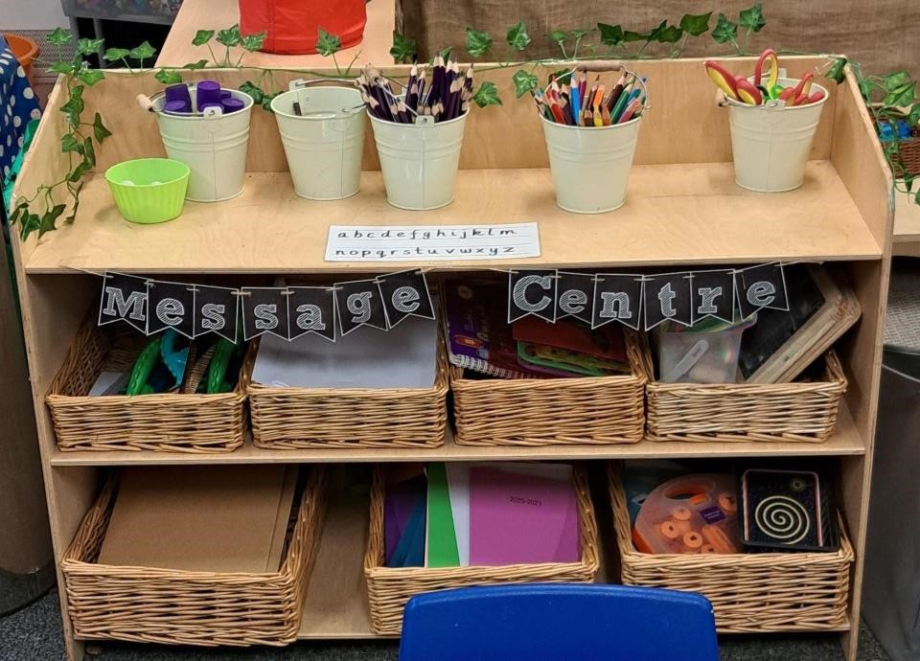

Drawing Club
- Each week in Foundation Stage we have a focus book linked to our Enquiry Question and school driver (Geography or History)
- We introduce up to 8 key vocabulary words linked to the story. Book talk is modelled at the beginning of each session alongside either a book, eBook, animation or piece of music.
- Each word has an action and simple definition to help us remember the word. Visuals such as Widgit are used to provide additional support.
- We complete Drawing Club across 5 sessions:

Day 1 – Character
Day 2 – Setting
Day 3,4 and 5 – Adventure Time

- The children are encouraged to add detail to their drawings and explain to the adults what they have drawn. The adult scribes this next to their pictures.
- We encourage them to use symbols and introduce writing letters, words, and tricky words they are ready.
- By the end of the year, they will be drawing pictures and writing captions and short sentences.
- Words do not have to be spelt correctly, just phonetically plausible.

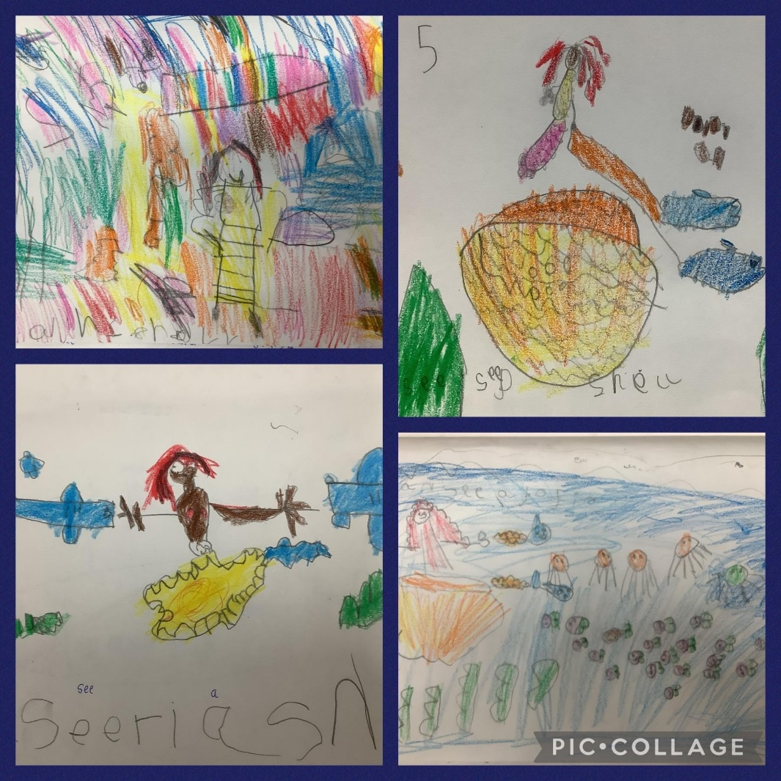
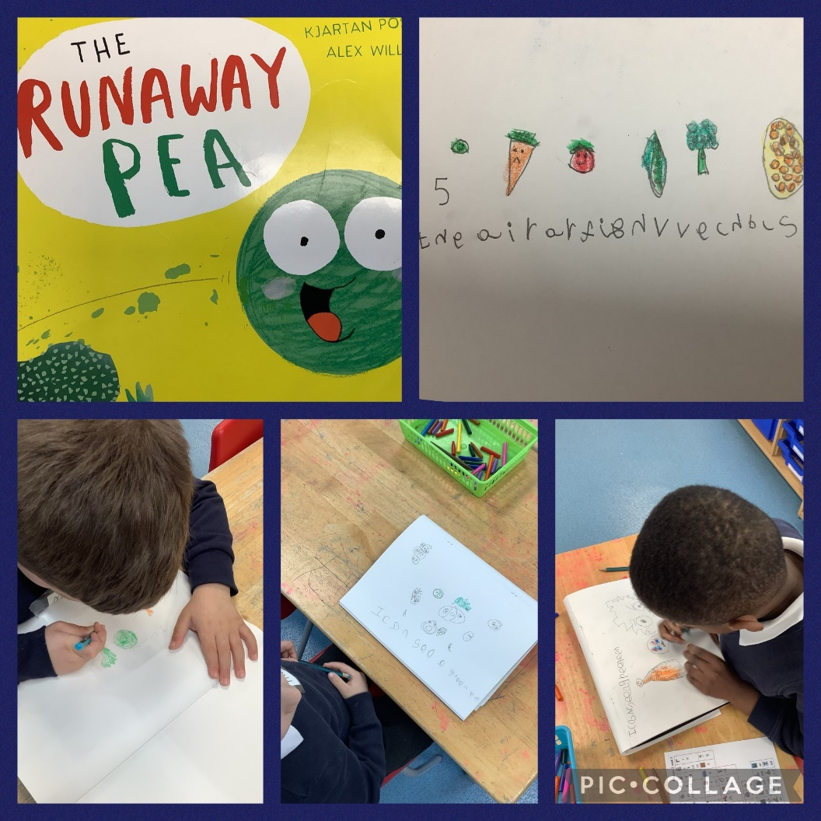

Pencil Grips
• According to their stage of development, children progress through stages of pencil grips. They will only be ready to grip a pencil in the most efficient grip (image 4) once they have developed the fine motor strength to do so. By the end of FS2 most children will be using a tripod pencil grip.
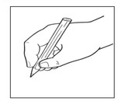
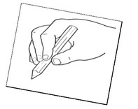
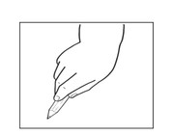
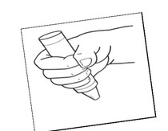

How to hold a pencil
- Put the pen or pencil in front of your child with the nib facing them.
- Encourage them to pick up the pencil, in their preferred hand, with their fingers.
- Flip it back and grip it.
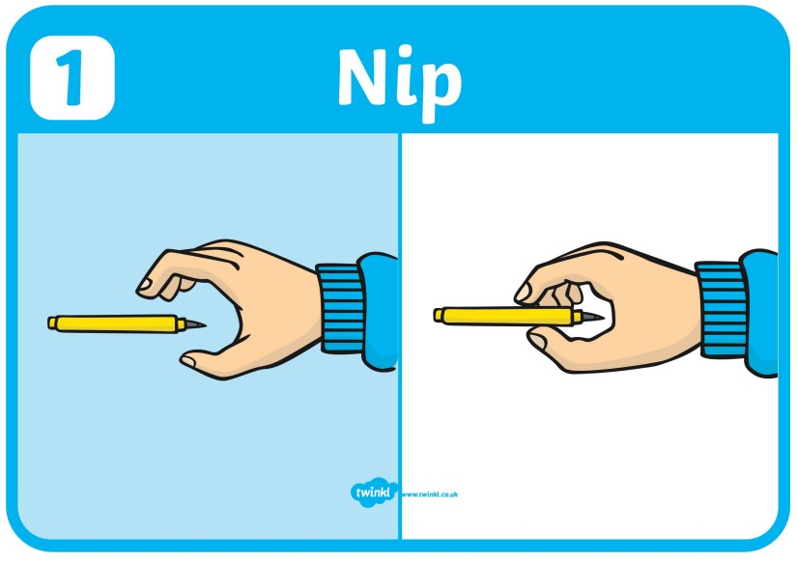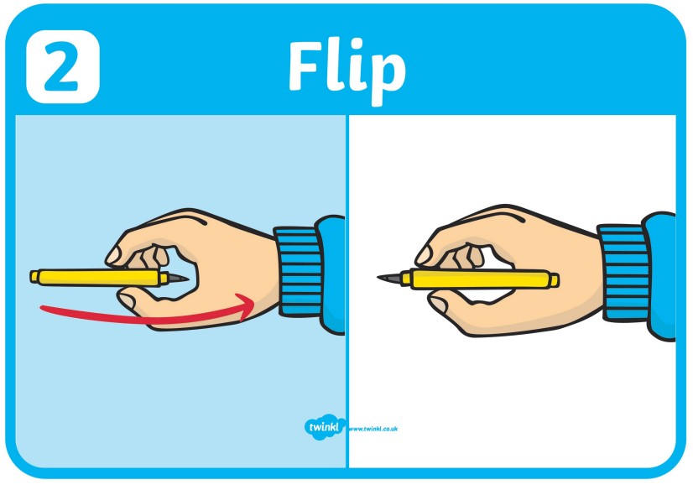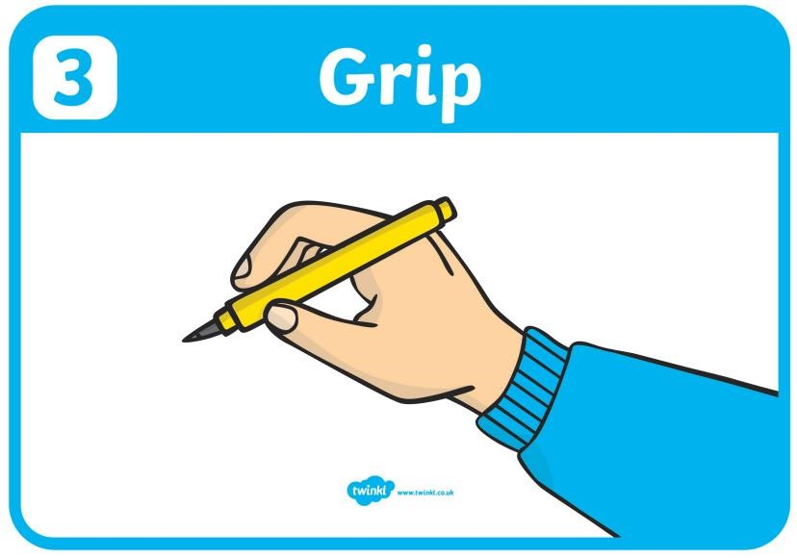

Letter Formation
- It is important that your child is encouraged to hold a pencil correctly with the thumb and forefinger pinching the pencil and the third finger supporting underneath. Most children by now will automatically use their dominant hand but some may swap between right and left.
- Left handed children will find it helpful to sit slightly at an angle to the table and have their page also at an angle to see their writing.
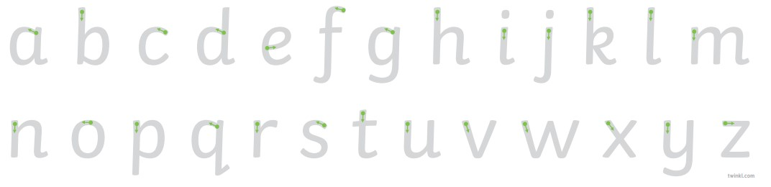

Early Learning Goals
Children at the expected level of development will:

Fine Motor Skills
- Hold a pencil effectively in preparation for fluent writing – using the tripod grip in almost all cases.
- Begin to show accuracy and care when drawing.

Writing
- Write recognisable letters, most of which are correctly formed.
- Spell words by identifying sounds in them and representing the sounds with a letter or letters.
- Write simple phrases and sentences that can be read by others.

How to help at home
- Get messaging! Leave symbols around the house, in your child’s bed, in their shoes, in their lunchbox! Send messages from their favourite toys e.g. a teddy, superhero etc. and encourage them to message back.
- Look for symbols and letters whilst you are out and about, what do they mean?
- Get creative with mark making – use chalk, paint, mud, water, glitter, shaving foam, the possibilities are endless!
- When they are ready encourage them to form letters.
- Remember to write words phonetically, this will mean that some words are spelt incorrectly but that is ok! e.g. sinumu (cinema) sosij (sausage)

Supporting your child with writing at home

- Talk about writing
- Model writing (make lists, write letters, invitations, phone numbers)
- Encourage your child to say a word out loud and write down the phonemes (sounds that they hear)
- Pronounce words correctly
- Share definitions (use Google, Google Translate or a dictionary) if a child asks what something means
- Encourage them to use a grapheme mat or resources sent home from school
- Enjoy writing, being creative and using your imagination!

