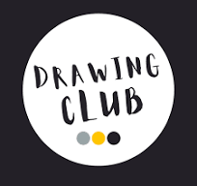
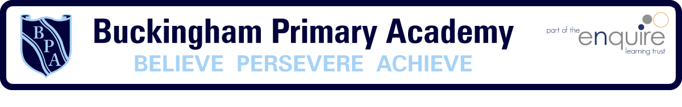
3M’s
Mark Making
Making Conversation
Maths
Drawing Club Approach
Oracy
Vocabulary
Retrieval
I do, We do, You do

Buckingham follows a fortnightly cycle of activities
Week 1 - Drawing Club
Week 2 – Enquiry Time
Continuous Provision – Message Centre
Assessment / retrieval practise / internal and hub moderation / deep dives

