
Buckingham Primary Academy Geography on a Page
Our Key Threads:

Chronology
Significance



Location
Our Curriculum:






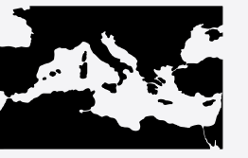



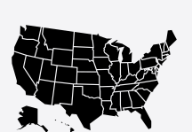



Will you ever see the water you drink again?

Is World Trade always fair?

Why do we love to be by the seaside?

Where would you prefer to live: Hull in England or Harare in Zimbabwe?
What will we see on our journey around the UK?

Why can’t a meerkat live in the North Pole?

What skills do astronauts need?

Who am I?
How has the fishing industry shaped Hull?

Why are rainforests the oldest ecosystem?

Why do you think that so many people go to the Mediterranean for their holiday?

What makes the Earth angry?

Would you prefer to live in London or Hull?

What is so special about the USA?

Our Approach:

Time zones
Geographical vocabulary
Informed Responses
Main Events
Chronological Framework
Compass directions
Hemisphere


Communicate Geographically

Compare and contrast
Ask and answer questions
Fieldwork
Continents and countries
Study Location
Understand Chronology
Connections and Links
Similarities and Differences
significance
Map work

