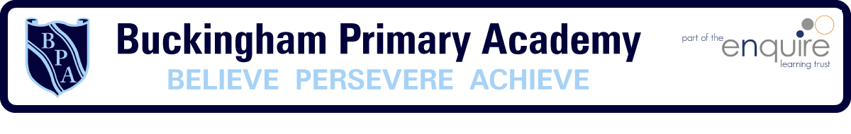
Phonics Approach
Vocabulary
Grapheme
Phoneme
Digraph
Trigraph
Blend / Sweep
Grapheme Mat
Non-Negotiables
- Phonics is taught daily
- Strategies are embedded across the school
- Grapheme mats and resources are to be consistently used and clearly displayed
- Children should be sitting in rows facing the teacher “Eyes on Me”
- Little Wandle resources to be used – additional resources must be on cream card
- Correct terminology and vocabulary to be used
- Planning and sequencing to be followed and printed out
- “How to Videos” and training modules to be used to support CPD
Phonics Program
Little Wandle Letters and Sounds Revised systematic synthetic Phonics program validated by the DfE

