

Long Term Plan Enquiry Question, Text Coverage with Writing Purpose Progression and poetry.
EYFS – “writing outcome” will change yearly to suit the interests of the cohort.
Autumn  (9 Weeks) | Autumn  (9 Weeks) | Spring  (9 Weeks) | Summer  (9 Weeks)
Who Are We?  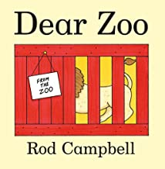  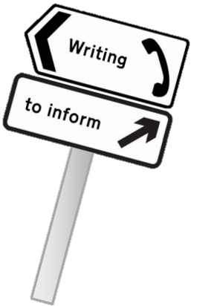  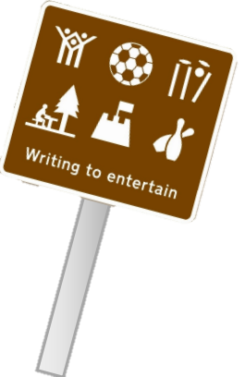 | Where Do We Fit In Our World?  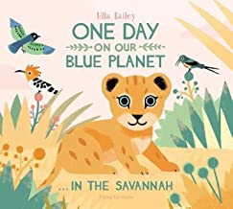  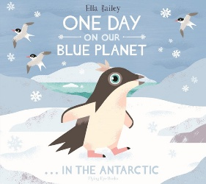 | What Skills Do Astronauts Need?  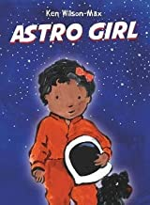  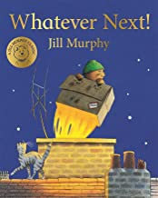 | What Is a Traditional Tale?  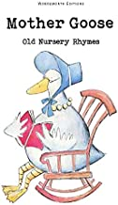  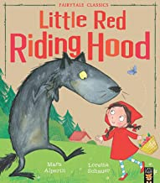

Year 1

Autumn 1  (9 Weeks) | Autumn 2  (9 Weeks) | Spring 1  (9 Weeks) | Summer 1  (9 Weeks)
Why can’t a Meerkat live in the North Pole?  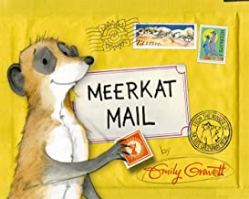  Writing Piece 1:  Sentence work  Writing Piece 2:  Postcard  Writing Piece 3:  Fact file | What impact did Florence Nightingale have?  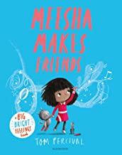  Writing Piece 1:  Character description  Writing Piece 2:  Instruction writing  Writing Piece 3:  Recount  Rhyming Poem | What will we see on our journey around the UK?  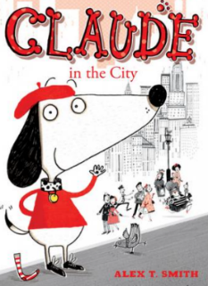  Writing Piece 1:  Wanted poster  Writing Piece 2:  Description  Writing Piece 3:  Retelling a section of the story | What has changed over the last 100 years?  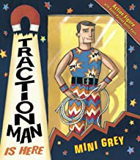  Writing Piece 1:  Diary entry  Writing Piece 2:  Simple letter  Writing Piece 3:  Retelling the story  Acrostic Poem

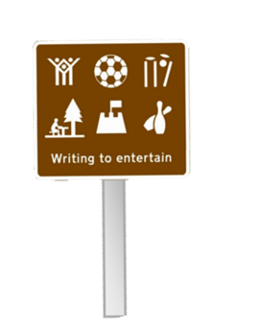
Year 2
Autumn 1  (9 Weeks) | Autumn 2  (9 Weeks) | Spring 1  (9 Weeks) | Summer 1  (9 Weeks)
Where would you prefer to live England or Africa?  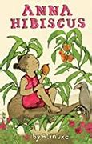  Writing Piece 1:  Setting description  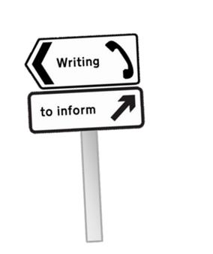  Writing Piece 2:  Character description  Writing Piece 3:  Informal letter | Why was the Fire of London so Great?  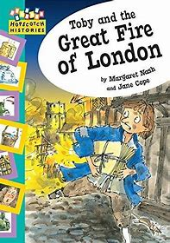  Writing Piece 1:  Recount  Writing Piece : 2  Explanation of events  Extra pieces – Letter to Father Christmas and writing an invitation to the nativity  Concrete Poem | Why do we love to be by the seaside?  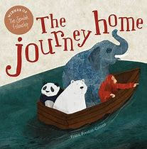  Writing Piece 1:  internal monologue  Writing Piece 2:  Narrative – story opening  Writing Piece 3:  Fact file about an animal  humorous Poem | Why was Neil Armstrong a brave person?  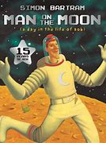  Writing Piece 1:  Letter  Writing Piece 2:  Fact file – Neil Armstrong  Writing Piece 3:  Narrative – including speech

Year 3

Autumn 1  (9 Weeks) | Autumn 2  (9 Weeks) | Spring 1  (9 Weeks) | Summer 1  (9 Weeks)
What makes the Earth angry?  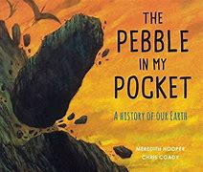  Writing Piece 1:  Setting description  Free verse Poem  Writing Piece 2:  Explanation text  Writing Piece 3:  Book review | Do you think Mary Anning was a heroine or villain?  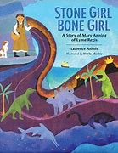  Writing Piece 1:  Narrative – including dialogue  Writing Piece 2:  Non chronological report  Writing Piece 3:  Diary | Why do so many people choose to go to the Mediterranean for their holidays?  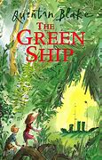  Writing Piece 1:  informal letter  Writing Piece 2:  Nonsense poem  recount  Writing Piece 3:  persuasive advert | Who first lived in Britain?  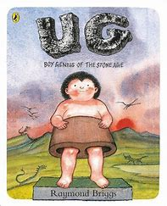  Writing Piece 1:  Narrative  Writing Piece 2:  Fact file of prehistoric animals  Writing Piece 3:  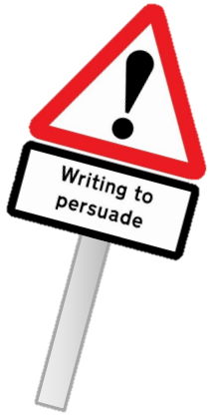  Instructions

Year 4
Autumn 1  (9 Weeks) | Autumn 2  (9 Weeks) | Spring 1  (9 Weeks) | Summer 1  (9 Weeks)
Why are rainforests the oldest ecosystem?  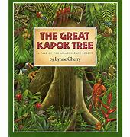  Writing Piece 1:  Setting description  Haiku Poem  Writing Piece 2:  Letter of complaint  Writing Piece 3:  Explanation text - Rainforest | Did the Ancient Greeks do much for our Modern World?  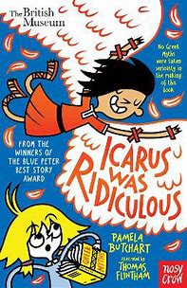  Writing Piece 1:  Narrative – including dialogue  Writing Piece 2:  Non chronological report    Writing Piece 3:  Historical Fiction | Would you prefer to live in London or Hull?  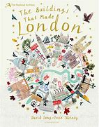  Writing Piece 1:  Kenning Poem  Fact file  Writing Piece 2:  Postcards  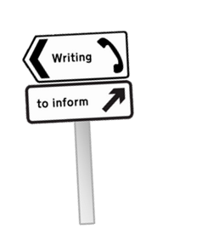  Writing Piece 3:  Formal letter | Why was Boudicca so powerful and what did we learn from her?  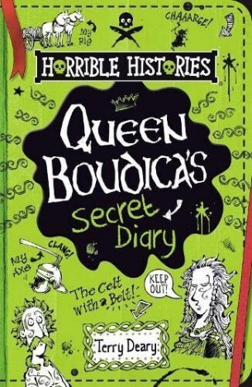  Writing Piece 1:  Story opening  Writing Piece 2:  Newspaper report  Writing Piece 3:  Recount

Year 5

Autumn 1  (9 Weeks) | Autumn 2  (9 Weeks) | Spring 1  (9 Weeks) | Summer 1  (9 Weeks)
What is so special about the USA?  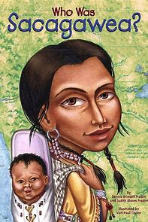  Writing Piece 1:  Lymerick Poem  Setting description  Writing Piece 2:  Non chronological report about Sacagawea  Writing Piece 3:  Explanation text - tipis | Who were the Anglo Saxons?  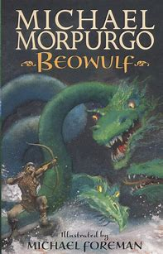  Writing Piece 1:  Fictional Narrative – (Use Saga of Ragnor for inspiration)  Writing Piece 2:  Newspaper report  Writing Piece 3:  Character description | How has the fishing industry shaped Hull?  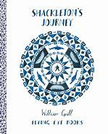  Writing Piece 1:  Sonnet Poem  Information Text  Writing Piece 2:  Persuasive debate – should they or shouldn’t they go to sea  Writing Piece 3:  Poetry | Why should gunpowder, treason and plot never be forgotten?  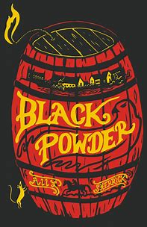  Writing Piece 1:  Historical fiction – suspense story  Writing Piece 2:  Formal letter  Writing Piece 3:  Autobiography – Guy Fawkes

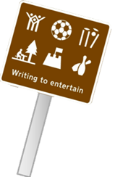

Year 6
Autumn 1  (9 Weeks) | Autumn 2  (9 Weeks) | Spring 1  (9 Weeks) | Summer 1  (9 Weeks)
Will you ever see the water you drink again?  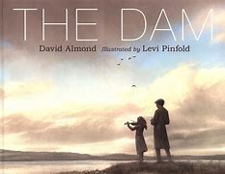  Writing Piece 1:  Setting description  Writing Piece 2:  Balanced Argument  Writing Piece 3:  Internal monologue  Ode Poem  Writing Piece 4:  Formal letter | How did Britain change as a result of WWII? 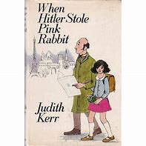  Writing Piece 1:  Historical Narrative – (Use Nazi Germany Train Station)  Narrative Poem  Writing Piece 2:  Biography  Writing Piece 3:  Piano – emotive writing | Is World Trade always fair?  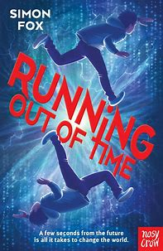  Writing Piece 1:  Diary entry  Writing Piece 2:  Narrative  Writing Piece 3:  Mystery narrative | Were the Mayan’s Unique?  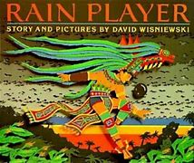  Writing Piece 1:  Explanation text – Mayans / Hieroglyphics  Writing Piece 2:  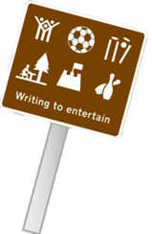  Informal letter - How to cope in year 6 to the year 5’s

