
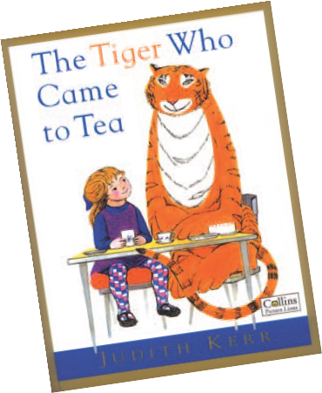
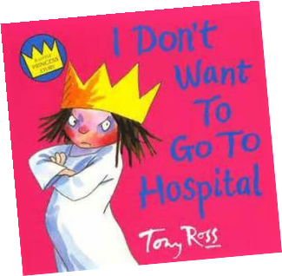
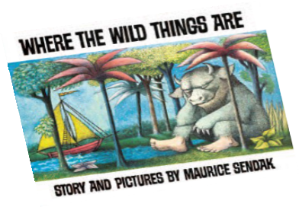

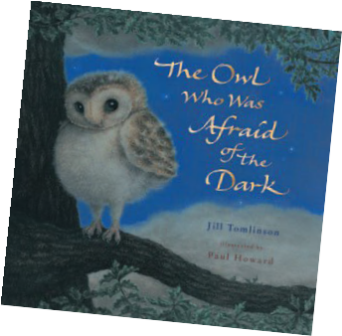
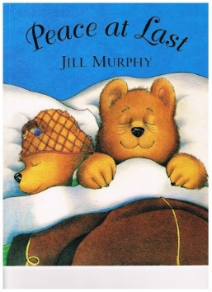
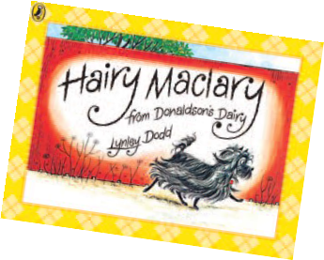
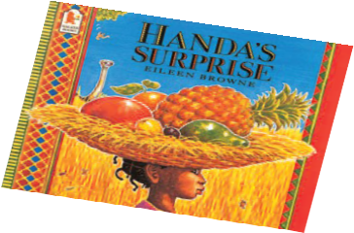
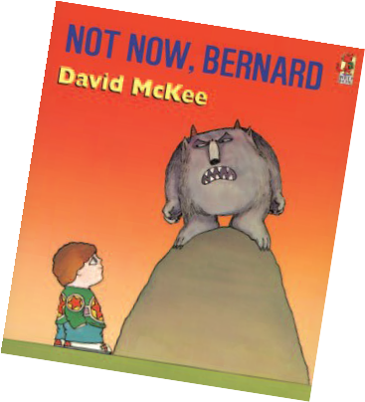
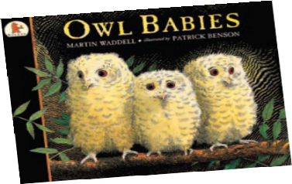
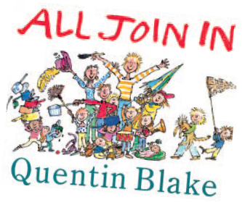
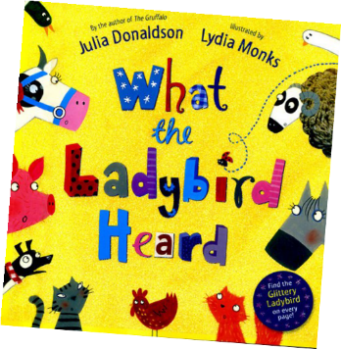
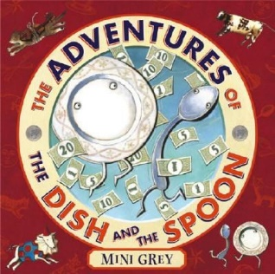

Year 1 Information Leaflet for Parents
Has your child
read these books?
Fun ide a s to he lp yo ur c hild ma k e progres s i n Englis h:
- Make a character profile of their favourite book characters.
- Provide opportunities to talk and write about fun experiences.
E.g. a visit to the farm, a holiday, baking...
- Play word games such as ‘word tennis’.
- Make sock puppets to act out a favourite story.
Ke y Term i nol og y: letter, capital letter, word, singular, plural, sentence, punctuation, full stop, question mark, exclamation mark.
Writing Targets
Transcription
Add the prefix –un.
Add -s and -es to words.
Add the endings –ing, –ed and –er to verbs where no change is needed to the root word. Add –er and –est to adjectives where no change is needed to the root word.
Spell words ending –y.
Spell words containing –tch (for example catch, fetch, kitchen).
Spell the /v/ sound at the end of words (for example have, live, give).
Use new consonant spellings ph and wh (for example alphabet, dolphin, elephant). Use k for the /k/ sound (for example sketch, kit).
Spell compound words (for example football, playground). Spell common exception words.

Handwriting
Form lower-case letters correctly (correct direction, start/finish in the right place). Form capital letters that can sometimes be distinguished from lower case.
Form digits 0-9.
Begin to demonstrate consistent and correct pencil grip.
Leave spaces between letters and (finger) between words.

Composition
Say what they are going to write about. Say a sentence aloud before writing it. Form short narratives.
Sequence sentences to form short narratives. Discuss own writing.
Re-read writing to check that it makes sense.

Vocabulary, Grammar and Punctuation
Use spaces to separate words.
Begin to punctuate sentences using a full stop, question mark or exclamation mark. Use a capital letter for start of sentence, names, personal pronoun I.
Understand what a sentence is.
Join words and sentences using and. Sequence sentences to form short narratives. Understand what a noun is.
Use regular plurals with ‘-s’, ‘-es’, endings Use nouns with ‘-er’
Use third-person singular ‘-s’
Use simple past tense correctly: ‘-ed’.

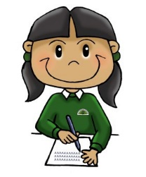
What you can do at home
Reading
•

•

•

•

•
Read books regularly
together
Talk about the parts you both most enjoyed
Ask them to point to words they recognise
Talk with them about how words and illustrations work together in what they read
Point out words in the world, for example, road signs, shop names, building names
Reading Targets
Word Reading
Speedily match correct sound/s to graphemes for all 40+ phonemes.
Blend sounds in unfamiliar words containing sound/letter matches that have been taught. Read year 1 tricky words noticing unusual matches between spelling and sound.
Read regular words containing sound/letter matches that have been taught and –s, –es,
–ing, –ed, –er and –est endings.
Read words of more than one syllable that contain sound/letter matches that have been taught.
Read words with contractions [for example, I’m, I’ll] and understand that the apostrophe represents the missing letter(s),
Read reasonably quickly and accurately words that have been seen often before.
Read aloud books, at the matching phonics level, which only require the use of phonic strategies, showing fluency and confidence in word reading.

Comprehension
Listen to and discuss a wide range of poems, stories and non-fiction at a level beyond what can be read independently.
Link what they read or hear read to their own experiences.
Become very familiar with key stories such as fairy stories and traditional tales. Retell key stories such as fairy stories and traditional tales.
Consider the particular characteristics of fairy stories and traditional tales. Recognise and join in with predictable phrases.
Appreciate rhymes and poems. Recite rhymes and poems by heart.
Spoken Language Targets

Listen to a wide range of poems, stories and non-fiction, which cannot be read
independently.
Listen to a book and clearly explain understanding.
Participate in a discussion about what has been read aloud by taking turns and listening to what others say.
Say words aloud before writing them. Compose a sentence orally before writing it.
Recognise sentence boundaries in spoken sentences. Discuss the significance of the title and events (of a book). Discuss own writing with the teacher or other pupils.
Use and understand the grammatical terminology when discussing own writing. Recite some rhymes and poems by heart.
Read aloud own writing clearly enough to be heard by their peers and the teacher.

to help your child make progress
Speaking and listening
•

•

•

•

•
Listen attentively to what
they say and respond
Help sustain their talk by prompting, asking questions and repeating
Encourage imaginative play by taking a role yourself
Point out and talk about
how different people speak
Storytelling

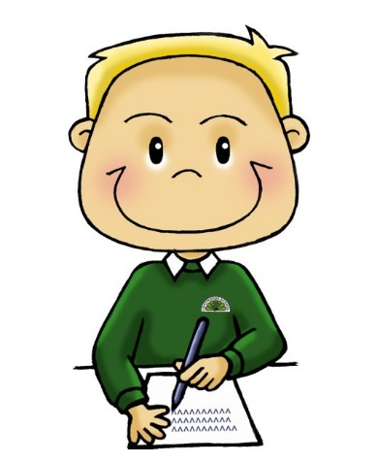
Writing
•

•

•

•
Encourage them to have
fun with writing, for example, drawing cartoons and writing captions or speech bubbles
Write with them, prompting them with suggestions when they are stuck
Take an interest in what
they write, for example, ask them to read their writing aloud to you and respond
to it
Help them reflect on their writing, for example, what they were pleased with, how they might develop or
improve it

