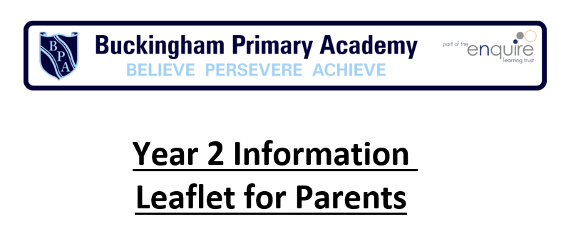

Fun ide a s to he lp yo ur c hild ma k e progres s i n Englis h:
- Design a poster to persuade your friends to read your favourite book
- Make reading real—read newspapers (www.firstnews.co.uk), magazines, leaflets, signs at museums etc...
- Leave messages for each other on post-its or fridge magnets.
Writing Targets
Transcription
Use and spell contractions correctly (for example hasn’t can’t). Use the possessive apostrophe (singular nouns).
Use and spell homophones and near-homophones correctly (for example their/there, quite/quiet).
Use the /dʒ/ sound spelt as ge and dge at the end of words, and sometimes spelt as g elsewhere in words before e, i and y (for example badge, age, gem).
Use the /l/ or /əl/ sound spelt –le, -el and –al at the end of words (for example apple, bottle, tunnel, pedal).
Spell words ending –il.
Spell the /aɪ/ sound spelt –y at the end of words. Adding –es to nouns and verbs ending in –y.
Add –ed, –ing, –er and –est to a root word correctly Spell words ending in –tion.
Use the suffixes –ment, –ness, –ful , –less and –ly correctly. Spell the /i:/ sound spelt –ey.
Spell the /s/ sound spelt c before e, i and y (for example ice, cell).
Spell the /n/ sound spelt kn and (less often) gn at the beginning of words (for example knee, gnat).
Spell the /r/ sound spelt wr at the beginning of words (for example written, wrote). Spell the /ɔ:/ sound spelt a before l and ll (for example all, ball).
Spell the /ʌ/ sound spelt o (for example mother, brother). Spell the /ɒ/ sound spelt a after w and qu.
Spell the /ɜ:/ sound spelt or after w. Spell the /ɔ:/ sound spelt ar after w. Spell the /ʒ/ sound spelt s.
Spell common exception words.
Handwriting
Use clear letter formation (letters generally correctly shaped - may be inconsistent). Ensure that capital letters and digits correct size, orientation and relationship to other letters (upper and lower case).
Use correct spacing between words.
Use some diagonal and horizontal strokes to join letters. Understand which letters (together) are best left unjoined.
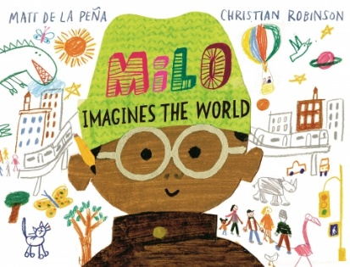
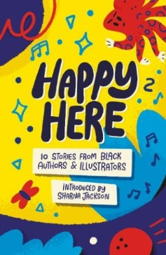
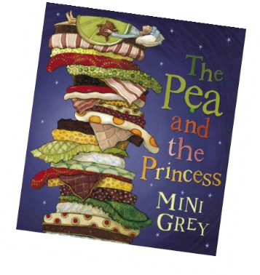
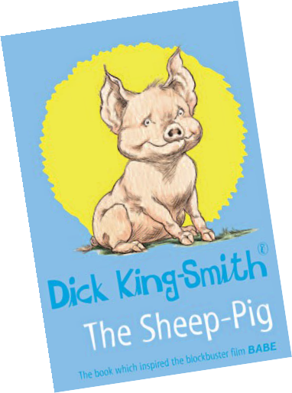
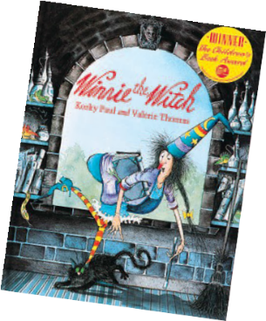
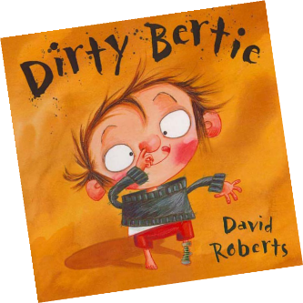
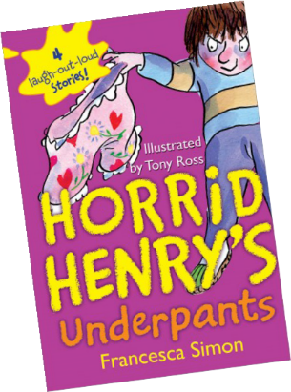
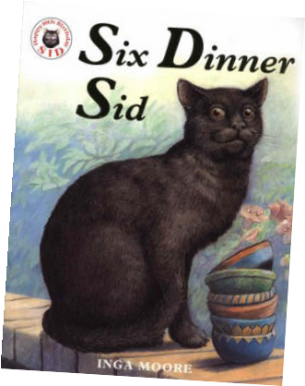

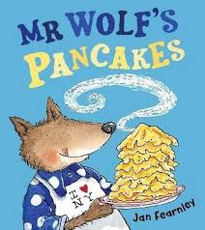
Has your child
read these books?
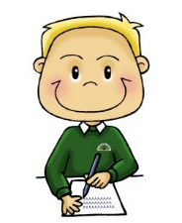
Reading
•

•

•
read books together,
reading a section in turn, and talk about what happened, how the pictures support the story and which parts they liked best
encourage them to choose books independently encourage them to decode
unfamiliar words
independently, but prompt them if they lose the gist of what they’re reading
Key Terminology: noun, noun phrase, statement, question, exclamation, command, compound, suffix, adjective, adverb, verb, tense (past, present), apostrophe, comma.
Spoken Language Targets
Listen to books and ask and answer relevant questions.
Demonstrate understanding by listening to books and asking and answering relevant
questions.
Listen to, or read independently, a range of books, poems and other material. Explain and discuss understanding of a range of books, poems and other material.
Discuss and clarify the meanings of words, linking new meanings to known vocabulary. Participate in discussions about a range of texts and books, which have been read aloud or read independently, by taking turns and listening to what others say.
Use and understand the grammatical terminology when discussing own writing. Read aloud own writing with appropriate intonation to make the meaning clear. Learn how to use some features of written Standard English.
Learn a range of poems by heart and recite some with appropriate intonation to make the
meaning clear.
Show an appreciation for poems learnt by heart.

W hat you c a n do a t home
Writing Targets Continued
Composition
Plan/talk about ideas for writing.
Write down ideas and key words, including new vocabulary.
Verbalise sentence by sentence before writing in order to plan what to say. Evaluate writing with support.
Re-read writing to check for correct use of time verbs and verbs in the continuous form. Proof-read to check for errors in spelling, grammar and punctuation.
Vocabulary, Grammar and Punctuation
Use spaces that reflect the size of the letters. Use capital letters correctly.
Use full stops correctly.
Use question marks confidently.
Use exclamation marks confidently. Use commas to separate items in lists. Use apostrophes for contractions.
Use a range of suffixes in writing (for example ’-ment’, ‘-ness’, ‘-ful’, ‘-less’).
Use and understand statements, questions, exclamations and commands in sentences. Use subordination to add detail to sentences (for example when, if, that, because).
Use coordination to add detail to sentences (for example or, and, but).
Use expanded noun phrases for description (for example the blue butterfly). Use possessive apostrophes for singular nouns.
Use correct and consistent use of past and present tense. Use progressive form of verbs in the past and present tense. Add suffix ‘-ly’ to an adjective to form an adverb.

to help your child make progress
Writing
•

•

•
encourage writing in play
and what they do, for example, lists for shopping, record the results for their favourite sports team
engage with their writing through saying what you liked in it, asking where their ideas have come from and asking them to show you where a sentence begins and ends
help them to organise and sequence their writing by asking them to talk about their ideas or to draw a sequence of simple pictures to show how the main events in a story might be organised
Speaking and listening
- talk with them about their ideas, for example, when painting or modelling
ask them to retell simple stories in their own words
- encourage their play in
- different roles
- listen together to stories on CDs, radio or television

Reading Targets
Word Reading
Use phonics to read words until reading is fluent and automatic. Blend the sounds in words that contain the graphemes.
Recognise alternative sounds for graphemes.
Read year 2 tricky words, noticing unusual matches between spelling and sound. Read words containing common word endings.
Read words of two or more syllables that contain sound/letter matches that have been taught.
Read quickly and accurately words that have been seen often before.
Read aloud books, at the matching phonics level, which only require the use of phonic strategies, showing fluency and confidence in word reading.
Comprehension
Listen to, discuss and express views about a wide range of poetry (including contemporary and classic), stories and non-fiction at a level beyond that they can read independently.
Discuss the sequence of events in books and how items of information are related. Introduce to non-fiction books that are structured in different ways.
Become familiar with and retell a wider range of stories, fairy stories and traditional tales.
Recognise simple recurring literary language in stories and poetry. Build up a repertoire of poems learnt by heart and appreciate these. Recite some, with appropriate intonation to make the meaning clear.
Draw on what they already know or on background information and vocabulary provided by the teacher.
Check that the text makes sense to them as they read and correct inaccurate reading. Make inferences on the basis of what is being said and done.
Answer and ask questions.
Predict what might happen on the basis of what has been read so far.

