
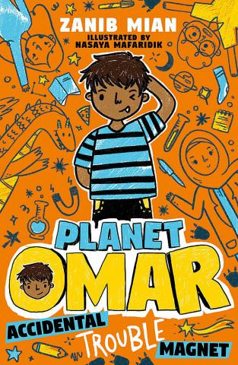
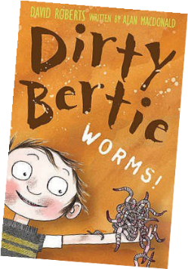
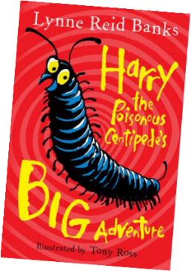
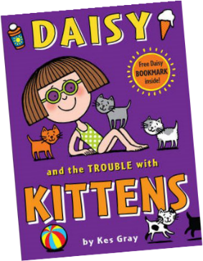
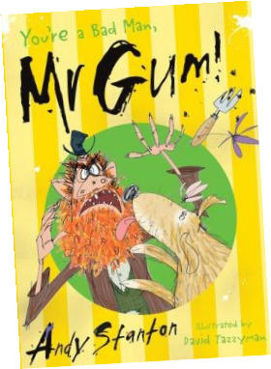
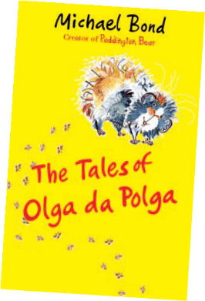
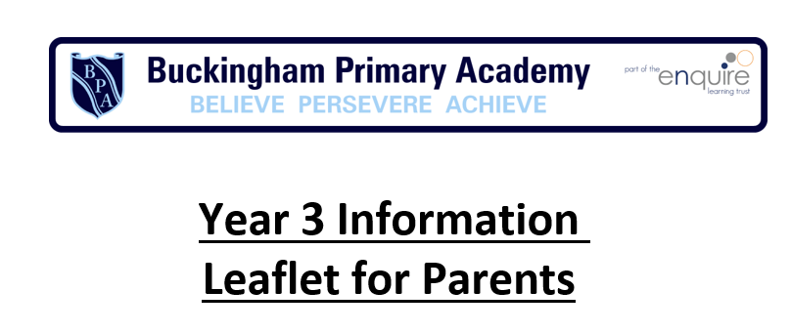

•
Fun ide a s to he lp yo ur c hild ma k e progres s i n Englis h:
Play paper and pencil games such as Call My Bluff, Hangman and Categories.
•

•
Setting up a pin board or magnetic board for display, messages,
certificates, postcards etc... Is a great way to be creative about being organised.
Try turning a part of your book into a play script. You could even act it out!

Has your child read these books?
Writing Targets
Transcription
Spell words of Greek origin which contain the /k/ sound spelt ch (for example scheme, chorus, chemist, echo).
Spell words containing a variety fo prefixes (for example mis, dis, ill, un, in, im, re, sub, inter, super, anti, auto, ir).
Add suffixes beginning with a vowel letters to words of more than one syllable (for example
forgetting, forgotten, beginning, beginner).
Add the suffix –ly to an adjective to form adverb (for example sadly, completely).
Spell words with endings that end like -sure or –ture (for example creature, furniture, treasure, pleasure).
Spell words with endings ei, eigh or ey (for example vein, weigh, neighbour, they).
Handwriting
Shape letters correctly (sometimes inconsistently). Increase the legibility and quality of handwriting.
Ensure that downward strokes of letters are parallel and equidistant. Space lines of writing efficiently (ascenders and descenders do not touch). Composition
Identify structure, vocabulary and grammar in a variety of different texts. Discuss and record ideas for writing.
Compose and rehearse sentences orally using a range of sentence structures. Create settings, characters and plot in narratives.
Organise paragraphs around a theme.
Use simple organisational devices for non-fiction texts (for example headings and sub-headings). Suggest improvements to own and others’ writing.
Suggest changes to grammar and vocabulary including the accurate use of pronouns. Proof-read for spelling and punctuation errors.
Read own writing aloud with appropriate intonation and volume to make the meaning clear.
Vocabulary, Grammar and Punctuation
Begin to use inverted commas and other punctuation to indicate direct speech. Begin to use possessive apostrophes for plural nouns.
Use a comma after fronted adverbial.
Spell word families based on common words (for example solve, solution, solver, dissolve, insoluble). Begin to use paragraphs.
Use headings and subheadings.
Use words that express time and cause (for example when, so, before, after, while, because). Use conjunctions confidently to combine clauses.
Form nouns with prefixes.
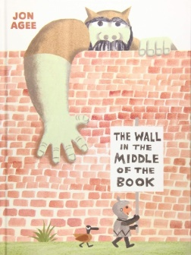
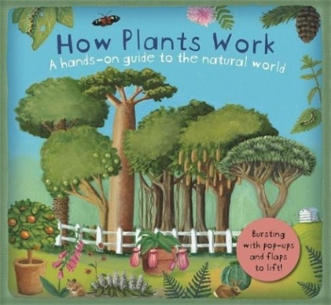

Writing Targets Continued
Choose appropriate noun or pronoun to avoid repetition.
Use the forms –a and –an accurately.
Use possessive apostrophe with plural words.
Use present perfect form of verbs instead of the simple past. Use correct present perfect tense instead of simple past.
Introduce/revise adverbs.
Express time and cause (for example then, next, soon).
Use fronted adverbials (for example later that day, I heard the good news). Choose appropriate adjectives.
Use other prepositions which are useful for writing (for example before, after, during, in, because of).
Spoken Language Targets Continued
Discuss words and phrases that capture the reader’s interest and imagination. Participate in discussions about books that have been read aloud and those that have been read independently, taking turns and listening to what others say.
Become more familiar with using language in a greater variety of situations, for a variety of audiences and purposes, including through drama, formal presentations and debate. Increase familiarity with a wide range of books, including fairy stories, myths and legends, and retelling some of these orally.
Prepare poems and play scripts to read aloud and to perform, showing understanding through intonation, tone, volume and action.


What you can do at home
Ke y Term i nol og y: preposition, conjunction, word family, prefix, clause, subordinate clause, direct speech, consonant, consonant letter, vowel, vowel letter, inverted commas (speech marks).
Reading Targets
Word Reading
Read year 3 tricky words, noticing unusual matches between spelling and sound.
Use knowledge of root words, prefixes and suffixes taught in year 3, to help read words aloud and to understand their meaning.
Comprehension
Listen to and discuss a wide range of fiction, poetry, plays, non-fiction and reference books or textbooks.
Read books that are structured in different ways. Read for a range of purposes.
Use dictionaries to check the meaning of words.
Increase familiarity with a wide range of books, including fairy stories, myths and legends.
Retell a wide range of books, including fairy stories, myths and legends. Identify themes and conventions in a wide range of books.
Discuss words and phrases that capture the reader’s interest and imagination. Prepare poems and play scripts to read aloud and to perform.
Show understanding through intonation, tone, volume and action. Recognise some different forms of poetry (e.g. Free verse, narrative poetry). Check that the text makes sense to them, discussing their understanding.
Explain the meaning of words in context.
Identify main ideas drawn from more than one paragraph and summarise these.
Draw inferences such as inferring characters' feelings, thoughts and motives from their
actions.
Justify inferences with evidence.
Ask questions to improve their understanding of a text. Predict what might happen from details stated and implied.
Identify how language, structure, and presentation contribute to meaning. Retrieve and record information from non-fiction.
Participate in discussion about both books that are read to them and those they can read for themselves, taking turns and listening to what others say.
to help your child make progress

Speaking and listening
•

•
encourage them to develop their ideas by taking longer turns, adding
detail and thinking about how ideas connect
play listening and guessing games where they have to listen and ask questions, for example, ‘I spy’, ‘20 questions’
encourage them to take different roles when playing in groups

Spoken Language Targets
Listen to and discuss a wide range of fiction, poetry, plays, non-fiction and reference books or textbooks
Ask questions independently to improve understanding of a text.
Begin to develop, agree on, and evaluate rules for effective discussion so that all pupils take part.
Discuss similar texts prior to writing in order to understand and learn from its structure, vocabulary and grammar.
Listen to and discuss a wide range of fiction, poetry, plays, non-fiction and reference books or textbooks.
Reading
•

•

•
engage with what they read by
asking them to predict what will happen next in a story, describe their response when they know what does happen, explain why a character behaves as they do, point to particular parts of a text that they like and talk about what a text suggests or implies
talk with them about their likes and dislikes in what they read
encourage them to read a range of texts, for example, fiction and information books, comics and poems
Writing
•

•

•
encourage them to write
more, for example, a shopping list, a plan for a party or family celebration, a story that they can email to grandparents
talk with them about how they might improve or rephrase sections, for example, by including more descriptive detail, varying the way they open sentences or using connectives (such as ‘and’, ‘but’) to combine sentences
help them to organise their writing into sections or paragraphs, e.g. beginning middle and end or sections of writing with subheadings

