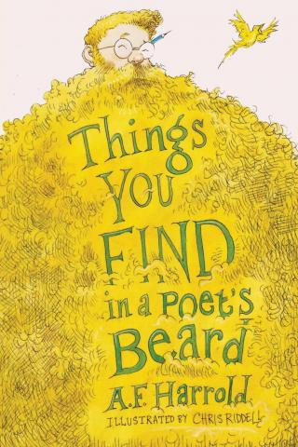
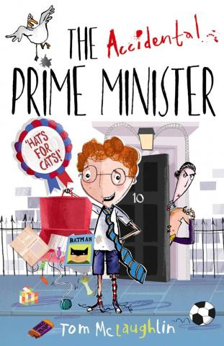

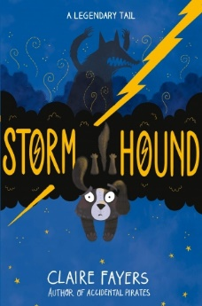
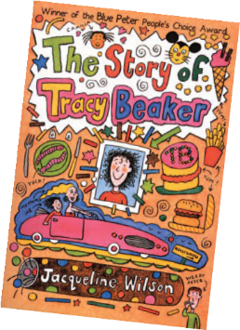
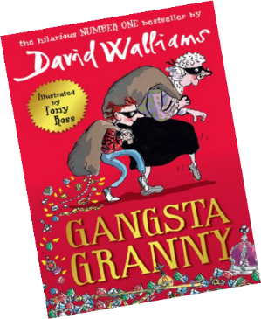
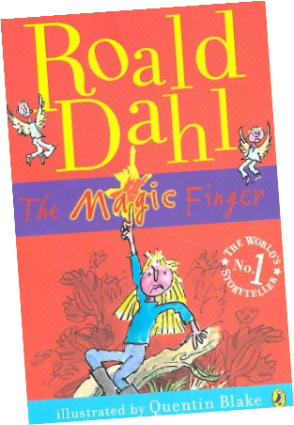
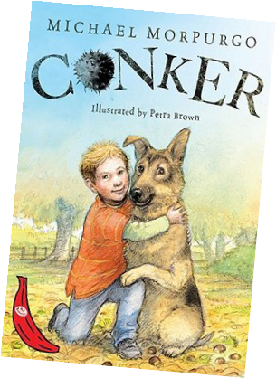
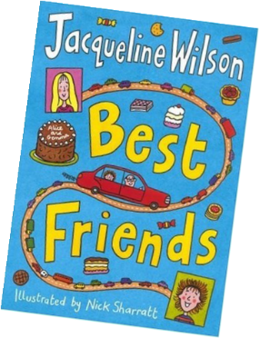
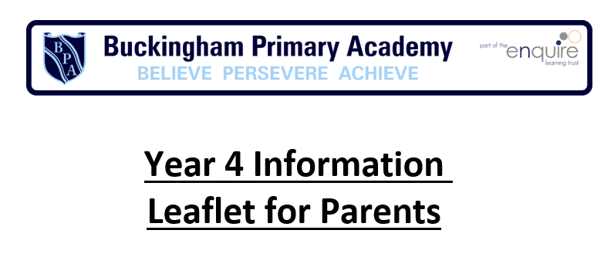


Has your child read these books?
Fun ide a s to he lp yo ur c hild ma k e progres s i n Englis h:
- Visit your local library—there are regular events and activities throughout the year.
- Read and write instructions or recipes for creative activities and cooking.
- Play word games like scrabble and boggle.
- E-books can make reading feel hi-tech!
- Make up book quizzes.
Wr iting Targ ets
Transcription
Use possessive apostrophe with plural words (for example babies’, children’s, men’s - note: singular proper nouns ending in an s use the ‘s’ suffix e.g. Cyprus’s population).
Spell words of French origin with ch (for example chef, chalet, machine).
Spell words of French origin ending with the /g/ sound spelt –gue and the /k/ sound spelt –que (for example league, antique).
Spell words of Latin origin with the /s/ sound spelt sc (for example discipline, fascinate).
Spell and use correctly homophones and near-homophones (affect/effect, ball/bawl, berry/bury). Spell words containing the suffix –ation.
Spell words which have endings that sound like –sion. Spell words with endings spelt –tion, -sion, -ssion, -cian.
Spell words containing y elsewhere than at the end of words (for example myth, gym, Egypt). Spell words containing the sound spelt ou (for example touch, country).
Handwriting
Use accurate and consistent letter formation
Form and shape letters consistently and correctly.
Use diagonal and horizontal strokes used to join letters. Demonstrate a legible style.
Understand which letters are best left unjoined when adjacent to each other.
Composition
Identify structure, vocabulary and grammar in a variety of different texts. Discuss and record ideas for writing.
Compose and rehearse sentences orally using a range of sentence structures.
Create settings, characters and plot in narratives. Organise paragraphs around a theme.
Use simple organisational devices for non-fiction texts (for example headings and sub-headings). Suggest improvements to own and others’ writing.
Suggest changes to grammar and vocabulary including the accurate use of pronouns. Proof-read for spelling and punctuation errors.
Read own writing aloud with appropriate intonation and volume to make the meaning clear.


Writing
•

•

•
ask them to tell you what are the best
features of their writing
discuss possible improvements, for example, how to include more detail, vary the pace of a story, or rephrase a sentence
help them to use their reading to support them as writers, for example, ask them to look at how a writer they like uses varied sentences or
organises paragraphs
Key Terminology: determiner, pronoun, possessive pronoun, adverbial.
Writing Targets Continued
Vocabulary, Grammar and Punctuation
Indicate direct speech by using inverted commas and other punctuation.
Use apostrophe to mark singular and plural possession. Use plural and possessive ‘-s’.
Organise paragraphs around a theme.
Choose appropriate noun or pronoun to aid cohesion and avoid repetition.
Expand noun phrases by adding modifying adjectives, nouns and prepositional phrases (for example: The strict teacher... becomes The strict maths teacher with curly hair...).
Use standard English forms for verb inflections instead of local spoken forms.
Use forms for verb inflections instead of spoken forms (We were not/ we was/I did not/ I done). Use a wider range of conjunctions.
Understand what an adverbial phrase is.
Use fronted adverbials (for example: Later that day, I heard the good news).
Use a comma after fronted adverbial.
Spoke n La nguage Targe ts Continue d
Listen to and discuss a wide range of fiction, poetry, plays, non-fiction and reference books or
textbooks.
Discuss words and phrases that capture the reader’s interest and imagination.
Participate in discussions about books that have been read aloud and those that have been read independently, taking turns and listening to what others say.
Presenting and performing using Standard English
Become more confident in using language in a greater variety of situations, for a variety of audiences and purposes, including through drama, formal presentations and debate.
Increase familiarity with a wide range of books, including fairy stories, myths and legends, and retelling some of these orally.
Prepare poems and play scripts to read aloud and to perform, showing understanding through
intonation, tone, volume and action.
W hat you c a n do a t home
Reading Targets
Word Reading:
Read year 4 tricky words, noticing unusual matches between spelling and sound.
Use knowledge of root words, prefixes and suffixes taught in year 4, to help read words aloud and to understand their meaning.
Comprehension:
Listen to and discuss a wide range of fiction, poetry, plays, non-fiction and reference books or textbooks.
Read books that are structured in different ways.
Read for a range of purposes.
Use dictionaries to check the meaning of words.
Increase familiarity with a wide range of books, including fairy stories, myths and legends. Retell a wide range of books, including fairy stories, myths and legends.
Identify themes and conventions in a wide range of books.
Discuss words and phrases that capture the reader’s interest and imagination. Prepare poems and play scripts to read aloud and to perform.
Show understanding through intonation, tone, volume and action. Recognise some different forms of poetry (e.g. Free verse, narrative poetry) Check that the text makes sense to them, discussing their understanding. Explain the meaning of words in context.
Identify main ideas drawn from more than one paragraph and summarise these.
Draw inferences such as inferring characters' feelings, thoughts and motives from their actions. Justify inferences with evidence.
Ask questions to improve their understanding of a text. Predict what might happen from details stated and implied.
Identify how language, structure, and presentation contribute to meaning. Retrieve and record information from non-fiction.
Participate in discussion about both books that are read to them and those they can read for themselves, taking turns and listening to what others say.
to he lp your c hild ma k e progres s

Speaking and listening
•

•

•
encourage them to talk clearly and at length about their ideas listen to and talk about
things that are not immediately familiar, such as items on the news
play memory games, taking turns to answer questions about a story or film they’ve listened to
encourage them to take on specific roles in their social life, for example, in a sports team, after school club

Spoken Language Targets
Spoken Language: Listening
Listen to and discuss a wide range of fiction, poetry, plays, non-fiction and reference books or textbooks.
Discussing, exploring ideas, gaining understanding and responding. Ask questions to improve understanding of a text.
Develop, agree on, and evaluate rules for effective discussion so that all pupils take part.
Discuss similar texts prior to writing in order to understand and learn from its structure, vocabulary and grammar.
Reading
•

•

•

•
help them to think about the writer
behind the text, for example: why they chose the language they did? why they organised the text in that way? what effect they hoped to have on the reader?
when looking for information in print or on-screen, encourage them to scan ahead and think about how helpful the text is, whether it is a biased or reliable source
when they talk about their reading encourage them to refer to evidence in the text that will support their views
get them to share their opinions in
different ways, for example, blogging, social networking site contributions

