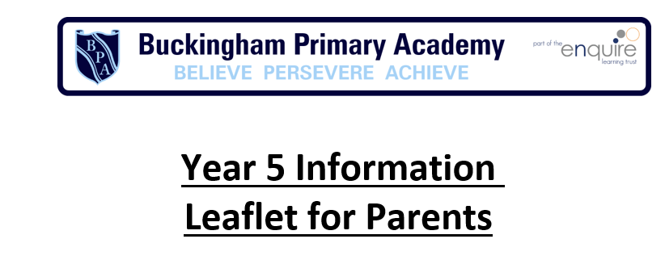
Reading
give them regular opportunities to make their own choices in what they read at
home, for example, visits to the library, magazines that cover out of school interests
- encourage them to develop their response to a text in more detail, for example, ask them to tell you how their feelings towards a character changed at different points in a story
- talk with them about the writer’s choice of language, for example, ask them to choose a section they think is good and explain why they think it works well
Key Terminology: modal verb, rela- tive pronoun, relative clause, parenthe- sis, bracket, dash, cohesion, ambiguity.
Wr iting Targ ets
Transcription
Spell homophones and other words that are often confused (for example Licence/license, practice/ practise)
Spell words ending in – cious or –tious.
Spell correctly words ending in –cial or –tial.
Spell words ending in –able and –ible.
Spell words with ei after c.
Spell words with the letter string ough.
Handwriting
Form and shape letters correctly and consistently. Use diagonal and horizontal joins in cursive script.
Distinguish which letters are left unjoined and apply this consistently in writing.
Composition
Identify the correct audience and purpose and select the appropriate form in note taking and writing. Understand how authors have developed characters and settings in narratives.
Select appropriate grammar and vocabulary, understanding how such choices can change and en- hance meaning in narratives (for example to describe settings, characters, develop atmosphere and use dialogue to enhance character and action).
Use a range of techniques for paragraph cohesion.
Organise and present writing to guide the reader (for example headings, bullet points, underlining). Précise longer passages.
Propose changes to vocabulary, grammar and punctuation to enhance effects and clarify meaning. Use consistent and correct use of tense.
Use correct subject and verb agreement when using singular and plural, formal and informal. Assess the effectiveness of own and others’ writing.
Proof-read for spelling and punctuation errors.
Perform own compositions, using appropriate intonation, volume, and movement so that meaning is
clear.
Vocabulary, Grammar and Punctuation
Use brackets, dashes or commas to mark parenthesis. Use commas to clarify meaning or avoid ambiguity. Begin to use hyphens.
Use bullet points correctly.
Convert nouns and adjectives into verbs using suffixes (‘-ate’, ‘-ise’, ‘-ify’). Use prefixes for verbs (‘dis-‘, ‘de-‘, ‘mis-‘, ‘over-‘, ‘re-‘).
Learn how words are related by meaning as synonyms and antonyms (for example big, large, little). Structure paragraphs confidently.
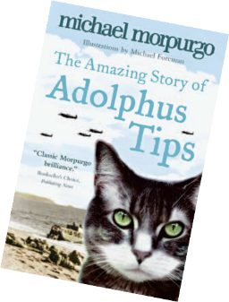

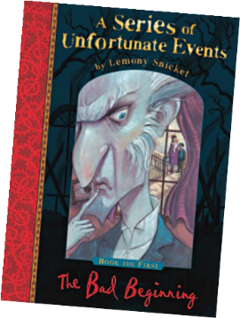


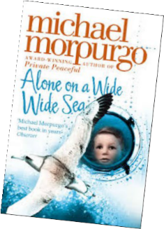
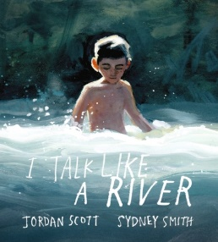
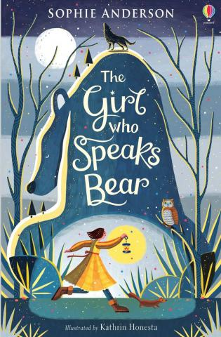
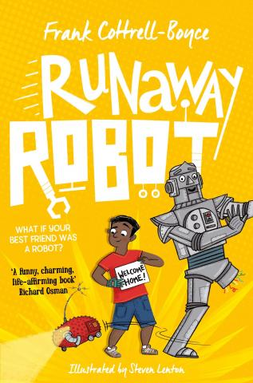
Fun ideas to help your child make progress in English:
•
Children may like to keep a Favourite Book journal which can have lists of titles,
quotations, pictures and sketches to encourage children to look back at what they’ve read.
•
Play around with anagrams to help with patterns and spelling, e.g. make as many
words as you can out of Constantinople (1697 apparently!).
•
Challenge your child to write a story in 500 words.
•
Encourage them to make up their own crossword puzzles or word searches
for friends and family to develop vocabulary and dictionary skills.
Bananagrams is great for this too.
•
If you have younger children then encourage your child to read to and with
them.
Has your child
read these books?

Writing Targets Continued
Use devices to build cohesion in a paragraph (for example then, after, than, firstly). Use relative clauses beginning with who, which, where, why, whose, that.
Understand the differences between formal and informal language. Use passive and active voice.
Use structures of formal and informal language (such as subjunctive forms). Locate and identify expanded noun phrases.
Use expanded noun phrases to convey complicated information concisely. Use passive verbs to affect the presentation of information in a sentence. Indicate degrees of possibility with modal verbs.
Use correct subject -verb agreement and consistent use of tense.
Use adverbials of time, place and number to link across paragraphs (for example later, nearby, secondly. Or tense choices He had seen her before).

Reading Targets
Use knowledge of root words, prefixes and suffixes taught in year 5, to help read words aloud and to understand their meaning.
Continue to read and discuss an increasingly wide range of fiction, poetry, plays, non-fiction and reference books or textbooks.
Read books that are structured in different ways. Read for a range of purposes.
Make comparisons within and across books.
Increase familiarity with a wider range of books including modern fiction, fiction from our literary heritage, and books from other cultures and traditions.
Identify and discuss themes and conventions in and across a wide range of writing. Recommend books that they have read to their peers, giving reasons for their choices. Prepare poems and play scripts to read aloud and to perform
Show understanding through intonation, tone, volume so that the meaning is clear to an audience.
Learn a wider range of poetry by heart.
In most reading:
Check that the book makes sense to them, discussing their understanding Explore the meaning of words in context
Summarise the main ideas drawn from more than one paragraph Identify key details that support the main ideas
Draw inferences and justify these with evidence from the text.
Ask questions to improve their understanding of what they have read. Predict what might happen from details stated and implied.
Identify how language, structure, and presentation contribute to meaning.
Discuss and evaluate how authors use language, including figurative language, considering the impact on the reader.
Distinguish between statements of fact and opinion. Retrieve, record and present information from non-fiction.
Participate in discussions about books that are read to them and those they can read for themselves, building on their own and others’ ideas and challenging views courteously. Explain and discuss their understanding of what they have read, including through formal
presentations and debates, maintaining a focus on the topic and using notes where necessary.
Provide reasoned justifications for their views.


What you can do at home
Writing
•

•

•

•
encourage their personal writing, for
example, a journal or diary, a blog
talk through their ideas with them before they start to write, fore example, prompt them to think about how they intend to tackle a subject
help them to reflect on their writing, particularly the effect they hoped to have on the reader, for example, is the reader sufficiently prepared for the ending?
encourage them to read through their
work, shaping their sentences for clarity and impact and checking their
accuracy.
Spoken Language Targets
Spoken Language: Listening
Listen to and learn new vocabulary and grammatical structures. Discussing, exploring ideas, gaining understanding and responding Ask questions to improve understanding.
Recommend books that have been read to peers, giving reasons for choices.
Explain and discuss understanding of what has been read, including through formal presentations and debates, maintaining a focus on the topic and using notes where necessary.
Continue to read and discuss an increasingly wide range of fiction, poetry, plays, non-fiction and reference books or textbooks.
Identify and discuss themes and conventions in, and across, a wide range of writing.
Participate in discussions about books that have been read aloud and those that have been read independently, building on own and others’ ideas and challenging views courteously.
Presenting and performing using Standard English
Understand nuances in vocabulary choice and age-appropriate, academic vocabulary.
(nuance = A subtle difference in or shade of meaning, expression, or sound).
Prepare poems and plays to read aloud and to perform, showing understanding through intonation, tone and volume so that the meaning is clear to an audience.
Take part in formal presentations and debates.
Recognise vocabulary and structures that are appropriate for formal speech and writing, including
subjunctive forms.
(subjunctive = verb used to indicate or suggest mood)
Demonstrate confidence and mastery of language through public speaking, performance and debate.

to help your child make progress
Speaking and listening
- find opportunities for them to talk at length about increasingly complicated ideas and situations, for example, explain an experiment they have done in science or a topical subject such as cyber bullying
- help them take more account of the listener’s reaction when speaking, for example, when telling a story to a younger sibling making it exciting
- encourage them to listen and express their opinions about local and national issues in the news

