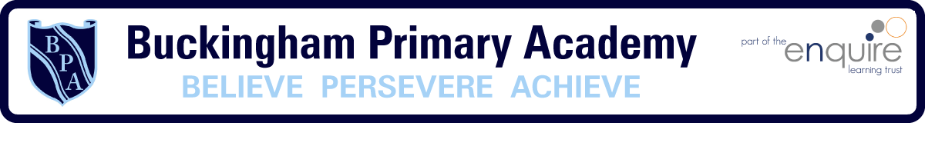

Buckingham Primary Academy – Art and Design

At Buckingham Primary Academy, we want to our children to be engaged, inspired and challenged through their art and design lessons. Our children are offered a range of experiences and opportunities through which they can explore, build upon and make connections with other subjects. We do not want our Art and Design curriculum to focus solely upon the finished product.
We offer the children the opportunities to learn about a different artist, architect and designer each year which gives a greater knowledge of the historical and cultural development of art and design. Children will learn skills to enable them to produce creative work in the forms of drawing, painting, sculpture and other design techniques. The children are able to celebrate their creations through a ‘Showcase’ of their learning and through displays around the school.
Along with the teaching of Art and Design, we offer a dedicated termly ‘Art and design Week’. We believe that by dedicating this time, children are able to look carefully and develop a broader understanding of the subject, knowledge and skills and allows them to make 3d links across the curriculum with vertical and horizontal links.

