Long Term Plan Art and Design and Design and Technology
Foundation Stage
Autumn |  | Spring | Summer
Art | D&T | Art | Art | D&T
Sketching | Cooking | Painting | Making/ sculpting | Textiles
Artist: Vincent Van Gogh  Lessons:  - Vincent Van Gogh appraisal  - Mark making with wax crayons  - Mark making with felt tips  - Mark making with chalk  - Observational pencil drawings  - Drawing Faces  - Drawing faces with colour  - Art Evaluation  Final Piece: Self-portrait  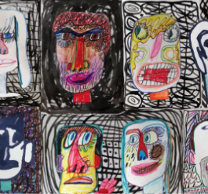 | - use the basic principles of a healthy and varied diet to prepare dishes  - understand where food comes from | Artist: Megan Coyle  Lessons:  - Megan Coyle appraisal  - Finger painting  - Painting to music  - Collage and transient art  - Landscape collage  - Group art  - Art Evaluation  Final Piece: Group firework display  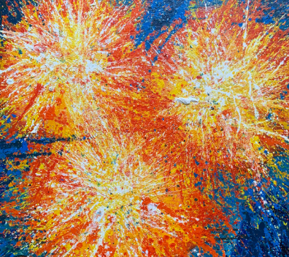 | Artist: Beth Cavener  Lessons:  - Artist’s appraisal  - Clay  - Playdough  - 3D Landscape art  - Designing animal sculptures  - Creating animal sculptures  - Painting animal sculptures  - Evaluation  Final Piece: Clay Animals  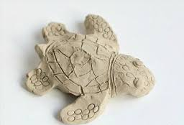 | Lessons:  - Exploring threading and weaving  - Paper weaving  - Sewing and hessian  - Designing bookmarks  - Creating bookmarks  - Evaluation  Final Piece: a fabric bookmark
Autumn |  | Spring | Summer
Art | D&T | Art | Art | D&T
Sketching | Cooking | Painting | Making/ sculpting | Textiles
Artist: Zaria Forman  Lessons:  - Zaria Forman appraisal  - Exploring Line  - Making waves  - Experimenting with media  - Mark making  - Drawing from observation  - Art Evaluation  Final Piece: observation drawing  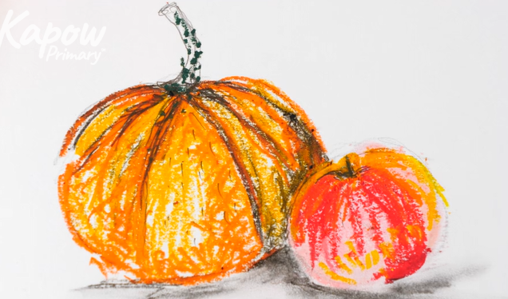 | - use the basic principles of a healthy and varied diet to prepare dishes  - understand where food comes from | Artist: Clarice Cliff  Lessons:  - Clarice Cliff appraisal  - Making colours  - Painting with colour  - Printing with paint  - Exploring colour mixing  - Clarice Cliff plates  - Art Evaluation  Final Piece: Clarice Cliff Plates  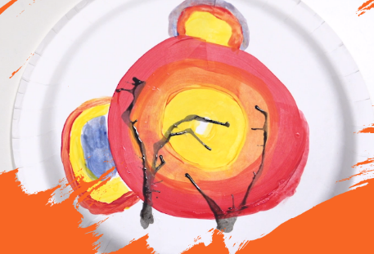 | Artist:  Samantha Stephenson  Lessons:  - Samantha Stephenson appraisal  - Tube towers  - 3D drawings  - Tree of life  - Giant spider model part 1  - Giant spider model part 2  - Evaluation  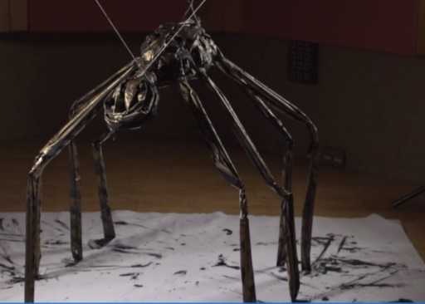  Final Piece: Giant spider sculptures | Lessons:  - Joining fabrics weaving  - Designing a puppet  - Making and joining puppet  - Decorating puppet  - Evaluation  Final Piece: puppet  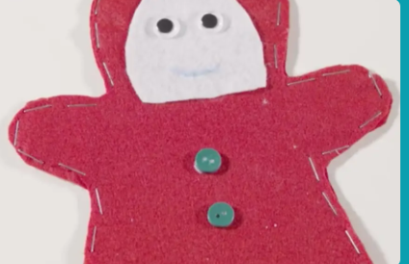
Year 1
Year 2
Autumn |  | Spring | Summer
Art | D&T | Art | Art | D&T
Sketching | Cooking | Painting | Making/ sculpting | Textiles
Artist: Quentin Blake  Lessons:  - Quentin Blake appraisal  - Charcoal markmaking  - Creating texture  - My toy story  - Creating characters  - Tell a story  - Art Evaluation  Final Piece: Story telling drawing  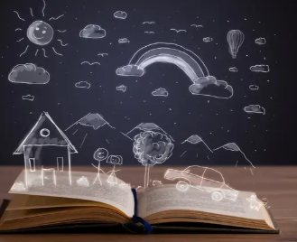 | - use the basic principles of a healthy and varied diet to prepare dishes  - understand where food comes from | Artist: Romare Bearden  Lessons:  - Romare Bearden appraisal  - Colour magic  - Texture Hunt  - Making textures  - Collage creation  - Developing detail  - Art Evaluation  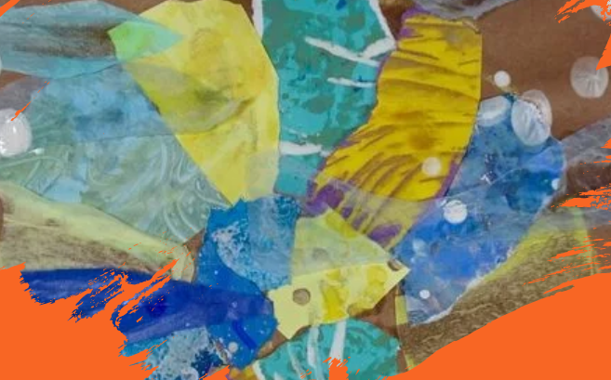  Final Piece: Collage painting | Artist:  Rachel Whiteread  Lessons:  - Rachel Whiteread appraisal  - Exploring clay  - Pinch pots  - Applying skills in clay  - Designing a tile  - House tiles  - Evaluation  Final Piece: Giant spider sculptures  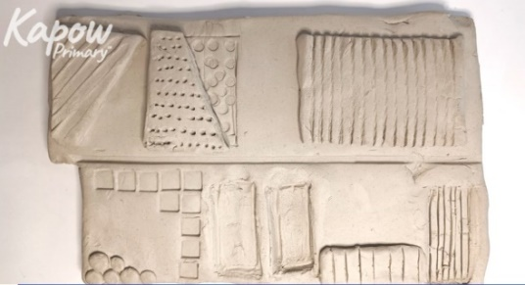 | Lessons:  - Running stitch  - Using a template  - Making a pouch  - Decorating a pouch  - Evaluation  Final Piece: pouch  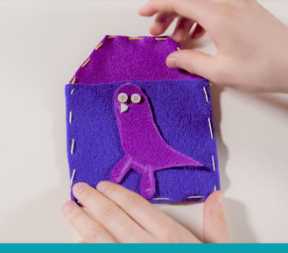

Year 3
Autumn |  | Spring | Summer
Art | D&T | Art | Art | D&T
Sketching | Cooking | Painting | Making/ sculpting | Textiles
Artist: Georgia O’Keeffe  Lessons:  - Georgia O’Keeffe appraisal  - See like an artist  - shading  - Texture pictures  - Botanical drawing  - Abstract flowers  - Art Evaluation  Final Piece: sketch an abstract flower  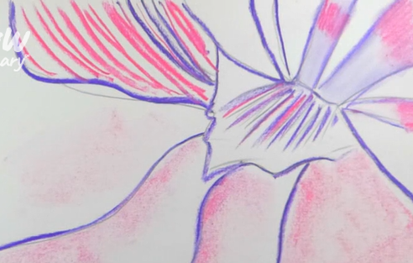 | - understand and apply the principles of a healthy and varied diet  - prepare and cook a variety of predominantly savoury dishes using a range of cooking techniques  - understand seasonality, and know where and how a variety of ingredients are grown, reared, caught and processed. | Artist: n/a  Lessons:  - Exploring prehistoric art  - Charcoal animals  - Prehistoric pallette  - Painting on the cave wall  - Hands on a wall  - Art Evaluation  Final Piece: Cave painting  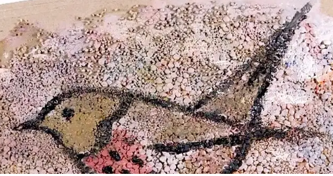 | Artist:  Anthony Caro  Lessons:  - Anthony Caro appraisal  - Structural shapes  - Constructing in 3D  - Seeing space  - Abstract sculpture  - Surface decoration  - Evaluation  Final Piece: 3D sculpture in the style of Anthony Caro  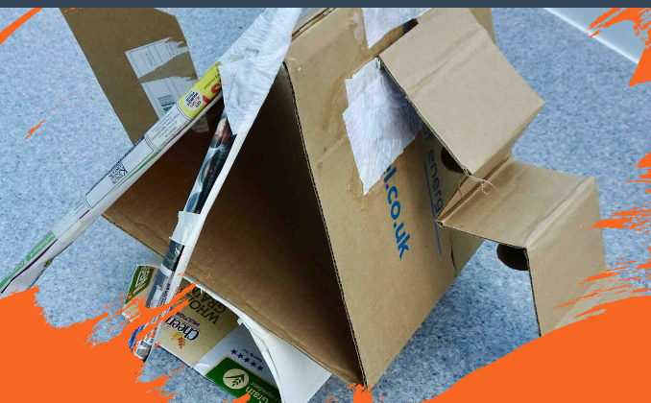 | Lessons:  - Cross-stitch and appliqué  - Cushion design  - Decorating my cushion  - Assembling my cushion  - Evaluation  Final Piece: cushion  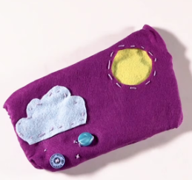

Year 4

Autumn |  | Spring | Summer
Art | D&T | Art | Art | D&T
Sketching | Cooking | Painting | Making/ sculpting | Textiles
Artist: Henry Moore/ Fernando Botero  Lessons:  - Henry Moore appraisal  - 3D pencil drawings  - Sense of proportion  - Drawing with scissors  - Wax resist  - Power prints  - Art Evaluation  Final Piece: create a print from a drawing  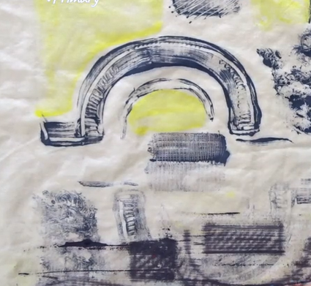 | - understand and apply the principles of a healthy and varied diet  - prepare and cook a variety of predominantly savoury dishes using a range of cooking techniques  - understand seasonality, and know where and how a variety of ingredients are grown, reared, caught and processed. | Artist: Audrey Flack Clara Peters  Lessons:  - Audrey Flack appraisal  - Comparison lesson  - Tints and shades  - Three Dimensions  - Painting techniques  - Composition  - Still Life  - Art Evaluation  Final Piece: Still life painting  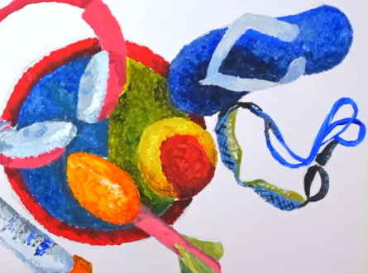 | Artist:  El Anatsui  Lessons:  - El Anatsui appraisal  - From 2D to 3D  - Soap sculptures  - Working with wire  - Shadow sculpture  - Recycle and recreate  - Evaluation  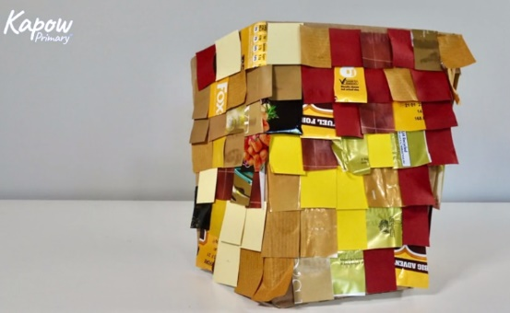  Final Piece: To choose and join a variety of materials to make a sculpture | Lessons:  - Evaluating fastenings  - Designing my book sleeve  - Paper mock-up and preparing fabric  - Assembling book sleeve  - Evaluation  Final Piece: book sleeve

Year 5

Autumn |  | Spring | Summer
Art | D&T | Art | Art | D&T
Sketching | Cooking | Painting | Making/ sculpting | Textiles
Artist: Karen Rose/ Teis Albers  Lessons:  - Karen Rose appraisal  - Space imagery  - Drawing decisions  - Teis Albers  - A vision of the future  - Revisiting ideas  - Art Evaluation  Final Piece: create a sketch in the style of Karen Rose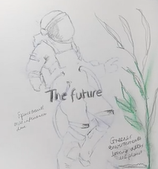 | - understand and apply the principles of a healthy and varied diet  - prepare and cook a variety of predominantly savoury dishes using a range of cooking techniques  - understand seasonality, and know where and how a variety of ingredients are grown, reared, caught and processed. | Artist: Chila Kumari Singh Burman and Frida Kahlo  Lessons:  - Frida Kahlo appraisal  - Comparison lesson  - Poem portrait  - Developing drawings  - Self-portraits  - Changing faces  - Mix Media portraits  - Art Evaluation  Final Piece: Mixed media self-portrait  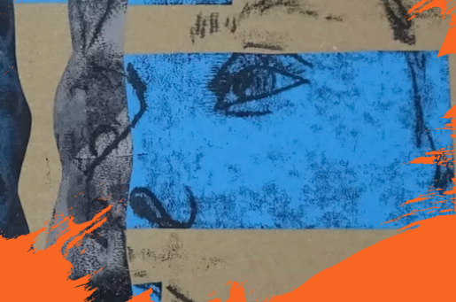 | Artist:  Cai Guo-Qiang  Lessons:  - Cai Guo-Qiang appraisal  - What is installation art?  - Space and scale  - Everyday amazing  - Creative concepts  - Viewer experience  - Evaluation  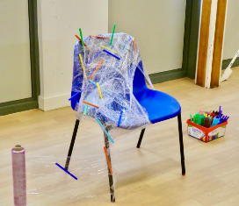  Final Piece: To apply their knowledge of installation art and develop ideas into a finished piece. | Lessons:  - Designing a stuffed toy  - Blanket stitch  - Details and appendages  - Stuffed toy assembly  - Evaluation  Final Piece: stuffed toy  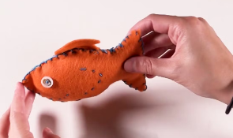

Year 6

Autumn |  | Spring | Summer
Art | D&T | Art | Art | D&T
Sketching | Cooking | Painting | Making/ sculpting | Textiles
Artist: Dan Fenelon/  Diego Rivera/  Leonardo Da Vinci  Lessons:  - Dan Fenelon appraisal  - Comparison  - Experimental mark making  - Symbolic imagery  - Chiaroscuro  - Street Art  - Powerful imagery  - Art Evaluation  Final Piece: create a sketch in the style of Dan Fenelon  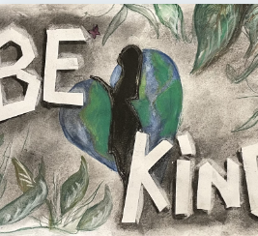 | - understand and apply the principles of a healthy and varied diet  - prepare and cook a variety of predominantly savoury dishes using a range of cooking techniques  - understand seasonality, and know where and how a variety of ingredients are grown, reared, caught and processed. | Artist: David Hockney, Fiona Rae, Paula Rego  Lessons:  - David Hockney appraisal  - Comparison lesson  - David Hockney  - Paula Rego – The Dance  - John Singer Sargent – The Front Line  - Fiona Rae  - Lubaina Himid  - Research and Planning  - Making Art  - Art Evaluation  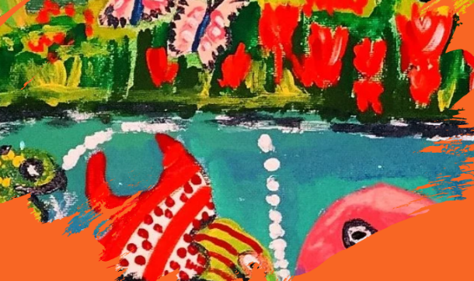  Final Piece: Mixed media self-portrait | Artist:  Louise Nevelson:  - Louise Nevelson appraisal  - Exploring self  - Relief sculptures  - Memory Museum  - Memory sculpture  - Complete and reflect  - Evaluation  Final Piece: create a sculpture depicting a primary school memory  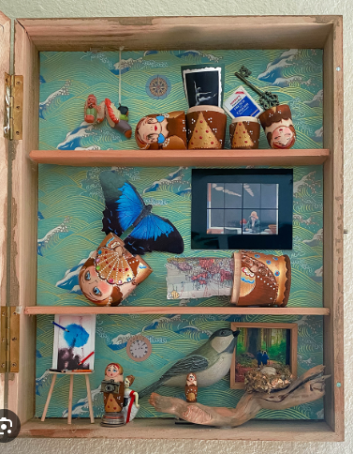 | Lessons:  - Waistcoat design  - Preparing fabric  - Assembling my waistcoat  - Decorating my waistcoat  - Evaluation  Final Piece: waistcoat  