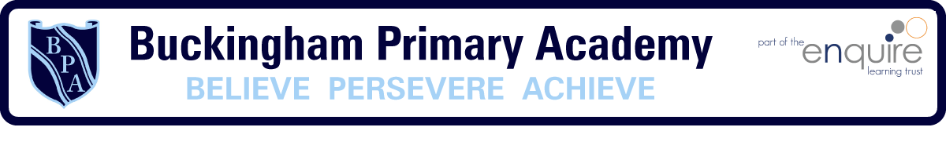

Buckingham Primary Academy - PSHE

Be Respectful, Be Responsible, Be Kind, Be Safe

At Buckingham Primary Academy, we believe that it is vital for all our pupils to develop their character, resilience, confidence and have high aspirations. Children learn how we can establish safe, open and positive learning environments based on trusting relationships between all members of the school community. We encourage our pupils to ask questions about the world, explore its diversity and to reflect on their own beliefs, values and experiences.
We are following the Jigsaw Approach, which allows horizontal and vertical links with previous year groups and encompasses all aspects of PSHE and RSE. This curriculum ‘holds children at its heart, and its cohesive vision helps children understand and value how they fit in and contribute to the world.’ With strong emphasis on emotional literacy, building resilience, perseverance, and nurturing mental and physical health, it delivers engaging and relevant lessons within a whole school approach
At Buckingham Primary Academy, we believe that by developing our pupils’ character, resilience and confidence, we enable them to achieve and develop high aspirations for the future.

