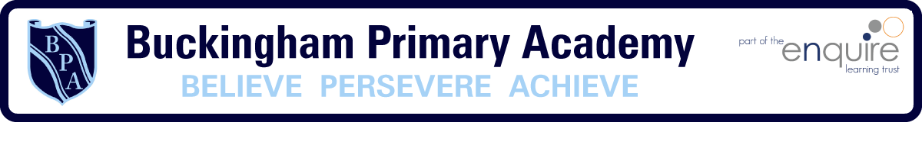

Buckingham Primary Academy - RE

At Buckingham Primary Academy, we believe that it is vital for all our pupils to learn from and about religion, so that they can achieve a broad understanding of the world around them. Through Religious Education, pupils develop their knowledge of the world faiths, and their understanding and awareness of the beliefs, values and traditions of other individuals, societies, communities and cultures. We encourage our pupils to ask questions about the world and to reflect on their own beliefs, values and experiences, which are designed in our 3D curriculum, allowing horizontal and vertical links with previous year groups.
We use a learning challenge concept, which is designed around children taking more involvement with their own learning. It requires belief, perseverance and deep thinking while encouraging learners to work using a question as their starting point to advance their cultural capital.

