At Buckingham Primary Academy, we believe that it is vital for all our pupils to learn from and about Computing and Technology, so that they can understand the world around them. Through teaching computing at Buckingham Primary Academy, we aim to equip our children to participate in a rapidly changing world where work and leisure activities are increasingly transformed by technology. It is our intention to enable children to find, explore, analyse, exchange and present information as well as having the skills to manipulate, develop and interpret different forms of technology in an ever-changing world. In such a fast-moving curriculum, we are constantly looking at new ways of delivering relevant and exciting activities, while still delivering the fundamental skills needed for computing. Perseverance is key in Computing to ensure that pupils do not stop when they come to barrier but work through using the skills they have learnt and ensuring the achieve a high level of success and progression. We encourage our pupils to make links across the curriculum, the world and our local community, to reflect on their own experiences, which are designed in our 3D curriculum, allowing horizontal and vertical links with previous year groups.
Our Computing Curriculum is built around 3 areas: Computer Science, Digital Literacy and Information Technology. At the heart of computing lies computer science, wherein students are instructed in the principles of information and computation, comprehending how digital systems operate and applying this knowledge through programming. This foundation enables students to utilise information technology effectively, creating programs, systems, and diverse content. Additionally, computing ensures the development of digital literacy, empowering students to proficiently use and express themselves through information and communication technology. This prepares them for the future workplace and active engagement in a digital world.
Our ambitious computing curriculum is now organised into three distinct areas, allowing students from Early Years to Year 6 to progress through varying levels of knowledge. Each segment of the curriculum provides students with ample time to practice and internalise the knowledge necessary for proficiency in computing, preparing them for the next stage of learning.

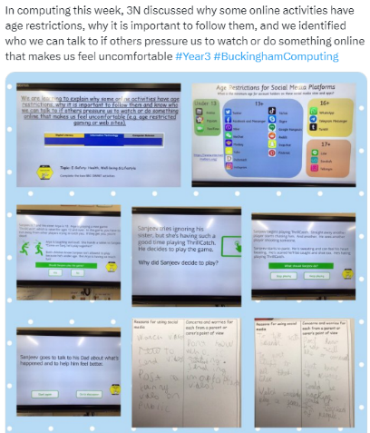
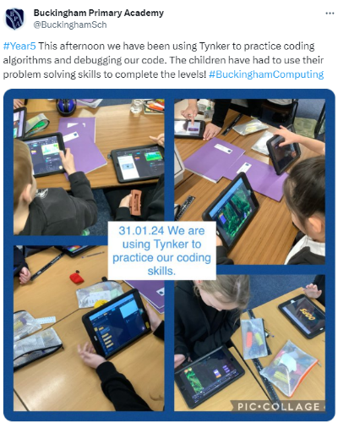
Using technology safely and responsibly is a main priority and ensuring all are able to use the internet and equipment appropriately is of paramount importance. To support with the e-safety aspect of our curriculum teachers follow the project evolve sessions, which are mapped out to ensure progression across the school. Teachers use these lessons at the start of computing sessions which allow classes to visit topic such as: our online presence and rights and responsibilities. To further support with pupils understanding of e-safety, we have a team of 8 ‘Digital Leaders’ from year 6 who are responsible for sharing e-safety scenarios with children weekly and supporting with computing lessons. This allows our pupils to be role models to others and share their knowledge of computing.
