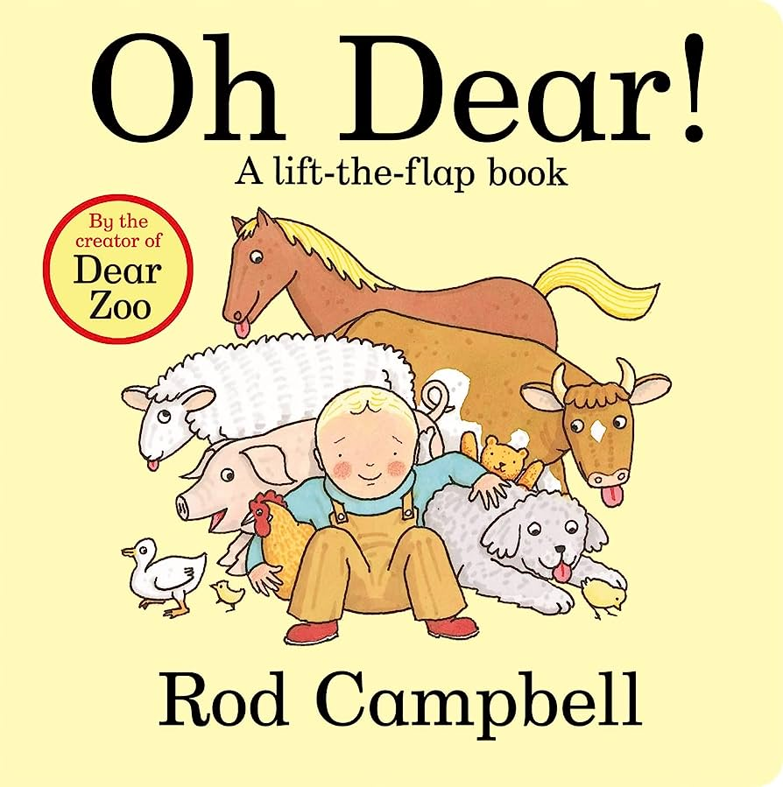

Physical Development

We will be learning to collaborate with others to manage and move large objects especially when playing with the deconstructed role play outside. We will be developing our gross motor skills and large movements. The grownups will encourage us to become more independent as we meet our own care needs including brushing our teeth, using the toilet and washing our hands. We will also have access to a variety of healthy snacks.

EAD

As we choose our learning during continuous provision we will be developing our imaginations and pretend play. Using objects and prompts we will pretend they are familiar objects. We will use a variety of different media and utensils to mark make, draw, paint and create.

Understanding the World

As we explore the immediate world around us we will begin to make sense of our own life-story and our family. As we settle into FS1 we will talk about our homes and families. As we learn about ‘our world’ we will show interest in animals that live on a farm. We will be learning about the different roles of farm animals and will make observations about animals and their babies.

Maths

As we become mathematicians we will be developing understanding of colour as we sort different objects and recognise colours in our environment. We will also be working together to explore pattern and size both in our maths sessions and during provision.

PSED

As we embark on the start of our journey in FS1 we will be developing our confidence in new social situations. We will become more outgoing when meeting the new grownups who will be helping us to learn in our new classroom. As part of our new FS1 family we will be nurturing a sense of self, responsibility and community.

Communication and Language

We will be encouraged to listen and pay attention to more than one thing at a time, this can be super tricky especially when we are busy learning and playing. We will be sharing and listening to longer stories and will try to remember and recall what has happened. We will be encouraged to talk about and share some of our favourite stories, toys and experiences.

Literacy

During our daily phonic sessions we will be developing our phonological awareness. We will be going on listening walks in our environment, beginning to spot and explore rhymes. We will be sharing stories, rhymes and poems throughout the session. We will learn that print in a book carries meaning and may begin to use our fingers to follow the words from left to right on the page as handle different books.

*Who Lives On The Farm?*