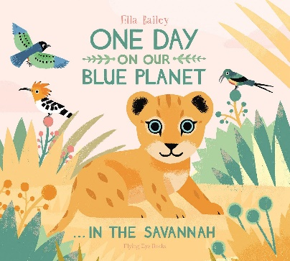

Understanding the World

As we explore the world around us, we will be talking about ourselves, families, and homes. We will be discussing similarities and differences as we highlight what makes us unique. As we learn about the wider world, we will be making observations about contrasting environments, habitats and the amazing animals that live there. As we journey across the seas, we will make comparisons as we discover our blue planet!

Maths

As we become mathematicians, we will be deepening our understanding of numbers to ten. Building on our one-to-one correspondence, numeral recognition and awareness of quantities we will be learning to subitise up to five.

Literacy

During our daily literacy sessions we will be sharing stories, non-fiction books, poems and rhymes. We will be developing our phonic knowledge to begin to decode and read simple words and sentences. We will be focusing on our pencil grip and letter formation as we begin to form recognisable letters. During continuous provision we will have lots of opportunities to access mark making, drawing and writing.

Physical Development

We will be talking about the importance of good health and wellbeing including toothbrushing and oral health. We will be developing the skills we need to successfully navigate the school day including lining up, preparing for meal times, handwashing and toileting. We will also be using the outdoor area and our PE slot to refine our gross motor movements including rolling, jumping, hopping and climbing.

Communication and Language

As we develop our communication and language skills we will be encouraged to talk in full sentences. We will share, listen to and talk about our favourite stories. During continuous provision we will be encouraged to retell and explore the new vocabulary we have been exposed to.

PSED

Through both adult led sessions such as *Jigsaw*, the text *Colour Monster* and continuous provision we will be fostering both a sense of self and community. As the children transition from nursery into FS2 we will be building an inclusive environment and nurturing respectful relationships as we get to know our new friends.

EAD

As we choose our learning during continuous provision we will be building upon our prior knowledge as we refine our skills. Working hard with our friends we will be working collaboratively, sharing ideas and resources. The grownups will be helping to show us how to develop our imaginations and learning through play.

*Where Do We Fit In Our World?*