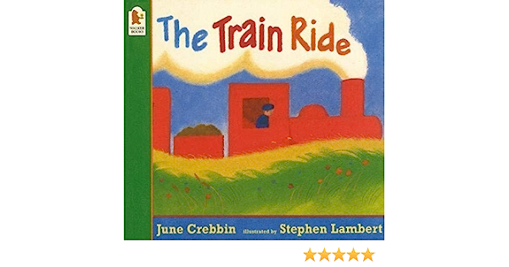

Understanding the World

As we continue to learn about our homes and communities, we will begin to explore the different people who help us. We will learn about doctors, nurses, vets, police, dentists, and librarians. We will also find out about the skills they need to help us and how they use different modes of transport to travel around the local area. We will make comparisons using our own experiences and memories.

Maths

During our maths sessions we will be learning to say one number for each item in the correct order “1, 2, 3, 4, 5”. We will be able to show “finger numbers” up to 5. We will also be beginning to link numerals to amounts working with numbers up to 5.

Literacy

During our daily literacy sessions we will be sharing stories, non-fiction books, poems and rhymes. We will be exploring and learning how to orientate books as we share stories and read for pleasure with the grown-ups. We will be learning that print carries meaning and that books have different purposes. During phonics we will be exploring syllables.

Physical Development

We will be continuing to develop our movement and balance skills. These include riding a balance bike, scooter and trikes (if your child can do this confidently at home please send us a photograph via Class Dojo as we would love to celebrate your child’s achievements). We will be playing games like musical statues to develop our gross motor skills during our dance sessions.

PSED

As we venture into the Spring term we will begin to feel more confident within the setting with our peers, grownups and routines. We will be beginning to understand why the rules and routines are important in the classroom. During our continuous provision we will be playing with and alongside our friends.

Communication and Language

As we develop our communication and language skills we will be developing our listening skills as we begin to follow two part instructions. We will also be developing our understanding of ‘why’ questions. The grownups will be encouraging us to use a new vocabulary that we have been exposed to during the school day. The grownups will explain and model what the vocabulary means so that we can apply our new skills.

EAD

During continuous provision we will begin to develop more complex stories and narratives in our role play when using the small world equipment. We will begin to merge construction sets and resources when developing our imaginations. When working at the ‘Creation Station’ we will be encouraged to explore the different media.

*Who Can Help Us?*