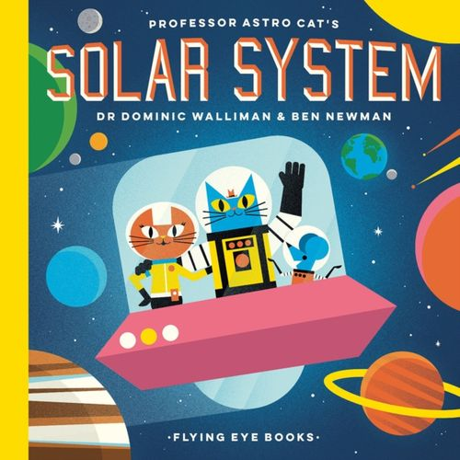

Maths

As we become mathematicians, we will introduce zero. We will be exploring the composition of different numbers as we learn our number bonds to ten. We will use songs, rhymes, and actions to embed our maths knowledge. We will use tactile resources such as Numicon and tens frames to combine two groups.

Literacy

During our daily literacy sessions we will be sharing stories, non-fiction books, poems and rhymes. During our phonic sessions we will learn to read individual letters by saying their sounds, digraphs and common exception words. We will begin to write short meaningful sentences and re-read phonetically decodable books that match our phonic phase.

Understanding the World

As we travel beyond our world and into the realms of space, astronauts, and asteroids we will introduce figures from the science including Neil Armstrong, Mae Jemison, and Tim Peake. We will retrieve our prior knowledge of the world to talk about the similarities and differences between our world and space. We will make observations about what we can see, hear and feel whilst outside.

Physical Development

During our PE sessions we will be developing our overall body strength, co-ordination, balance and agility. We will be developing our gross motor skills on the trim trail and in the deconstructed role play as we build, construct and create. Using a variety of tools safely we will be focusing on our fine motor skills and pencil control. We will use cutlery in the dining hall for our lunch.

PSED

During our *Jigsaw* sessions we will discuss challenges, disputes and how to overcome difficulties. We will be nurturing our resilience and trying to preserve in the face of a challenge. Working with the grownups and our friends we will offer one another support and recognise our personal achievements and goals.

Communication and Language

As we develop our communication and language skills we will learn how to listen and understand why listening is an important skills. As we learn and extend our breadth of vocabulary we will use it in context throughout the day. We will explore our questioning skills to find out more and to show that we understand what we have learned. Modelled by the grownups we will develop and extend social phrases.

EAD

As we learn about space and life beyond our world we will be creating a space themed dance. We will create and perform our own dances in response to what we learn about. We will explore and engage in music making, dance and performance both on our own and in a group.

*What Skills Do You Need To Become An Astronaut?*