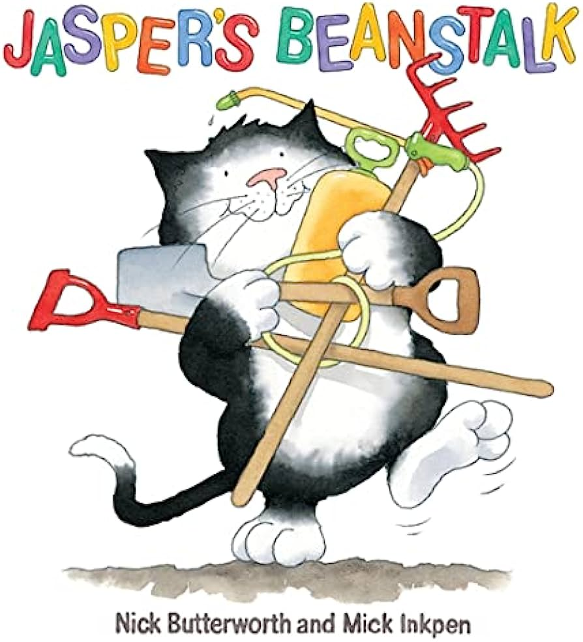

Physical Development

On a Tuesday and a Thursday we will be enjoying our fine motor ‘Dough Disco’ to help develop the dexterity of our fingers and support the basis of a pencil grip. When working in our outdoor area we will also be developing our gross motor skills by throwing and catching, running and galloping.

Understanding the World

We will be exploring the natural world around us as we investigate and identify signs of seasonal change and summer. During the summer months we will talk about ways to stay safe in the sunshine and the clothes we need to wear. We will share our own experiences of holidays and trips to the seaside.

Maths

As mathematicians we will be developing our understanding of numbers to five. We will also be exploring size, capacity, shape and measure. Some elements of our maths learning will be enhanced as we explore growing (including plants and humans).

Literacy

During our Phonics sessions we will be listening for and identifying the initial sounds in some words for example “d” is for “daddy. When accessing the continuous provision the grown-ups will be encouraging us to give meaning to our marks and to begin to write our own names.

PSED

As we meet new friends in FS1 and begin to think about our transition into FS2 we will be working and playing cooperatively with each other. We will continue to nurture and build relationships with our friends and the grown-ups in Foundation Stage.

Communication and Language

We will be continuing to develop our spoken language by articulating words and speaking clearly. We will be using sentence stems and adult modelling to help us to speak in four, five and six word sentences. We will be using our skills developed in Literacy to retell familiar stories, tradition tales and nursery rhymes.

EAD

During the Summer term we will explore colours, colour mixing and tone. Using different colours we will experiment to create our own artwork, designs and creations inspired by growing and seasonal change.

*How Do We Know It Is Summertime?*