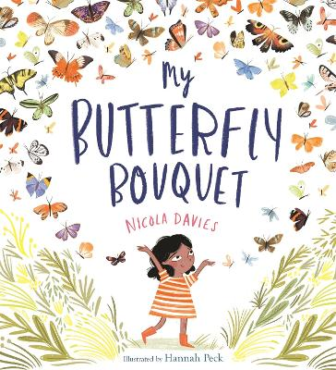

EAD

As artists we will develop our use of water colour paints. Combining our knowledge of symmetry and pattern we will carefully create our own butterflies. We will use pencils to explore tone and shade as we sketch different minibeasts and insects. We will use the stage, role play areas and puppet theatre to develop our own characters inspired by the stories, poems and rhymes we have shared.

Understanding the World

Through our enquiry question we will be exploring conservation and impactful ways we can look after out planet. We will learn how to take care of plants and animals in our own environment and talk about the importance of being responsible. We will discover the ways in which minibeasts, and insects build their own ecosystems and how to become more sustainable.

Maths

During our maths sessions we will be exploring numbers to twenty. We will learn to count forwards and backwards from a given number being able to find one more or one less. We will explore doubling, sharing, odd and even numbers.

Literacy

In literacy we will be developing and embedding our Phonic knowledge to read and write independently. We will be exploring fiction and non-fiction texts to further develop our knowledge of the world around us. We will share facts and information to create life cycles, fact files and posters about minibeasts and insects. Using RSC strategies, we will recite nursery rhymes and poems with our friends.

Physical Development

In preparation for our annual Sports Day we will be developing our collaboration skills. We will be developing our gross motor skills, strengthening our muscles and following instructions. During our PE sessions we will be negotiating space and obstacles safely whilst moving in different ways including running, jumping, hoping, skipping and climbing.

PSED

We will be developing our personal, social and emotional skills as we prepare to transition into Year 1. During *Jigsaw* circle time we will have a focus on being sensitive towards the needs and feelings of our peers. We will be focusing on building confidence in the classroom. We will be setting and working towards simple goals.

Communication and Language

We will be focusing on developing our spoken language skills, asking questions and answering in full sentences. Working together we will be applying our new-found vocabulary to offer our own ideas, thoughts and opinions when working on a one to one basis, in a small group or whole class discussion. We will be listening attentively to others around us and will respond appropriately with relevant comments and questions.

*Who Lives Under Our Feet?*