Buckingham Primary Academy – History Intent
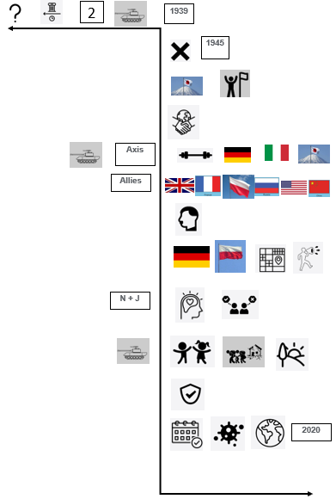
At Buckingham Primary Academy, we believe that high-quality history topics inspires pupils to show a curiosity in the past and understand how it has shaped the world they live in today. The design of our 3D curriculum allows children to make horizontal and vertical links to a range of historical enquiry challenges. Children have opportunities to investigate and interpret the past, understand chronology, build an overview of Britain’s past, as well as that of the wider world, and to be able to communicate historically.
Our curriculum aims to build pupils’ knowledge of local, British and global history progressively over time through studying time periods chronologically. They achieve success through engaging in retrieval tasks and rehearsing their narrative of learning each session to bring prior learning back to their working memory; allowing pupils to build on this, develop schemas and make links.
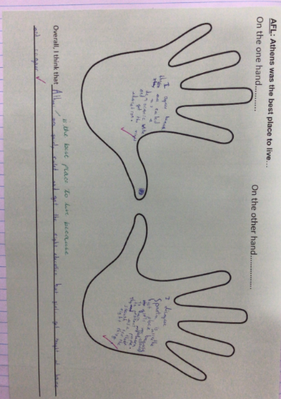
Pupils deepen their understanding through engaging in second-level thinking tasks. These look at:
- Cause and consequence
- Similarities and differences
- Historical significance
- Reliability of artefacts and sources of information
- Comparing events and their impact
We develop children with the following essential characteristics to help them become historians:
- An excellent knowledge and understanding of people, events and contexts from a range of historical periods, including significant events in Britain’s past;
- The ability to think critically about history and communicate ideas confidently to a range of audiences;
- The ability to support, evaluate and challenge their own and others’ views using historical evidence from a range of sources;
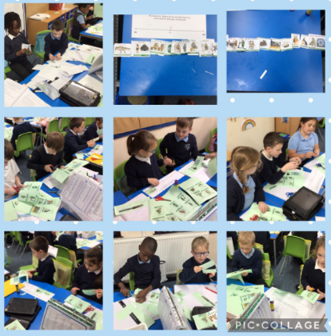
- The ability to think, reflect, debate, discuss and evaluate the past by formulating and refining questions and lines of enquiry;
- A respect for historical evidence and the ability to make critical use of it to support their learning;
- A desire to persevere with challenging activities, including opportunities to undertake high-quality research across a range of history topics;
- A developing sense of curiosity about the past and how and why people interpret the past in different ways.
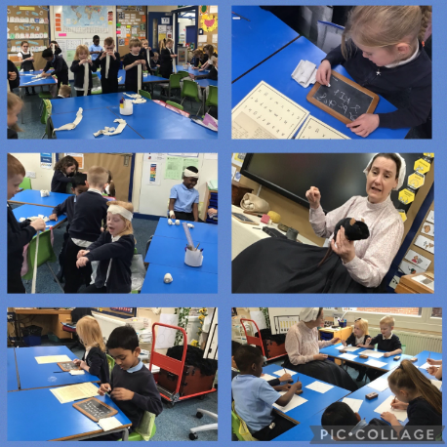
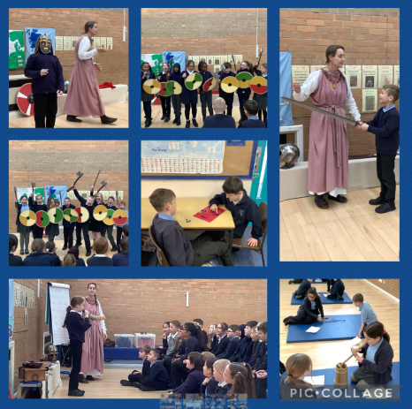
Our curriculum also promotes knowledge of Britain’s democratic Parliamentary system linking to British Values. Pupils education is enhanced through hands-on experiences such as visits or visitors into school, supporting our personal development offer.

