Mathematics Intention
At Buckingham Primary Academy, Mathematics is a key aspect of the curriculum along with reading, writing, speaking, and listening, including oracy, it makes a significant contribution to pupils as thinkers through fluency and reasoning.
Buckingham Primary Academy strives to achieve two primary objectives through our maths curriculum: fostering a lifelong passion for mathematics and equipping students with the confidence and fluency to become proficient mathematicians capable of successful reasoning and problem-solving. As a school, we prepare children for this as our teachers are highly skilled to ensure retrieval and use of effective questioning is embedded into all aspects of the school day allowing children to be successful. This also prepares children for mathematics in further education settings.
Mathematics is introduced progressively and sequentially throughout the academy, commencing from the Nursery level. During the Foundation Stage, we prioritise instructing pupils through hands-on and practical learning experiences, emphasising the mastery of early numerical concepts. A diverse range of learning opportunities, prevalent throughout the entire setting, facilitates the development of pupil’s comprehension of relationships and patterns. This approach enables them to engage in reasoning about numbers and to solve problems through practical activities.
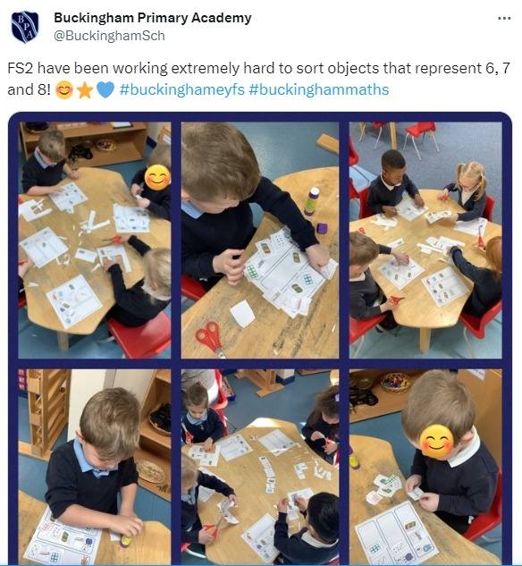
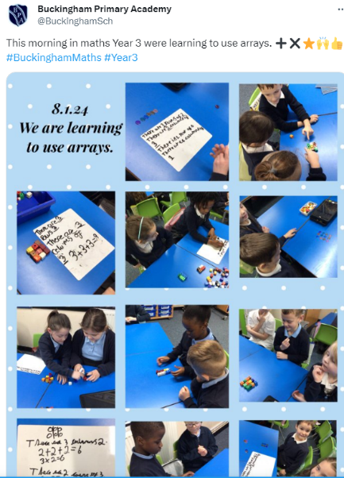

The teaching of Mathematics from Nursery through to Key Stage 2 is underpinned by the expectations and programme of study set out by the DfE’s National Curriculum (2014):
Purpose of study:
Mathematics is a creative and highly interconnected discipline that has been developed over centuries, providing the solution to some of history’s most intriguing problems. It is essential to everyday life, critical to science, technology and engineering, and necessary for financial literacy and most forms of employment. A high-quality mathematics education therefore provides a foundation for understanding the world, the ability to reason mathematically, an appreciation of the power of mathematics, and a sense of enjoyment and curiosity about the subject.
Aims:
The predominant aim for Mathematics within the national curriculum, is to ensure that children develop knowledge to help them be successful later in life but to also encourage the engagement in Science, Technology and Engineering (STEM). It is built upon a strong emphasis to ensure that children develop a strong understanding of the world that can enable them to be successfully with employment. Aswell as ensuring children are ‘prepared’ for life after their education it is also important that they experience enjoyment to allow them to become immersed in the subject.
The National Curriculum for Maths aims to ensure that all pupils:
- Become fluent in the fundamentals of mathematics, including through varied and frequent practice with increasingly complex problems over time, so that pupils develop conceptual understanding and the ability to recall and apply knowledge rapidly and accurately.
- Reason mathematically by following a line of enquiry, conjecturing relationships and generalisations, and developing an argument, justification or proof using mathematical language.
- Can solve problems by applying their mathematics to a variety of routine and non-routine problems with increasing sophistication, including breaking down problems into a series of simpler steps and persevering in seeking solutions.
School Curriculum:
The programme of study for Mathematics at Buckingham Primary Academy follows a mastery approach, which is set out in strands that teachers follow. Although set out in strands a significant part of the maths curriculum is the use of retrieval this ensure that links can be made to previous learning to allow knowledge and skills to be further embedded. Our curriculum is supplemented with Gareth Metcalf ‘Goal Led, Goal Free questioning and the NCETM resources.
Embracing a mastery approach, we avoid streaming children by ability, aiming to provide every child with the chance to reach age-related expectations. Mastery teaching allows our students the time to cultivate a profound and transferable comprehension of mathematical concepts. Our school prioritises a lesson structure that integrates abstract, pictorial, and concrete applications, fostering the development of fluency and reasoning skills. We take pride in quality-first teaching and effective questioning, which nurtures children's self-confidence and belief in every aspect of their learning journey.
Through our bespoke layout of maths opportunities throughout the day, which includes the retrieval opportunities at the start of every maths lesson, Rapid Recall focus and Arithmetic opportunities, children are given high quality opportunities to both extend their learning and develop a deeper understanding. Children show a high level of perseverance to ensure key skills are implemented into their long-term memory, which allows them to achieve and believe and therefore means they become confident learners. In addition to the above, we also appreciate how important it is for our children to become fluent in all aspects of calculation, therefore, one session per week must be dedicated to practicing arithmetic through a given test.
Retrieval
As previously mentioned, as a school we place a high emphasis on retrieval and understand the importance of children revisiting prior knowledge to further deep an enhance their knowledge and understanding. Our retrieval opportunities, also allow for children to develop their oracy around maths and be able to discuss and explain their learning confidently.
Our retrieval opportunities follow a DNA at the start of lessons, 2-weekly cycle between bar model question and a ‘goal led, goal free’ question and the Rapid Recall:
DNA
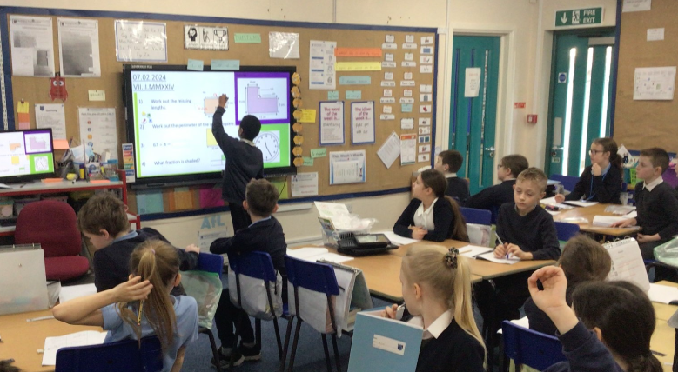
Therefore, all maths lessons, begin with a ‘Do Now Activity (DNA)’, the DNA is broken down into 4 questions, last lesson, last week, last term, last year. The DNA provides an opportunity for teachers to retrieve prior knowledge and understanding. The DNA is a done to a fast pace to ensure children can develop their fluency. However, we also acknowledge that this is a valuable opportunity to cover any misconceptions therefore, effective teacher modelling and questioning is used.

Bar Model
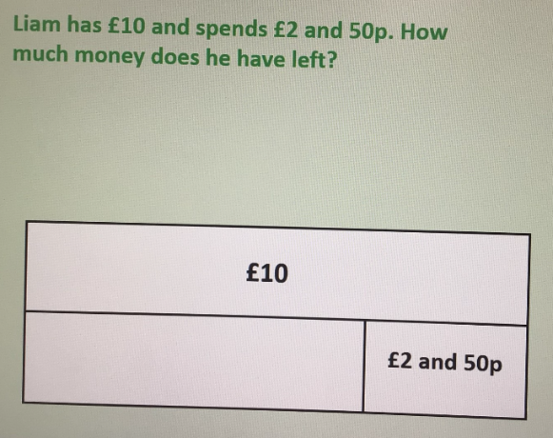
We have implemented a short ‘5 minute’ bar model question, which follows the DNA. The bar model question has been developed to ensure that children have understanding of how to both ‘draw a bar model’ and also ‘how to use a bar model’. The repetition and ‘drip-feeding’ of the skills ensured children become confident in how to approach this style question.

Goal Led, Goal Free
To support the teaching of reasoning and problem solving we have adapted the process of goal led, goal free by Gareth Metcalfe. Teachers prepare a reasoning and problem-solving questions and slowly reveal the question to the children. The purpose of the slow reveal is for children to think about the steps to success to answering the question and also to develop children’s oracy around maths.
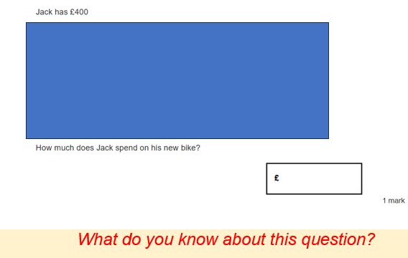
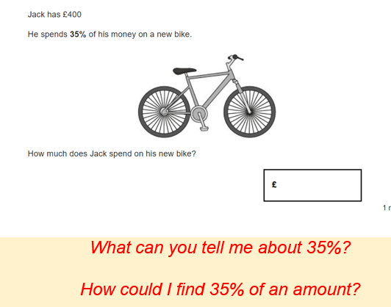

Rapid Recall
Rapid Recall is an integral aspect at Buckingham Primary Academy, emphasising the need to cultivate not only children's reasoning and problem-solving skills but also their fluency. Each day, following lunchtime, children engage in the Rapid Recall, providing an opportunity to reinforce fluency across various skills. The weekly focus adjusts based on ongoing assessments and data. Through consistent daily practice and retrieval, we strive to instil confidence and fluency in the children's skill set.
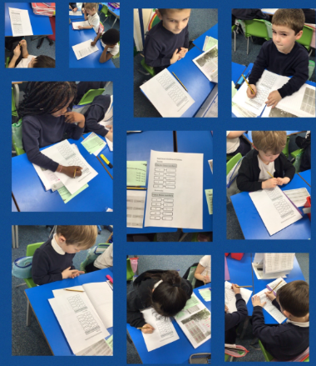
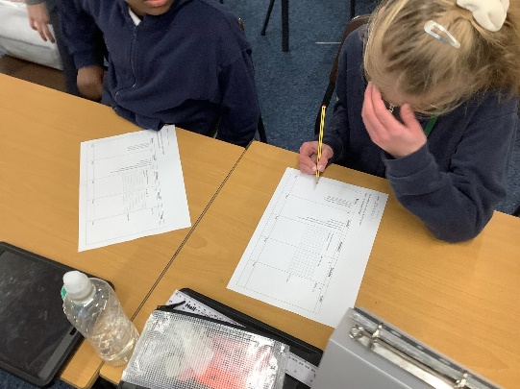

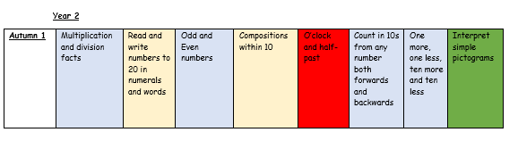
An example of the Year 2 Autumn 1 overview is provided below:

