Mathematics Intention-
At Buckingham Primary Academy, the foundations for teaching the National Curriculum Maths are begun in Early Years Foundation Stage, with the development of high quality lessons that incorporate a level of both fluency and reasoning of key skills.
The teaching of Maths at KS1 and KS2 is underpinned by the expectations and programme of study set out by the DfE's National Curriculum (2014):
Purpose of study
Mathematics is a creative and highly interconnected discipline that has been developed over centuries, providing the solution to some of history’s most intriguing problems. It is essential to everyday life, critical to science, technology and engineering, and necessary for financial literacy and most forms of employment. A high-quality mathematics education therefore provides a foundation for understanding the world, the ability to reason mathematically, an appreciation of the beauty and power of mathematics, and a sense of enjoyment and curiosity about the subject.
Aims
The predominant aim for Mathematics within the national curriculum, is to ensure that children develop knowledge to help them be successful later in life but to also encourage the engagement in Science, Technology and Engineering (STEM). It is built upon a strong emphasis to ensure that children develop a strong understanding of the world that can enable them to be successfully with employment. Aswell as ensuring children are ‘prepared’ for life after their education it is also important that they experience enjoyment to allow them to become immersed in the subject.
The National Curriculum for English aims to ensure that all pupils:
- Become fluent in the fundamentals of mathematics, including through varied and frequent practice with increasingly complex problems over time, so that pupils develop conceptual understanding and the ability to recall and apply knowledge rapidly and accurately
- Reason mathematically by following a line of enquiry, conjecturing relationships and generalisations, and developing an argument, justification or proof using mathematical language
- Can solve problems by applying their mathematics to a variety of routine and non-routine problems with increasing sophistication, including breaking down problems into a series of simpler steps and persevering in seeking solutions
School curriculum
The programme of study for Mathematics at Buckingham Primary Academy is set out as strand within school that teachers follow and we follow a mastery approach. This means that children are not streamed by ability because we believe that all children are to be given the opportunity to achieve age related expectations. Mastery teaching provides our children with the time to acquire a deep and transferable understanding of mathematical concepts. As a school, we follow White Rose Maths that incorporates the abstract, pictorial and concrete application alongside developing children’s fluency and reasoning skills. We pride ourselves in quality-first teaching that supports children to develop self-confidence and belief in every strand. Through our bespoke layout of sessions, which includes the DNA, Rapid Reasoning (Bar Model) and Rapid Recall children show a high level of perseverance to ensure key skills are implemented into their long-term memory, which allows them to achieve and be confident learners. In addition to the above, we also appreciate how important it is for our children to become fluent in all aspects of calculation, therefore, one session per week must be dedicated to practicing arithmetic through a given test.
DNA (Do it now activity)
All lessons at Buckingham Primary Academy begin with a ‘Do Now Activity (DNA)’, which is split into four parts. It should recap prior learning relevant to the lesson (last lesson and last week) and recaps prior learning from previous topics (last topic and last half term). The purpose of the DNA is to ensure that children can carry on developing and building on their prior knowledge. By revisiting what you did last lesson you can ensure that, you are embedding their understanding into their ‘long-term’ memory. The DNA provides a high quality assessment as it can be adapted and changed daily/after every session to ensure it is current and matches the needs of their class. It also provides teachers with an opportunity to see their knowledge from previous units, which can in turn inform teachers planning. The DNA has since been extended to include a challenge. The challenge can include any strand but it provides teachers with and opportunity to build on children’s reasoning and problem solving skills to ensure fluency can be applied to a deeper understanding.
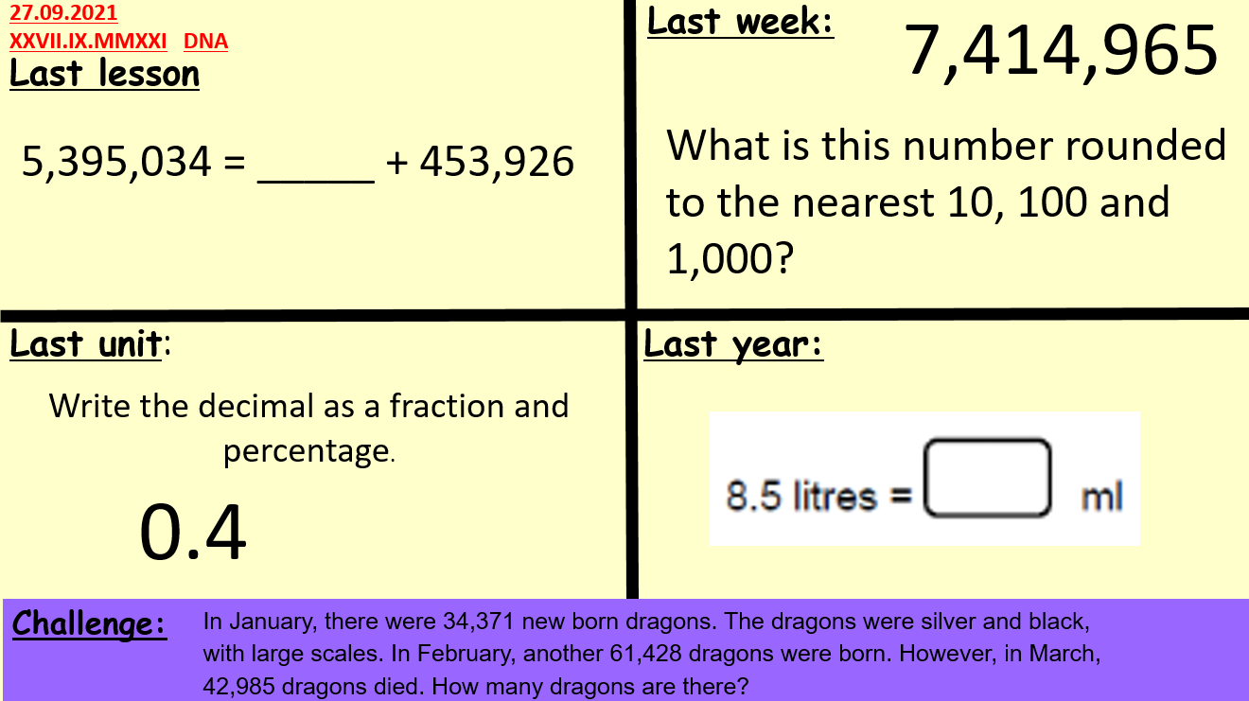

Bar Model (Rapid Reasoning)
To support the teaching of Mathematics and the teaching of White Rose Maths we have implemented a short ‘5 minute’ bar model question which follows the DNA. The bar model question has been developed to ensure that children have understanding of how to both ‘draw a bar model’ and also ‘how to use a bar model’. The repetition and ‘drip-feeding’ of the skills ensured children become confident in how to approach this style question.

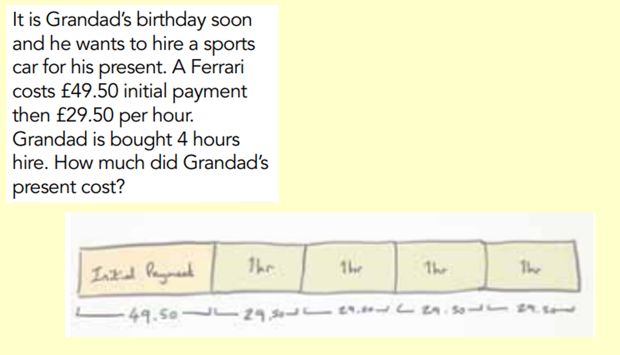

Rapid Recall
At Buckingham Primary Academy, we recognise the importance of not only ensuring children have develop their reasoning and problem solving skills but also fluency. Every day after lunchtime, children complete the Rapid Recall this is also a chance to ensure children are fluent across different skills. The Rapid Recall is an assessment for learning which is changed and adapted weekly and supports year group expectations. It is a prime opportunity for staff to further embedded strategies such as multiplying 4 digits by 2 digits in year 6 into children’s long-term memory. Children who may have struggled with this concept can then show perseverance daily through practising the skills to allow them to master the process.
