The Process of Teaching Maths at Buckingham Primary Academy
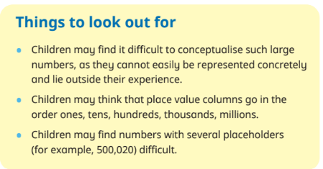
Connections to be made through strands
Money- connections to be made through addition/subtraction/multiplication and division.
Addition/subtraction/multiplication/division- links to place value
Staff to add this to their S Plan for the week so staff are clear on how they are going to make connections

Sentence Stems
Staff to use the whole school sentence stems linking to Declarative/Procedural/Conditional/Conceptual
I know that…
I know how…
I know when…
I know why…
Staff to use the strand specific sentence stems on their overview for the small step in addition to the above.
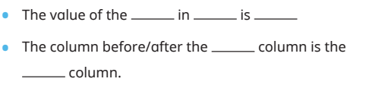
Vocabulary
Staff to use the vocabulary from WRM for their particular strand.
file:///T:/2022-%202023/Maths%20necessities/Vocabulary/MathsSkillsKnowledgeandVocabularyMap.pdf
Progression of vocabulary document

Barriers to Learning and Progression
Staff to carefully think about this throughout their teaching of a particular strand and identify on their S Plans for that particular week.
Misconceptions- Do pupils have misconceptions.
Staff to use the misconceptions section on WRM when planning teaching.

Supplement Strategies
Gareth Metcalf- Low Threat/High Challenge
Deconstructing word Problems
If I know… I know…
NCETM Planning Prioritisation Document to support teachers with subject knowledge and barriers they may come across.
Test Base- Reasoning and problem solving questions to support with the teaching of word problems.
CPD Videos- WRM
Staff can use the WRM home learning videos to supplement their teaching to allow them to have confidence in their subject knowledge and understanding.

Bromcom to be regularly updated throughout to reflect teaching
The process is then repeated for the following strand

