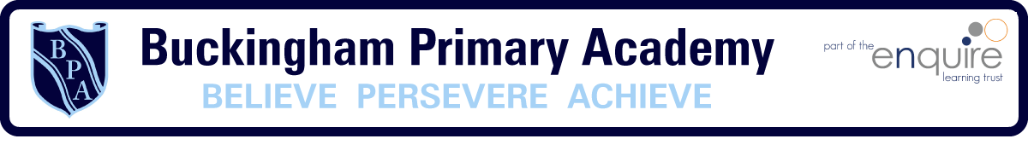

Buckingham Primary Academy - Music

At Buckingham Primary Academy, we believe that it is important for all our pupils to learn about Music, so that they can become confident musicians. This is evident with the number of children choosing to continue music lessons in Key Stage 2. Our aim is, ‘to instil a love of lifelong learning in our children and prepare them for the life beyond our school gates’, we feel Music has an integral role to play in helping us to fulfil this statement. We are constantly working hard to provide high quality lessons and extra-curricular activities which are accessible to all children in the school, these include performing to a wider audience and having specialist music teaching in Year 4 which continues in Y5 and Y6. We encourage our pupils to ask questions about Music and it is promoted throughout the school, not just in designated music lessons. Our children enjoy a variety of opportunities to enjoy and participate in music activities both in school and in the wider community to reflect the high quality teaching of music throughout the whole school. Events include: singing assemblies, the Carol Concert, music concerts at Hull City Hall and the Albermale, the Nativity in KS1 to name a few. This is reflected in our 3D curriculum, allowing horizontal and vertical links with previous year groups and previous activities taught.
We approach Music with a focus of progression of skills across year groups. Charanga supports this through continually recapping and reflecting on skills previously learnt whilst building on them. With this, we equip children with the skills required to be successful, then look at how they can transfer those skills into other activities and across the wider curriculum. This in turn requires deep thinking and encourages learners to work using their experience as their starting point and advance their cultural capital.

