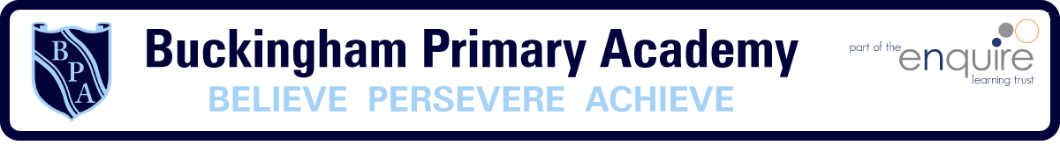

Buckingham Primary Academy

Personal Development Curriculum

Personal Development at Buckingham Primary

Our curriculum extends far beyond the academic, to allow pupils to develop in many diverse aspects of life. This is encapsulated in our Personal Development Curriculum.

We aim to ensure that, over their time at Buckingham Primary, learners receive a Personal Development programme that gives them the knowledge that they need to make decisions, to strengthen them personally and to allow them to develop their character and personality. We provide these rich experiences in a coherently planned way, in the curriculum and through extra-curricular activities.

At Buckingham Primary, there are four key drivers that underpin our Personal Development approach:
- Healthy & safe behaviours
- Awareness of the world
- Character development
- British Values

Healthy & safe behaviours include our PSHE curriculum, Relationship Education, Sex Education, Physical Health, Mental Wellbeing and Wider Aspects of Safety.

Awareness of the world includes Economic Understanding, Understanding Media and Technology and Spiritual, Moral, Social and Cultural development.

Character development includes development of children’s own character and personality, our school rules, children’s behaviour and wider opportunities for children to engage with.

British Values includes Democracy, Rule of Law, Respect & Tolerance and Individual Liberty.

Personal Development Curriculum Overview:

Some areas of our personal development approach are taught through subjects with their own curriculum, e.g. our PSHE curriculum, or the online safety strand of our Computing curriculum. Other aspects are taught discretely. The following table illustrates which aspects are taught through which approach.

Aspect of Personal Development | Integrated area of wider school curriculum | Discrete personal development curriculum
Safe Behaviours  Including;Relationship Education,  Sex Education, Physical Health,  Mental Wellbeing, Wider Safety | - Jigsaw PSHE curriculum – Healthy Me, Relationships, Changing Me  - PE curriculum  - Computing Curriculum – online safety strand  - Whole-school PACE approach | - Anti-bullying week – November  - Science week – March  - E-safety day – February  - NSPCC Pants  - NSPCC Speak Out Stay Safe  - Soltan Sunready  - St John’s Ambulance First Aid (KS2)  - Bikability Training ( Y6)  - Peddle Push (FS)  - Pedestrian Skills (Y3)  - NHS Toothbrushing scheme (EYFS and Y1)  - K9 Visits with Fire Brigade (Y5 and Y6)  - Knife Crime (Y6)  - Swimming (KS2)  - Mental Health weeks
Awareness of the world  Including; Economic  Understanding, Understanding  Media and Technology, Spiritual,  Social, Moral, Cultural | - Jigsaw PSHE curriculum – Dreams & Goals  - RE Curriculum  - Individual, ongoing subject contribution to SMSC (see statements)  - School visits programme, including virtual visits (Amazon, authors etc.)  - Diverse book spine and designated reads for each year group  - Buckingham Primary Reading Spine  - Multicultural weeks part of Black History Month  - Lyfta Assemblies | - Daily BBC Newsround  - My Money Matters week (Summer term)
Character  Including; development of character, confidence and resilience, citizenship, wider opportunities | - Jigsaw PSHE curriculum – Being Me In My World, Celebrating Difference,  - School rules  - School Behaviour Curriculum  - Extra-curricular clubs programme  - Pelican Parks (talent spotting)  - Instrument tuition programme  - Christmas performances & other performances (e.g. music)  - Career opportunities | - 101 things you’ll do across the curriculum  - Termly visitors or trips  - Residential Trip (Y6)  - Charity opportunities e.g. Dove House Hospice and Macmillan  - Skills for life passport
British Values  Including; Democracy, Rule of  Law, Respect & Tolerance, Individual Liberty. This also includes elements of citizenship. | - Jigsaw PSHE curriculum – Being Me In My World, Celebrating Difference  - Individual, ongoing subject contribution to British Values (see statements)  - RE Curriculum  - Learning council / Leaders of learning  - Democracy assembly – peer choice | - British Values assembly programme  - Black History Month  - Pride & Diversity week study  - Science weeks and studying particular scientists across history

Discrete Personal Development Long Term Plan:

 | Autumn 1 | Autumn 2 | Spring 1 | Spring 2 | Summer 1 | Summer 2
Discrete personal  development curriculum  (lesson time) | Safe behaviours:  NSPCC PANTS  (EYFS & KS1)  SJA: First Aid (KS2)  British Values  (in Jigsaw time)  Discrimination (KS2)  British Values  (in Jigsaw time)  Democracy (KS2)  Water safety (KS2)  Yorkshire Water | Safe behaviours:  Anti-Bullying  British Values  (in Jigsaw time)  Democracy (KS2) | Safe behaviours:  NSPCC Speak Out  Stay Safe  British Values  (in Jigsaw time)  Rule of law – the big legal lesson | Goals / careers and working alongside others | Safe behaviours: Soltan Sunready  Safe behaviours:  Knife Crime  Cybercrime  (police / outside agencies) | Awareness of the world:  Money Matters (Summer term)
Special Events / Days | National Poetry Day  Black History Month – each year group to  have a famous person to study  Pride & Diversity  Week - each year group to have a  famous person to study  K9 Safety (Drug dogs from Humberside fire and rescue) | Christmas  Performances  (December)  Anti-Bullying Week  Theatre Visit  Church Visit – Carol concert (community event)  Swimming year 6 | Safer Internet Day  (7/2/23)  Swimming year 5  Carbon Monoxide training for KS2  Prison Me no Way – KS2 | World Book Day  (2/3/23)  British Science Week (w/c 14/3/23)  Art exhibition | Earth Day (22/4/23) | Art exhibition

Personal Development Curriculum – Objectives / Progression of Learning:

Some aspects of personal development – such as the PSHE curriculum – are already mapped out in their own documentation.
Events – such as anti-bullying week – are thematic each year and do not have year group specific progression.
Other aspects – such as first aid – are more progressive each year and have specific objectives and are therefore mapped out here.
Safe behaviours
 | EYFS | KS1 | LKS2 |  | UKS2
NSPCC  PANTS | - Understand and learn the PANTS rules  - Name body parts and know which parts should be private  - Know the difference between appropriate and inappropriate touch  - Understand that they have the right to say “no” to unwanted touch start thinking about who they trust and who they can ask for help.
NSPCC  Speak Out  Stay Safe |  | - Understand abuse in all its forms and recognise the signs of abuse  - Understand that abuse is never their fault, and they have the right to be safe  - Know how to get help, and the sources of help available to them, including the Child line service.  - (Lesson plans are differentiated for KS1 and ks2)
Sun Safety |  | - UV rays cannot be seen, but they can damage the skin and lead to sunburn, wrinkles, rashes and more serious conditions in later life, including skin cancer. UVA and UVB are the two types of UV rays that affect humans the most.  - SPF stands for Sun Protection Factor: the higher the SPF number, the more protection the sun cream gives you. Children should use sun cream with an SPF of 30 or higher.  - The Star Rating refers to the product’s protection from UVA. The Star Rating goes from 1 to 5 and it is recommended that children use sun cream with five stars, as this gives the best protection.
First Aid |  |  | Emergencies & calling for help: • Understand it’s most important to ensure the safety of myself and others in the  event of an emergency  - Assist in an emergency by  correctly calling for help  - Know the  information I  need to give to emergency  services if they are called to an incident  Head injuries  - Identify a minor or major head injury  - Give first aid to a casualty who | Asthma:  - identify a casualty who is having an asthma attack  - assess and give  first aid to a casualty who is having difficulty breathing due to an asthma  attack  - understand  when to seek medical help for a casualty who  is choking | Bleeding:  - Ensure the  safety of themselves and others.  - Assess a  casualty’s condition calmly and give first aid to a casualty who is bleeding  - I can give first aid to a casualty who is in shock. I can seek medical help if required for a casualty who is bleeding | Choking  - Identify a casualty who is choking  - Assess and give  first aid to a casualty who is choking  - Seek medical  help if required  Basic Life Support  - Conduct a  primary survey  - Place an  unresponsive casualty, who is breathing normally, into the recovery  position  - Know when and  how to deliver CPR to an
 |  |  | has a head injury  - Call for help for a casualty who  has a head injury  Bites & stings  - Identify when a  casualty is having an allergic reaction  to a bite or sting  - Provide first aid treatment for a casualty who has been bitten  or stung  - Comfort and  reassure a casualty who has been bitten  or stung  - Seek medical  help if required |  |  | unresponsive casualty who is not breathing normally  Seek medical help

Awareness of the world
Economic  Development | My money week (whole school – Summer term)

Buckingham’s Fifty Famous Faces
We have identified fifty famous people from a diverse range of backgrounds who have made a significant impact on our world. We study these people across the curriculum where they link to the children’s planned learning using the high-quality ‘Little People, Big Dreams’ series as a stimulus.
Special Months:
 | Nursery | Reception | KS1 cycle A | KS1 Cycle B | Year 3 | Year 4 | Year 5 | Year 6
Black History  Month  (October) | 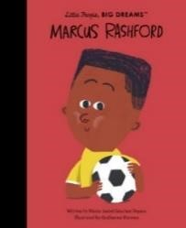 | 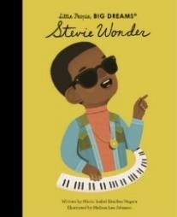 | 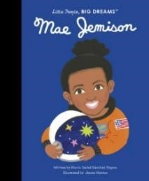 | 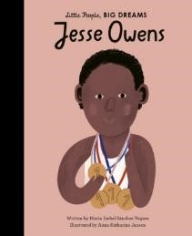 | 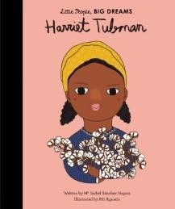 | 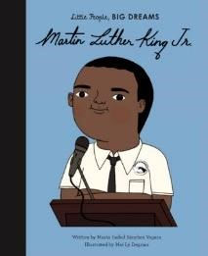 | 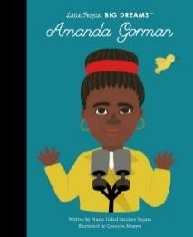 | 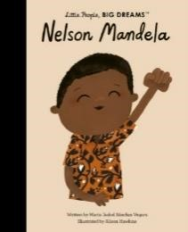
 | Marcus Rashford | Stevie Wonder | Mae Jemison | Jesse Owens | Harriet  Tubman | Martin Luther King Jr. | Amanda  Gorman | Nelson Mandela

 | Nursery | Reception | KS1 cycle A | KS1 Cycle B | Year 3 | Year 4 | Year 5 | Year 6
Pride Month  (September) | 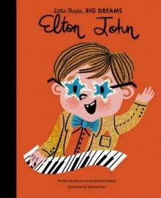 | 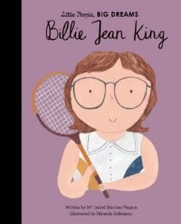 | 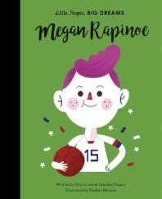 | 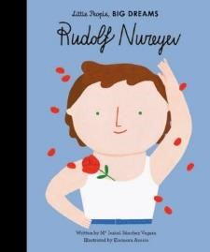 | 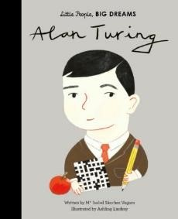 | 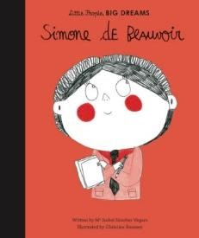 | 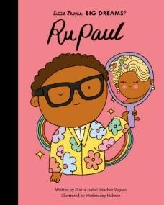 | 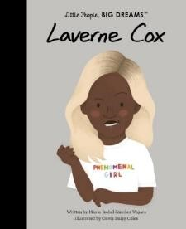
 | Elton John | Billie Jean  King | Megan Rapinoe | Rudolf Nureyev | Alan Turing | Simone de  Beauvoir | RuPaul | Laverne Cox

Across the curriculum:
Reception | 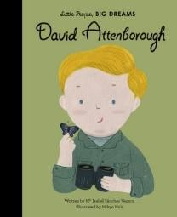 | 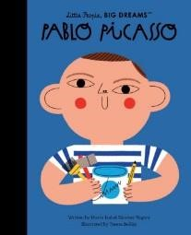
 | David Attenborough | Pablo Picasso
 | Understanding of the world | Expressive arts and design

KS1 Cycle A | 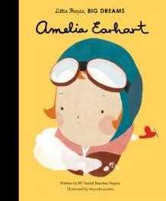 | 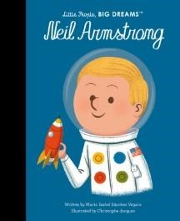 | 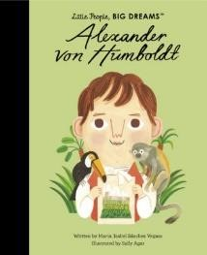 | 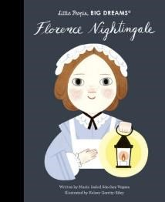
 | Amelia Earhart | Neil Armstrong | Alexander von Humboldt | Florence Nightingale
 | History | History | Science | History

KS1 Cycle B | 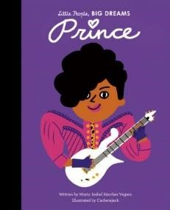 | 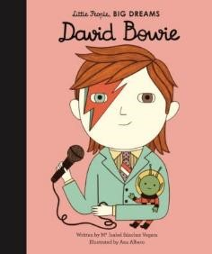 | 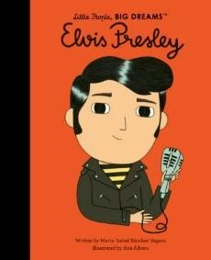
 | Prince | David Bowie | Elvis Presley
 | Music | Music | Music
Year 3 | 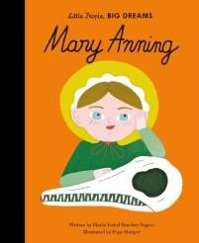 | 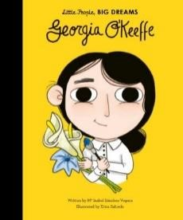 | 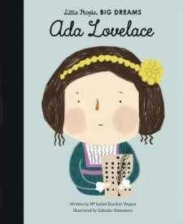
 | Mary Anning | Georgia O’Keeffe | Ada Lovelace
 | Science | Art | Computing

Year 4 | 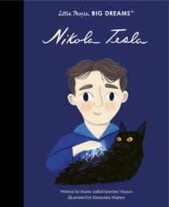 | 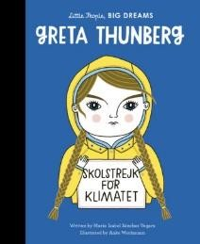 | 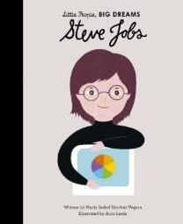 | 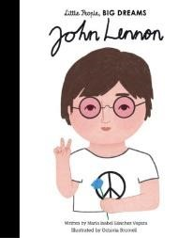 | 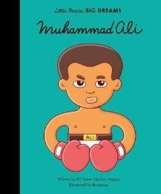
 | Nikola Tesla | Greta Thunberg | Steve Jobs | John Lennon | Muhammed Ali
 | Science | Science | Computing | Music | PE

Year 5 | 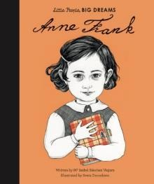 | 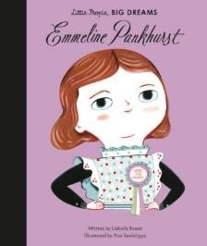 | 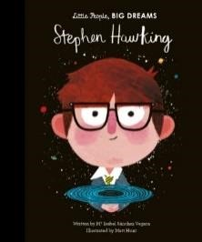 | 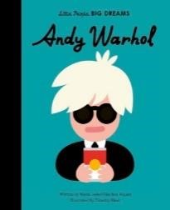 | 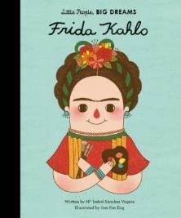
 | Anne Frank | Emmaline Pankhurst | Stephen Hawking | Andy Warhol | Frida Kahlo
 | History | History | Science | Art | Art

Year 6 | 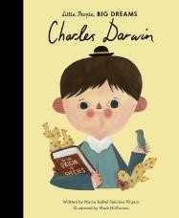 | 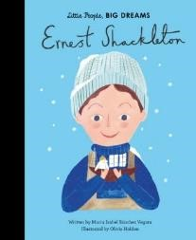 | 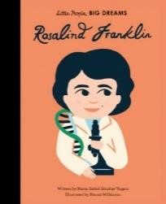 | 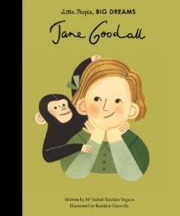
 | Charles  Darwin | Ernest Shackleton | Rosalind Franklin | Jane Goodall
 | Science | History | Science | Science

Values Assemblies:
Democracy | 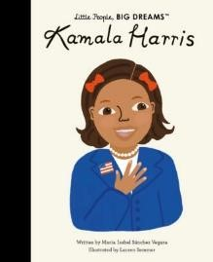 | 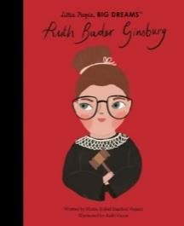 | 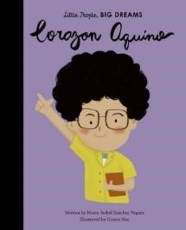
 | Kamala Harris | Ruth Bader Ginsburg | Corazon Aquino

Respect & tolerance | 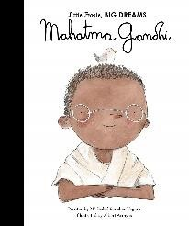 | 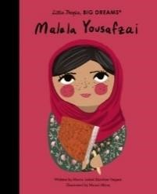 | 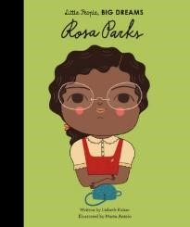 | 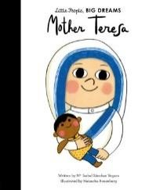
 | Ghandi | Malala  Yousafzai | Rosa Parks | Mother Teresa

Diverse Books for use from EYFS – Year 6

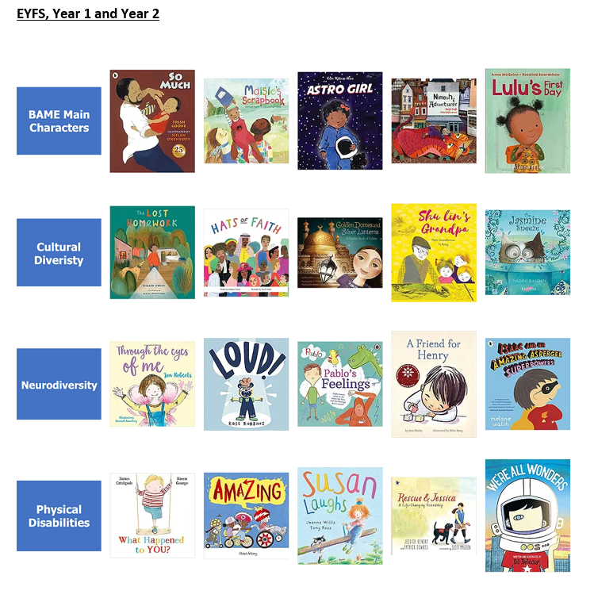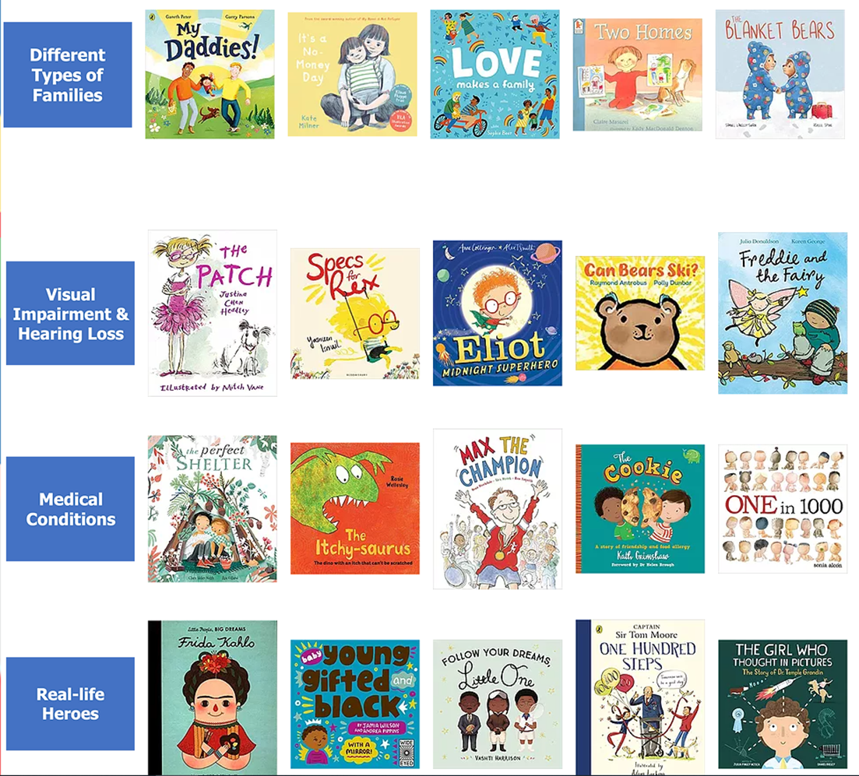

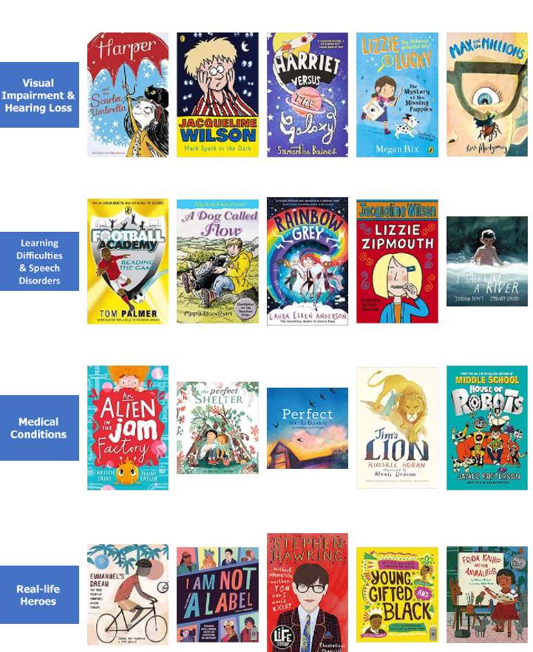
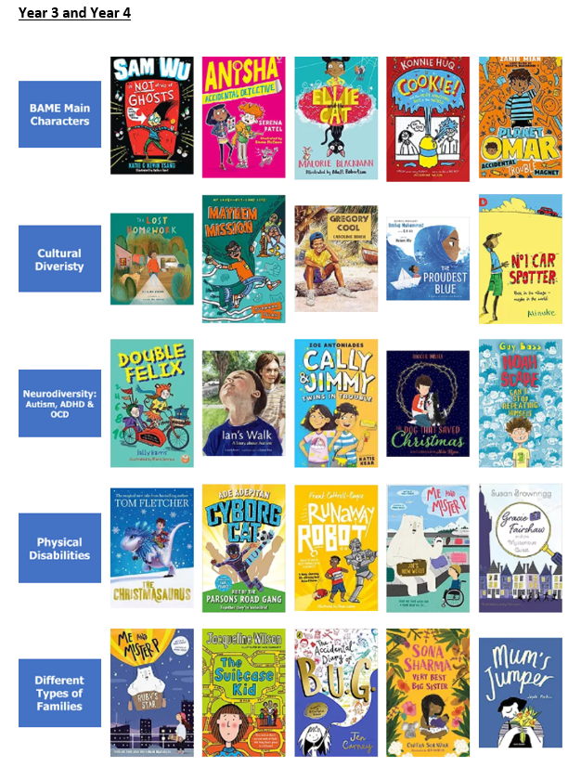

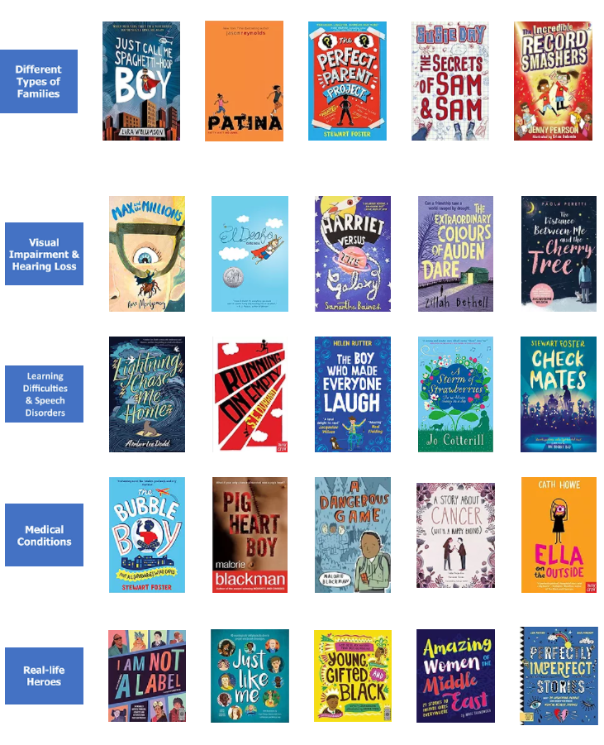
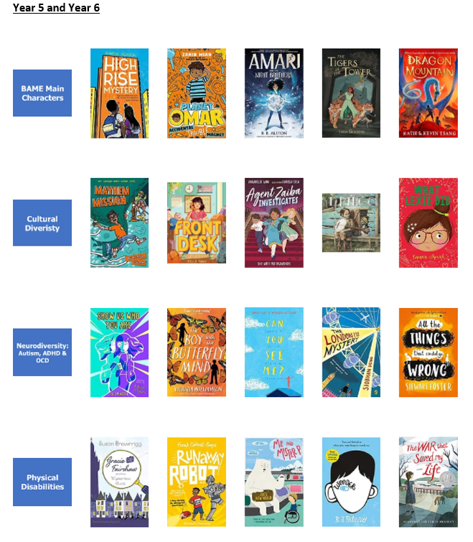

101 things you will do at Buckingham

Each year  Take part in Lyfta Assemblies | Watch a live theatre performance | Receive your very own book to keep | Sing together as a school | Help raise money for a local charity | Take part in a democratic process:  Celebration assembly and learning council voted by peers
 | Take part in a carol concert in the church | Design and create a decorated Easter Egg | Take part in a school party or disco | Take part in science week | Celebrate National poetry weeks
 | Try new and exciting foods | Take part in a sports competition | Join an after-school club | Go on a school trip | Display artwork for an audience
 | Have a visitor into your school or class | Learn about friendship and anti-bullying | Learn how to stay safe online | Celebrate Black History  Month | Celebrate Pride Month
FS1 | Grow something to eat | Take part in a Teddy Bears picnic | Meet and hold some interesting animals | Jump in muddy puddles | Bring up a butterfly
 | Sing Nursery Rhymes | Build a den | Be visited by Father  Christmas | Try new fruits and vegetables | Fly a kite / parachute games
FS2 | Take part in ‘Time to try’ | Visit to the Deep | Post a letter at a post box | Take part in a performance | Collect some minibeasts
 | Learn some Fairy tales | Make a sandwich | Take part in something special to me and share with their peers | Follow a map | See some sea creatures
Years 1 | Grow a sunflower | Learn to tie your own shoelaces | Use green-screen technology | Interview someone and find out about the past | Visit the theatre
 | Make a daisy chain | Go cloud watching | Sing in the Nativity | Find your way with a map | Make a bird feeder
Year 2 | Learn a new board game | Perform a random act of kindness | Perform in the Nativity | Create beach art using natural and recycled materials | Visit Bempton Cliffs
 | Learn to sew | Explore a rock pool | Design and make a healthy smoothie | Tell the time | Design and create a clay tile
Year 3 | Start to learn to speak  Spanish | Make an erupting volcano | Visit the theatre and write and perform own play | Start to learn First Aid | Complete pedestrian skills certificate
 | Make some Stone Age art | Learn about and touch fossils and dinosaur bones | Write to a pen pal | Learn how to be safe in the sun | Visit Pasco’s Italian and learn about healthy foods
Year 4 | Perform in a live music performance | Take part in the Ambassadors of Hull scheme | Make a paper aeroplane | Make an electrical circuit | Learn to play the glockenspiel
 | Live like a Greek for the day | Make an ecosystem using recycled materials | Learn origami | Decorate cookies or buns | Write a thank you note
Year 5 | Learn to swim safely | Learn how to cross stitch | Conduct an environmental walk and create a map of features in the local area | Take part in Big friends little friends | Learn to play the guitar
 | Campaign for the environment | Visit Magma | Perform a Shakespeare play at the theatre with other local primary schools | Learn to play chess | Make a sundial
Year 6 | Go on a residential trip | Have a part in the end of year show | Learn to ride a bike safely on the road (Bikeability) | Learn about different careers | Learn how to play a card game
 | Learn about money and finances | Take on leadership responsibility across  school | Play conkers | Make a healthy snack / meal | Volunteer in the community

Year group / trips and visitors | Autumn 1 | Autumn 2 | Spring | Summer
FS1 |  | Dental Nurse  Zoolab  Stay and read sessions with parents  Chris Holmes  Christmas Craft | Stay and read sessions with parents X2 | Stay and read sessions with parents
FS2 |  | Dental Nurse  Carol concert at the Church  Children’s university – Chris Holmes  Zoolab | Stay and read sessions with parents X2 | Stay and read sessions with parents  East Park visit linked to the library  The Big Malarky
Year 1 | Theatre Visit to Hull New Theatre  Virtual author visits | Florence Nightingale Visitor – hands on History  Dental Nurse  Carol concert at the Church  Children’s university – Chris Holmes | Stay and read sessions with parents  Visit to the Zoo | Street Life Museum – toys / transport
Year 2 | Theatre Visit to Hull New Theatre  Virtual author visits | Carol concert at the Church  Children’s university – Chris Holmes | Bempton Cliffs | The Big Malarky
Year 3 | Dinostar | Carol concert at the Church  Choir visiting Care Home | Pedestrian Skills  Pasco’s Italian – Children’s university | Theatre Visit – play in a day  Pedestrian Skills
Year 4 | Play in a day visitor – Herd Theatre production  Music percussion – Hull Music service | Hands on History – Roman experience  Carol concert at the Church  Music percussion – Hull Music service  Virtual author visits  Choir visiting Care Home | Ambassadors of Hull experience – Children’s University  Music percussion – Hull Music service | Albermarle Music performance  Music percussion – Hull Music service
Year 5 | Hull Truck Theatre – Twelfth Night  Music percussion – Hull Music service  Virtual author visits | Carol concert at the Church  K9 visit from the fire brigade  Rugby  K9 Fire service  Music percussion – Hull Music service  Amazon – Virtual tours  Choir visiting Care Home | Swimming  Smith and Nephew presentation – science week  Trawling in Hull experience – Children’s University  Prison Me No Way  Carbon Monoxide Training  Trawling visit – children’s University  Archbishop Sports coaches x 3 sessions  Music percussion – Hull Music service | Music percussion – Hull Music service  Magma – links with science  ABP – career aspirations
Year 6 | Yorkshire water  Music percussion – Hull Music service  Bishop Burton - Careers | Residential trip  Swimming  K9 visit from the fire brigade  Music percussion – Hull Music service  Amazon – Virtual tours  Choir visiting Care Home  Remembrance service | Smith and Nephew presentation – science week  Prison Me No Way  Music percussion – Hull Music service  Carbon Monoxide Training | Dearne Valley  Music percussion – Hull Music service  Bikeablility  David Hockney Paintbox  ABP – career aspirations  Book Club – The Big Marlarky

Year group / extra curricular activities / sports clubs | Autumn 1 | Autumn 2 | Spring | Summer
FS1
FS2 | Dance | Dance
Year 1 | Football  Lexia  Dance | Dance  Football  Lexia | Multi skills  Board Games | Art Club  Lexia
Year 2 | Dance  Football | Football | Multi Skills  Board Games  Revision Club | Art  Lexia
Year 3 | Girls Football  Football  Dodgeball  Choir | Dodgeball  Football  Girls Football  Choir | Dodgeball  Dance  Choir | Board Games  Choir
Year 4 | Girls Football  Dodgeball  Football  Choir | Girls Football  Dodgeball  Football  Choir | Dodgeball  Cross Stitch  Dance | Board Games  Art Club
Year 5 | Girls Football  Board Games  Football  Revision Club | Girls Football  Board Games  Football  Revision Club | Netball  Dodgeball  Cross stitch  Revision Club | Art Club  Photography club  Dance  Science  Revision Club
Year 6 | Board games  Football  Girls football  Revision Club | Board games  Football  Girls football  Revision Club | Netball  Dodgeball  James Reckitt Book Club  Revision Club | Photography  Dance  Science  Lexia  James Reckitt Book Club

