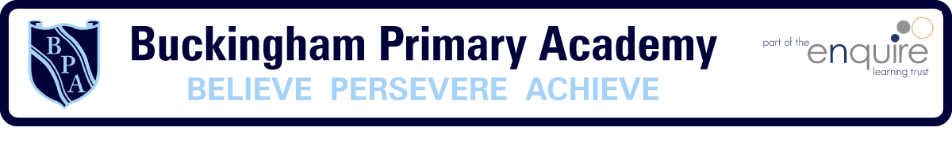
Phonics
Week 2

- Daily phonics sessions should be no longer than 15 minutes
- It is important that children repeat both the activities and the sounds
- Sessions should be practical and involve lots of games (either on an iPad or tablet or you can make your own)

Phase 2 | Phase 3
- Recap Phase 2 sounds s a t  - Recap Phase 2 Tricky words  - Learn Phase 2 sounds p i n  - Create list of words that use the initial sounds p i n  - Watch Geraldine the Giraffe does Phonics on YouTube https://www.youtube.com/watch?v=q0akp_j1nbc  - Listen to the Tricky Word Song on YouTube  https://www.youtube.com/watch?v=e2dx65u59aw  - Create your own Phase 2 flash cards  - Hide the flashcards around the house and go on a sound treasure hunt (focus on initial sounds p i n) | - Recap Phase 2 & 3 sounds j v w  - Recap Phase 3 Tricky words  - Learn Phase 3 sounds x y z  - Create list of words that use the sounds x y z  - Watch Geraldine the Giraffe does Phonics on YouTube https://www.youtube.com/watch?v=R0YLRRdZ3R4  - Listen to the Tricky Word Song on YouTube  https://www.youtube.com/watch?v=e2dx65u59aw  - Create your own Phase 3 flash cards  - Hide the flashcards around the house and go on a sound treasure hunt (focus on initial sounds x y z )
Phase 4 | Phase 5
- Recap Phase 2, 3 & 4 sounds  - Recap Phase 3 & 4 Tricky words  - Introduce new Phase 4 Tricky words said so he she we be  - Listen to the Tricky Word Song on YouTube  https://www.youtube.com/watch?v=R087lYrRpgY  - Using Phase 4 blends create flashcards to hide around the house and go on a Phase 4 treasure hunt (crab, drawing, flag )  - Play Phase 4 Buried Treasure https://www.phonicsplay.co.uk/BuriedTreasure2.html | - Recap Phase 2, 3, 4 & 5 sounds ay ou ie  - Recap Phase 3, 4 & 5 Tricky words  - Learn Phase 5 sounds ea oy ir  - Create list of words that use the sounds ea oy ir  - Watch Geraldine the Giraffe does Phonics on YouTube https://www.youtube.com/watch?v=L6F4KRdhqak  - Listen to the Tricky Word Song on YouTube  https://www.youtube.com/watch?v=e2dx65u59aw  - Create your own Phase 5 flash cards  - Hide the flashcards around the house and go on a sound treasure hunt (focus on ea oy ir)  - Play Phase 5 Buried Treasure  https://www.phonicsplay.co.uk/BuriedTreasure2.html

